|  |
| --- |
|  |





GitHub li

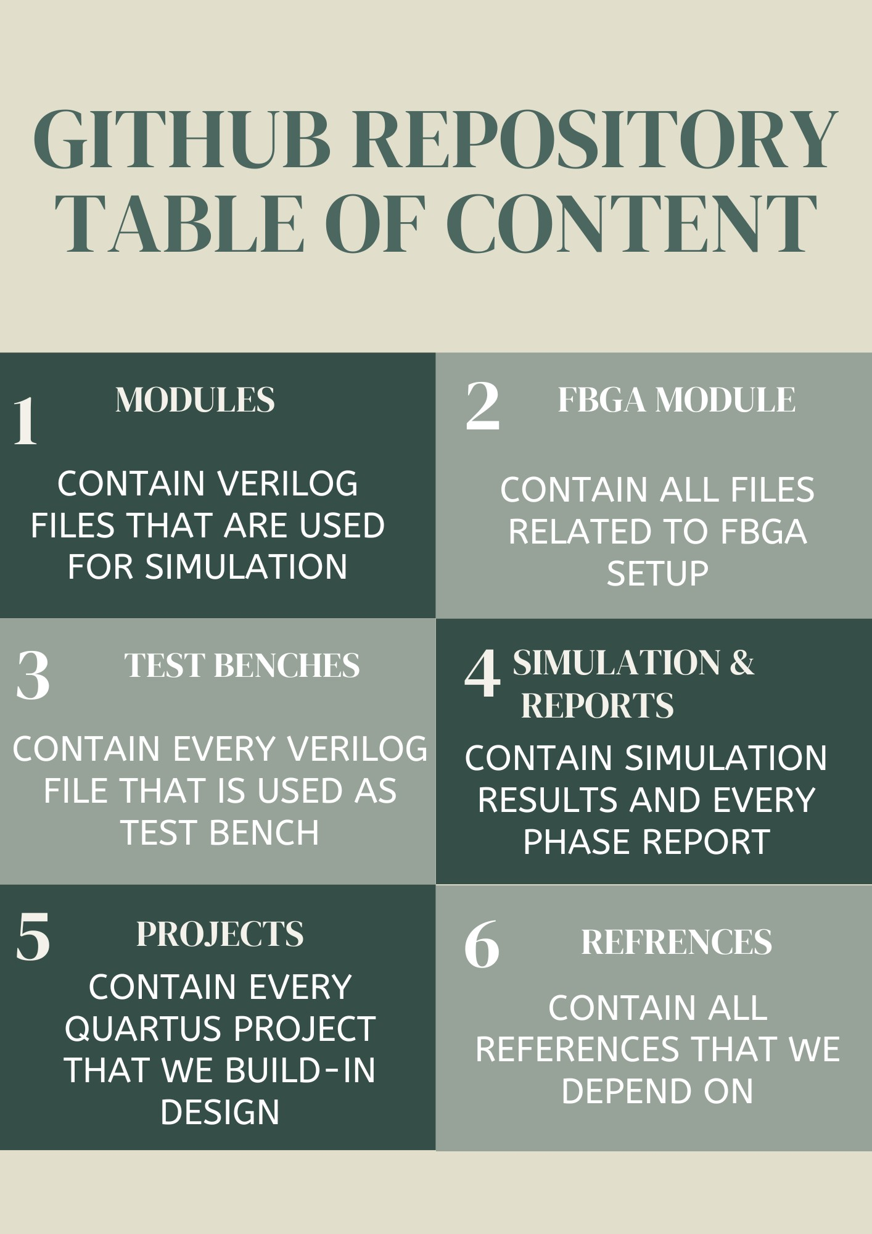

# Acknowledgments

It"It is with immense gratitude that I acknowledge the support and guidance of Professor Mohammad A. Alshboul during the intricate process of designing the pipeline CPU. His profound expertise and deep understanding of the subject were pivotal in navigating the complexities inherent in such an endeavor.

Professor Alshboul's meticulous attention to detail, patience, and hands-on approach were instrumental in every phase of the design. He consistently provided insightful feedback, ensuring that our design met the highest standards of precision and efficiency. His unwavering belief in the project's potential and my capabilities were a constant source of motivation, pushing me to delve deeper and refine our work further.

In parallel, the assistance and insights from Professor Osama have been equally vital to the success of this project. His expertise in complementary areas provided a broader perspective, enhancing our design's robustness and applicability. Professor Osama's enthusiasm for innovation and his strategic advice helped overcome several challenges, making our journey not just educational but also exceptionally rewarding.

Beyond the technical aspects, Professor Alshboul's dedication to nurturing creativity and fostering a spirit of inquiry has been truly inspirational. Similarly, Professor Osama's commitment to academic excellence and his encouragement to pursue novel solutions have significantly enriched my learning experience. Both have not only been mentors but also beacons of encouragement, instilling in me a passion for design and a commitment to excellence.

To Professor Alshboul and Professor Osama, I extend my heartfelt appreciation for your invaluable support, guidance, and mentorship. Your influence on this project, and on my academic journey as a whole, cannot be overstated. Thank you both for being the cornerstones of this achievement."

I am immensely grateful for the guidance, expertise, and unwavering support provided by Husam A. Suleiman. His contribution has been a cornerstone of the project's success.

For his invaluable contributions, steadfast support, and inspiring mentorship, I extend my deepest thanks to Husam A. Suleiman.

# Abstract

This project explores the design, implementation, and evaluation of a pipelined MIPS CPU, utilizing Verilog for the hardware description language. The objective was to create a processor architecture that enhances computational throughput and efficiency by introducing a pipelined approach to instruction execution. Unlike traditional single-cycle CPUs where each instruction is executed in one complete cycle, our pipelined MIPS CPU breaks down instruction execution into distinct stages, allowing multiple instructions to be processed simultaneously at different stages of execution.

The architecture is structured around five key stages: instruction fetch, instruction decode, execution, memory access, and write-back. This division enables the CPU to begin processing a new instruction at the fetch stage while previously fetched instructions progress through the subsequent stages, significantly improving instruction throughput compared to a single-cycle architecture.

A meticulous emphasis was placed on the modular design and scalability of the processor to facilitate future expansions and optimizations. Preliminary testing demonstrates that the pipelined MIPS CPU operates successfully, executing instructions with increased efficiency and speed. This project serves not only as a valuable educational resource for understanding pipelined CPU architectures but also lays a solid foundation for further research into optimizing pipeline performance and implementing advanced features such as branch prediction and hazard detection.

Future work will focus on enhancing the pipeline's efficiency through the integration of these advanced mechanisms, aiming to minimize stalls and improve the overall performance of the MIPS processor. Through this project, we contribute to the ongoing evolution of CPU design, highlighting the potential for significant advancements in processing speed and efficiency offered by the pipelined approach.

**Table of Contents**

Acknowledgments iii

Abstract v

Introduction 12

1.1 Introduction 12

1.2 The Importance of the Design 12

1.3 Motivation 12

1.4 Why This Topic is Important for Students 12

1.5 Objectives of the Project: 13

1.6 Description of Design Achieved: 13

1.7 Design Requirements: 14

1.8 Timeline project 15

1.9 The team’s member responsibility 16

1.9.1 Omar AL-khasawneh (Leader) 16

1.9.2 Omar AL-Salah 16

1.9.3 Moayyad Abu Mallouh 16

Design 17

1.10 Hardware Design and Implementation 17

1.11 Component 19

1.11.1 Forwarding : 21

**1.11.2** Program counter **:** 22

1.11.3 Hazard unit 23

1.11.4 Register file: 25

1.11.5 IF_ID register 28

1.11.6 ID_EX register 29

1.11.7 EX_MEM register 30

1.11.8 MEM_WB register 31

1.12 MIPS DATAPATH 32

1.12.1 Phase1 32

1.12.2 Phase 2 32

1.12.3 Phase 3 34

1.13 MIPS instruction execution phase 35

1.14 Coding and Software Development 35

1.14.1 Tools 35

1.14.2 Challenging 35

1.14.3 Instruction set architecture 38

Results 41

1.15 FPGA 41

1.15.1 Benchmark one 41

1.15.2 Testcase 2 44

1.15.3 Testcase 3 46

1.15.4 Testcase 4 49

1.15.5 Testcase 5 52

1.15.6 Testcase 6 56

1.16 Benchmark 58

**1.16.1** **Test case one** 58

**1.17** **Test case 2** 62

1.17.1 Data memory and instruction memory 62

1.17.2 Second Instruction SLL R1, R1, 2 Hazard Catch with stall cycle 62

1.17.3 Second Instruction SLL R1, R1, 2 MEM Stage Forwarding Catch 64

64

1.17.4 CPU Stage After Execution 64

1.18 Test case 3 66

1.18.1 Instruction memory and data memory 66

1.18.2 First Three Instruction Execution. 67

1.18.3 Fourth Instruction ADD R8, R8, R9 Load_Use_Hazard Catch 68

**1.18.4** Fourth Instruction Hazard End 69

1.18.5 eighth instruction ADDI R8, R8, 1 Forwarding EX Stage ALU Forwarding. 70

1.18.6 the CPU after execution 71

**1.19** **Test case 4** 72

1.19.1 Instruction memory and data memory 72

1.19.2 First Jump Instruction Branch not Taken 73

1.19.3 Branch Taken last Branch Instruction 74

1.19.4 CPU Status after execution 75

**1.20** **Test case 5** 76

1.20.1 Instruction memory and data memory 76

**No need for RAM** 76

1.20.2 When a =2 76

1.20.3 When a =6 80

**1.21** **Test case 6** 84

1.21.1 Instruction memory 84

1.21.2 First Branch BEQ R1, R9, EXIT Instruction Catch Branch Forwarding 84

1.21.3 First Branch BEQ R1, R9, EXIT Instruction Catch Branch Hazard 85

1.21.4 the last Iteration Branch Taken. 87

1.21.5 The CPU Status After execution 88

1.22 special case JAL & JS 89

1.22.1 Instruction Memory Values. 89

1.22.2 Initial Value First Cycle 89

1.22.3 First JAL Instruction 90

1.22.4 First JS Instruction JUMP Forwarding 92

1.22.5 First JAL Instruction 93

1.22.6 Last JS Instruction 94

1.22.7 CPU Status After Execution. 95

Evaluation Sheet Statics 97

Conclusion 101

1.22.8 Key Findings and Implications 101

1.22.9 Project’s objectives achieved. 101

Appendix A: CODE 102

1.23 ALU 102

1.24 branch 105

1.25 control unit 107

1.26 EX_MEM_Register 122

1.27 ForwardingUnit 124

1.28 Hazard unit 126

1.29 ID_EX_Register 129

1.30 ID_EX_Register 134

1.31 instruction memory(FSM) 138

1.32 JUMP 142

1.33 MEM_WB 143

1.34 Main 145

1.35 PC(FSM) 167

1.36 RAM(FSM) 169

1.37 Register file 171

1.38 Stack memory(FSM) 175

1.39 ALU control 177

1.40 Branch control 180

1.41 Sign_extend 181

appendix B FPGA code 181

1.42 Main 181

1.43 FPGA 206

# Introduction

## Introduction

In the ever-evolving landscape of computer science and engineering, the design and implementation of central processing units (CPUs) continue to be a focal point of innovation and exploration. Among the various CPU architectures, the development of a pipeline CPU, akin to the revered MIPS, stands as a compelling and vital undertaking. This project represents our endeavor to grasp and engineer a fundamental yet pivotal component of modern computing systems.

## The Importance of the Design

The importance of designing and understanding single-cycle CPUs is multifaceted and integral to the field of computer science and engineering. In a world where processing power and efficiency are at the forefront of technological advancement, the design of CPUs becomes an arena where every microarchitectural decision counts. The single-cycle CPU, characterized by its simplicity and transparency, holds particular significance. It offers a clear and unambiguous model for comprehending the inner workings of a CPU. By its nature, it encapsulates the essence of instruction execution in a single clock cycle, thereby facilitating a straightforward understanding of processor operations. In this project, we dive into this simplicity to harness its educational and practical merits.

## Motivation

The motivation behind this project stems from a shared passion for learning and a profound curiosity about the architecture of modern computers. Understanding the CPU, often referred to as the "brain" of a computer, is a fundamental step in comprehending how computers execute instructions, process data, and perform complex operations. As students in the field of computer science and engineering, our motivation is twofold. Firstly, we aim to deepen our knowledge of CPU design, enabling us to demystify the underlying mechanisms of computing systems. Secondly, we aspire to create a resource for students and enthusiasts alike to embark on a journey of discovery, employing our project as an educational tool.

## Why This Topic is Important for Students

For students, the significance of exploring the design and implementation of a single-cycle CPU lies in the educational value it holds. It serves as a comprehensive learning experience, bridging theory and practice in the field of computer architecture. As an educational endeavor, our project offers students the opportunity to delve into the intricacies of CPU design, to comprehend the essence of instruction execution, and to witness the tangible results of their efforts. This not only enhances their academic knowledge but also fosters a deeper appreciation for the technologies that underpin our modern world. By providing a practical and accessible entry point into CPU architecture, our project empowers students to become proficient problem solvers, critical thinkers, and innovative engineers.

## Objectives of the Project:

1. **Pipelined CPU Architecture:** The primary goal of this initiative is to develop and deploy a pipelined CPU, deeply rooted in MIPS architectural concepts. This CPU is designed to efficiently process a series of essential instructions across multiple stages within each clock cycle.
2. **Educational Resource:** We aim to create an educational resource that not only serves our learning goals but also benefits other students and enthusiasts in the field of computer science and engineering. The project aims to offer a clear, step-by-step insight into CPU design and facilitate a deeper understanding of the architectural choices involved.
3. **Comprehensive Understanding:** To achieve a comprehensive understanding of computer architecture, we will delve into the intricacies of various CPU components, including the control unit, ALU, registers, and memory hierarchy. This understanding will enable us to articulate the rationale behind design decisions.
4. **Performance Analysis:** The project seeks to analyze the performance of the single-cycle CPU in terms of execution speed, resource utilization, and comparison with other CPU architectures. This analysis will help in assessing the practical implications and limitations of the design.

## Description of Design Achieved:

In pursuit of these objectives, we have successfully designed a single-cycle CPU model with the following characteristics:

* **MIPS-Inspired Architecture:** Our CPU design is heavily influenced by the MIPS architecture, renowned for its simplicity and elegance. This architecture served as a valuable reference point in shaping our CPU's instruction set, control unit, and data path.
* **RISC (Reduced Instruction Set Computer) Principles:** Our CPU follows the RISC principles by focusing on a limited set of simple and frequently used instructions. This design choice enhances the CPU's efficiency and ease of understanding.
* **Pipelined Processing:** Our CPU architecture is engineered to handle instructions across multiple stages, each occurring in successive clock cycles. This pipelined approach streamlines instruction fetch, decode, execution, and the writing of results to registers, enhancing throughput and efficiency in contrast to single-cycle execution models.
* **Control Unit:** We have implemented a control unit that generates control signals to direct the CPU's operations based on the current instruction. This control unit is responsible for managing the flow of data within the CPU.
* **ALU and Registers:** The Arithmetic Logic Unit (ALU) performs arithmetic and logical operations, while the registers store data. Our CPU features a specific number of registers, and the ALU is capable of executing a variety of operations.
* **Memory Hierarchy:** We have incorporated a memory hierarchy with separate instruction and data memory. This design choice aligns with modern CPU architectures and offers an accurate representation of how instructions and data are stored and accessed.

## Design Requirements:

Our CPU design adheres to the following key requirements:

* **Simplicity:** The design should prioritize simplicity and clarity to serve as an educational tool. It should be comprehensible to students and enthusiasts with a basic understanding of digital logic and computer architecture.
* **Pipelined Execution:** Instructions progress through multiple stages within the CPU, with each stage completing in a single clock cycle, illustrating the essential mechanics of a pipelined CPU architecture.
* **Instruction Set:** The CPU should support a defined instruction set, inspired by the MIPS architecture. This instruction set should include fundamental operations such as arithmetic, logic, and data movement instructions.
* **Efficiency:** The design should strive for efficiency by optimizing the use of resources and minimizing redundancy.

## Timeline project

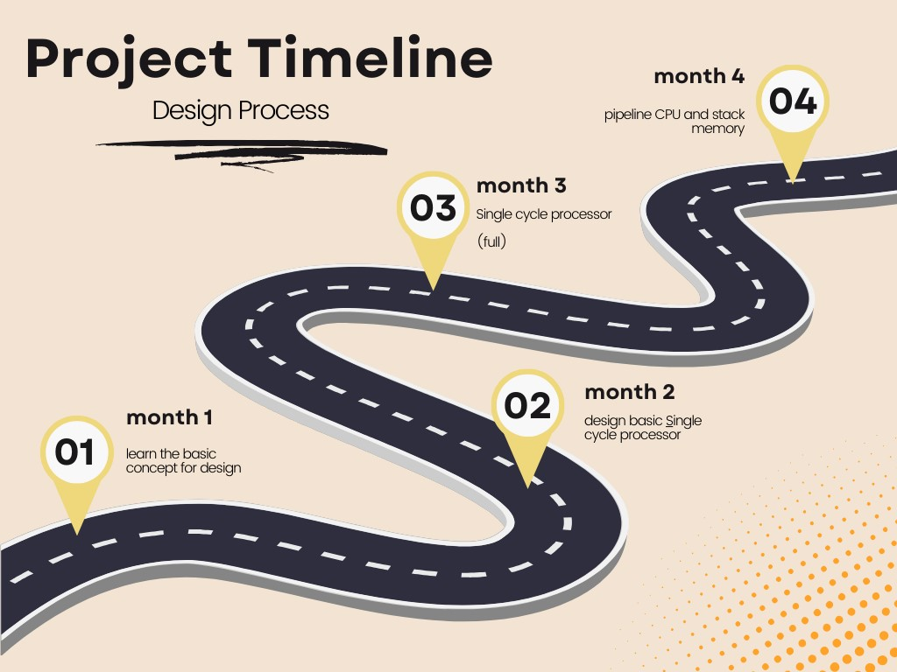

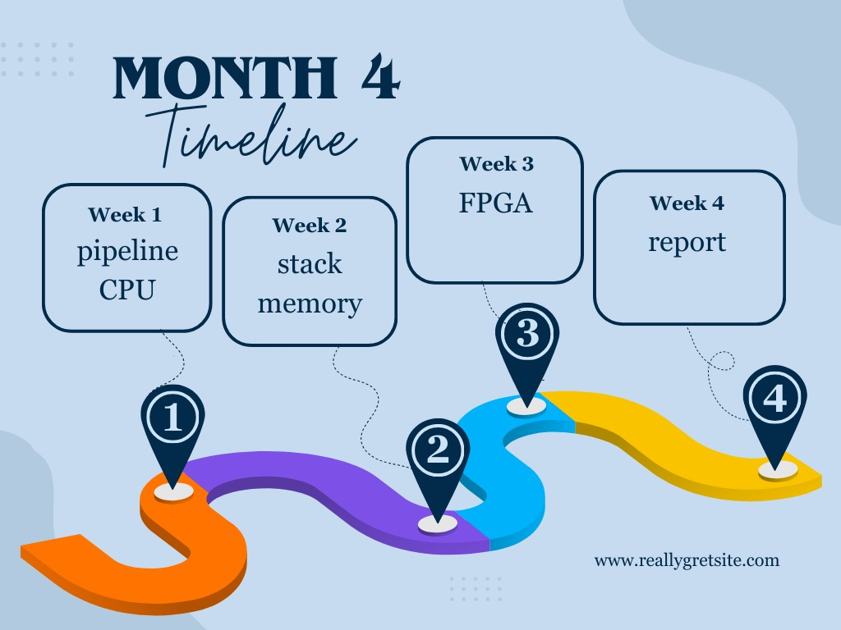

## The team’s member responsibility

### Omar AL-khasawneh (Leader)

* ALU design
* ALU control design
* PC design
* Forwarding
* Writing report

### Omar AL-Salah

* Register file
* Control unit
* Hazard unit
* Stack Memory Implementation
* Jump Forwarding Unit
* Debugger

### Moayyad Abu Mallouh

* Instruction memory
* Data memory
* Branch
* FPGA

Each member assists others with various tasks

# Design

## Hardware Design and Implementation

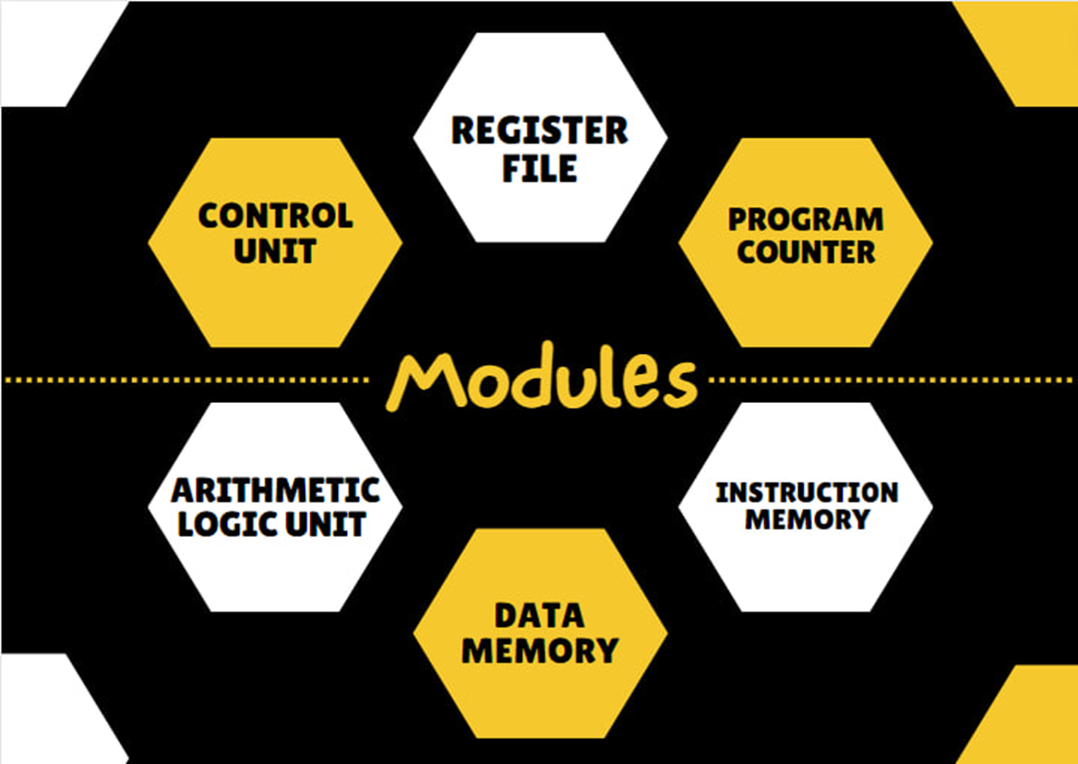

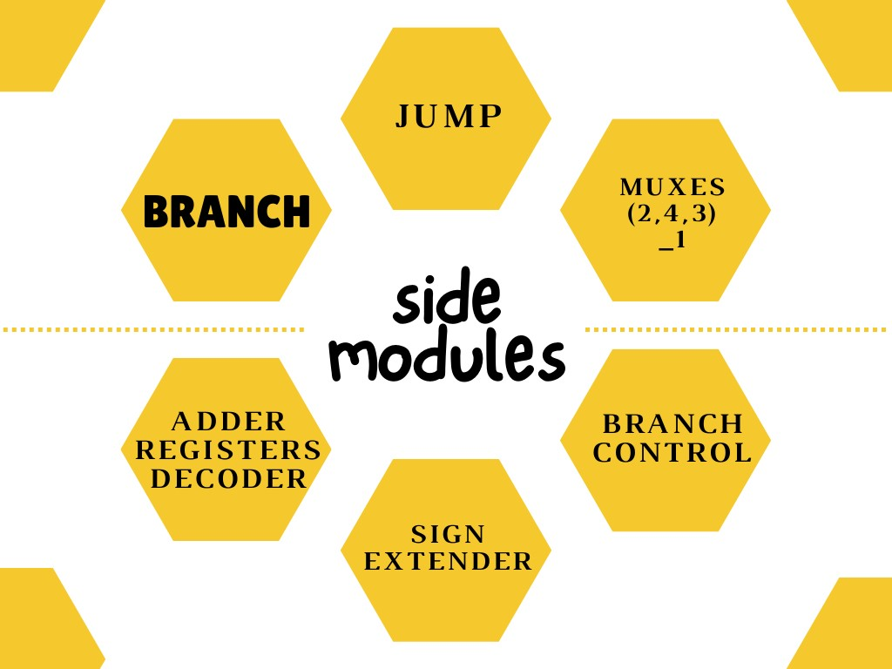

Extra module in phase 3

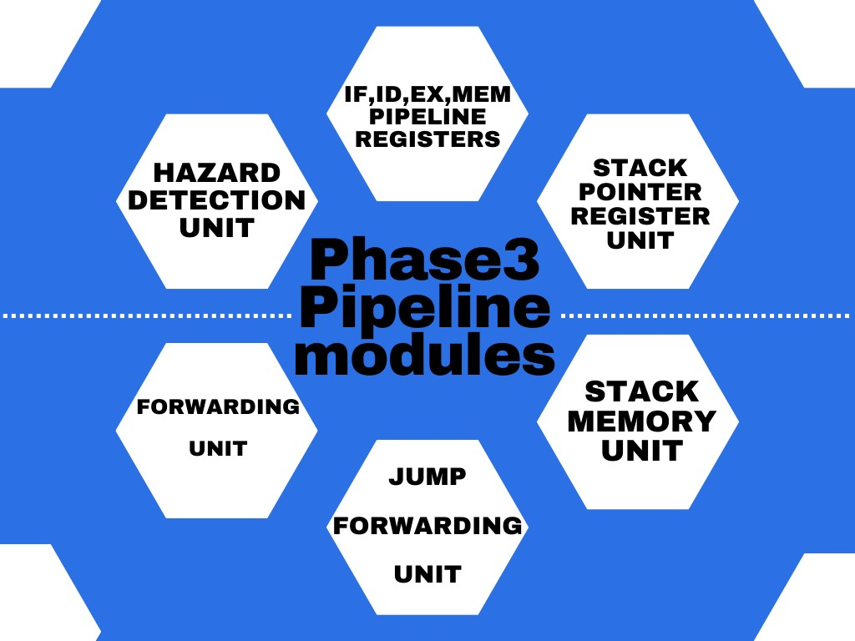

## Component

**Data Memory :** in the context of computer architecture and digital systems, is a component that stores and retrieves data during the execution of programs. It serves as a storage medium for variables, arrays, and other data structures used by a computer's central processing unit (CPU) to perform calculations and operations.

**Instruction memory**: also known as the Instruction Cache or Code Memory, is a component in a computer's architecture that stores the machine code instructions that the CPU (Central Processing Unit) fetches, decodes, and executes to perform various tasks and operations. These instructions are part of the computer program or software being run on the CPU. Instruction memory is essential for the operation of a computer because it holds the program's instructions in a format that the CPU can understand and execute sequentially.

**Note**: We Develop both Data Memory and Instruction Memory from scratch without using the built-in Memory, and initialize them with FSM Techniques

Arithmetic logic unit: (ALU)

is a crucial component of a computer's central processing unit (CPU). It performs arithmetic and logic operations on data, such as addition, subtraction, multiplication, division, and comparisons.

The ALU is designed to perform a variety of arithmetic and logical operations, dictated by a 4-bit control signal (ALUControl). It processes 32-bit inputs (A and B), handling basic arithmetic operations like addition, subtraction, multiplication, and division, as well as logical operations including AND, OR, XOR, and NOR. Additionally, it supports shift operations (logical left and right shifts) which are controlled by a 5-bit shift amount.

One of the notable features of this ALU is its ability to respond to different branch types, determined by a 3-bit signal (branch_type). This enables the ALU to participate in decision-making processes, fundamental in computational logic, by setting a Zero flag based on specific conditions (like equal, not equal, greater than, or less than comparisons).

Furthermore, the ALU includes an internal mechanism to handle overflow and carry-out scenarios, which are critical in signed arithmetic operations. These scenarios are managed through dedicated blocks that set the Overflow and CarryOut flags under specific conditions, like during addition or subtraction when the sign bit (most significant bit) might be incorrectly set or unset due to the arithmetic operation.

Overall, this ALU module illustrates the complexity and versatility of digital logic designs in performing essential computational tasks. It is a quintessential example of how various arithmetic and logical operations are implemented at a hardware level in computing systems.

### Forwarding :

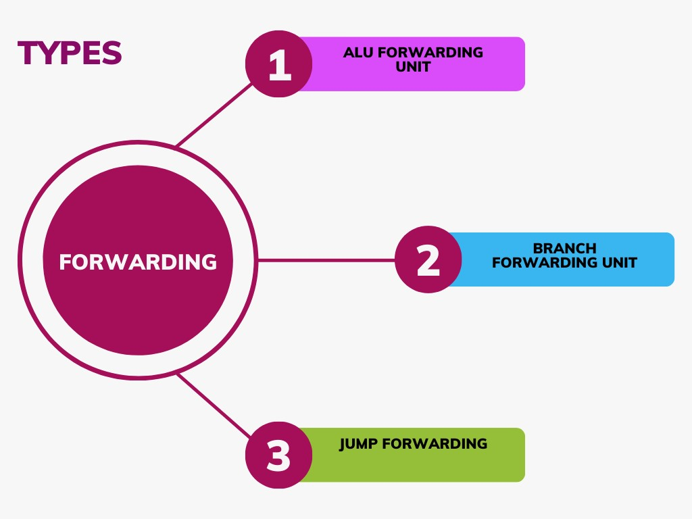

The Forwarding Unit in MIPS (Microprocessor without Interlocked Pipeline Stages) architecture plays a crucial role in optimizing the performance of pipelined processors by addressing data hazards that naturally occur due to the overlap of instruction execution.

Forwarding mechanisms play a crucial role in data dependency detection and instruction handling within the processor. The first module, the ALU Forwarding Module, operates within the EX stage and is primarily utilized for identifying data dependencies in R-type instructions. It produces output signals for ALU MUX A and MUX B selection lines. These signals indicate various forwarding scenarios: '00' signifies no forwarding, '01' denotes forwarding from the WB stage, and '10' represents forwarding from the MEM stage.

The second component, the Branch Forwarding Unit, is deployed during the ID stage to pinpoint data dependencies in branch instructions. It generates output signals for Branch Unit MUX A and B selection lines, following a similar pattern to the ALU Forwarding Module: '00' for no forwarding, '01' for forwarding from the WB stage, and '10' for forwarding from the MEM stage.

Lastly, in the ID stage, another forwarding mechanism is employed specifically for detecting data dependencies between JAL and JS instructions. This mechanism, labeled as 'JUMP Target Address MUX,' offers output signals indicating forwarding scenarios. A value of '0' signifies no forwarding, while '1' indicates forwarding from the MEM stage. These forwarding strategies collectively enhance the efficiency and performance of the processor's instruction handling processes.

### Program counter **:**

also known as the instruction pointer (IP) in some architectures, is a special-purpose register in a computer's central processing unit (CPU). It holds the memory address of the next instruction to be fetched and executed in a program. The PC is automatically incremented after each instruction is fetched, allowing the CPU to sequence through the program's instructions in order.

**we use state machine to make the design better and easy to upgrade .**

### Hazard unit

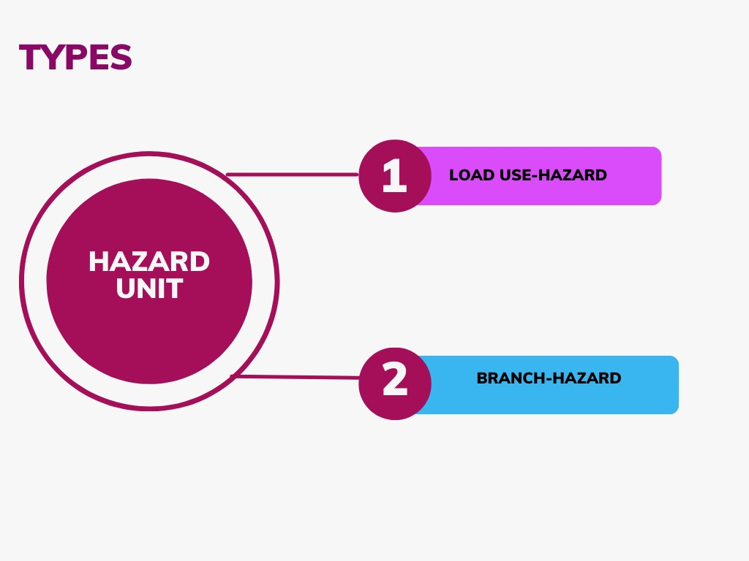

The Hazard Detection Unit serves the crucial role of identifying instances where forwarding mechanisms fail to operate effectively. Two primary hazard cases are monitored:

1. Load Use-hazard:

This occurs when an instruction in the ID stage exhibits data dependency with a load instruction in the EX stage.

1. Branch Hazard:

This situation arises when a branch instruction in the ID stage demonstrates data dependency either with an instruction in the EX stage or with a load instruction in the MEM stage.

Output signals from the Hazard Detection Unit provide crucial insights into the encountered hazards:

ID_EX_FLUSH: This signal transitions from 0 to 1, indicating the need to flush the ID_EX pipeline register by forcing its signals to become NOP signals.

IF_ID_write: It switches from 1 to 0, disabling the IF_ID pipeline register to repeat the same instruction that caused the hazard.

PC_write: This signal changes from 1 to 0, disabling the PC register by repeating the same value from the last cycle.

When a hazard is detected, the signal values are adjusted accordingly:

ID_EX_FLUSH is set to 1.

IF_ID_write is set to 0.

PC_write is set to 0.

These adjustments ensure proper handling of hazards and help maintain the integrity and functionality of the processor's pipeline system.

### Register file:

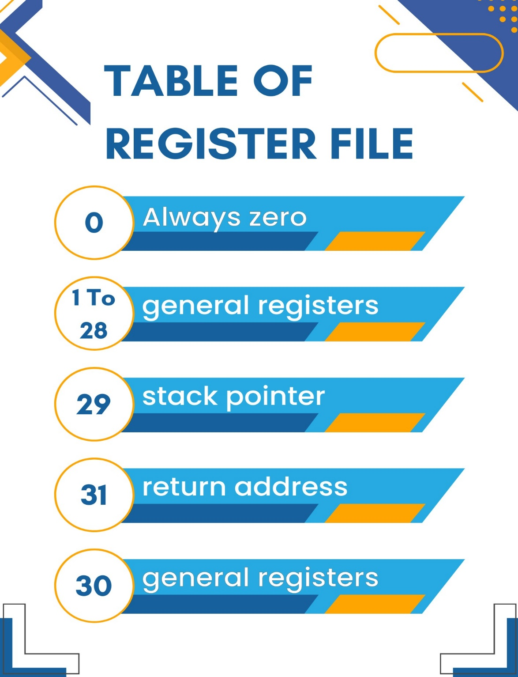

is a collection of registers that are used for temporary data storage and manipulation within a central processing unit (CPU). Registers are small, high-speed storage locations that are an integral part of the CPU. They store operands, intermediate results, and control information needed for executing instructions.

The Register File module stands as a cornerstone in the MIPS architecture, and in our CPU design, we have meticulously crafted a RegisterFile module to fulfill the essential role of managing registers efficiently. The module declaration encompasses standard signals, aligning with the MIPS convention, **including Clock, ReadReg1, ReadReg2, WriteReg, WriteData, Reg_write_Control, ReadData1, and ReadData2.**

* **We employ specific registers for distinct functionalities within our system:**

**Register 0** (Reg 0): This register is dedicated to always maintaining a value of zero.

**Register 29** (Reg 29): It serves as the stack pointer, which is routinely updated with each JAL or JS instruction. Its value is adjusted either positively or negatively, indicating stack growth or shrinkage. Initially, it holds the value 88 Using FSM techniques , representing the first address of the stack memory in RAM.

**Register 31** (Reg 31): This register functions as the return address register. It works in tandem with the stack memory during every JAL or JS instruction. Reg 31 facilitates the collaboration by retrieving the new stack pointer value from RAM, using the current Reg 29 value as an address. This mechanism ensures seamless management of return addresses within the system's execution flow.

**Control unit:** is a crucial component of a computer's central processing unit (CPU) or any computational device. It coordinates the activities of all the other hardware components in the system. Essentially, the control unit fetches instructions from memory and decodes and executes them, sending signals to the other components of the computer to control data flow and processing operations. It acts as a central manager, directing the operation of the processor and its interaction with other hardware components.

The control unit serves as the central intelligence of our CPU design, acting as the pivotal module that orchestrates the various operations within the processor. At the core of this module lies the ControlUnit entity, taking essential signals such as Clock, Reset, opcode, RegDst, ALUSrc, MemtoReg, MemWrite, MemRead, ALUOp, RegWrite, Branch, Jump, funct, pc_load, and PC_Store.

In aligning with the standard MIPS architecture, we have implemented familiar control signals such as Clock, RegDst, ALUSrc, MemtoReg, MemWrite, MemRead, ALUOp, RegWrite, Branch, Jump, funct , . These signals are crucial for directing the flow of data and control within the CPU.

Additionally, we have introduced new signals to tailor our design for specific functionalities:

**Reset Signal:**

The Reset signal serves as a mechanism to reset the control unit, initiating a no-operation (nop) instruction. This feature ensures a controlled start or restart of the CPU, enhancing the robustness and reliability of the system.

**Halt Signal:**

We have developed a new control signal termed "Halt" to address the Halt instruction, which invariably serves as the final instruction in a program, signaling the cessation of execution. Upon the control unit's receipt of the Halt instruction opcode "101101," the Halt control signal is raised to a high state, denoted as 1. This action triggers the cessation of the program counter (PC) and initiates the generation of an infinite loop of Halt instructions within the IF_ID pipeline register. Consequently, this halts further cycles of execution, effectively terminating program execution.

### IF_ID register

### The IF/ID pipeline register is responsible for storing the output from the Instruction Memory.

### ID_EX register

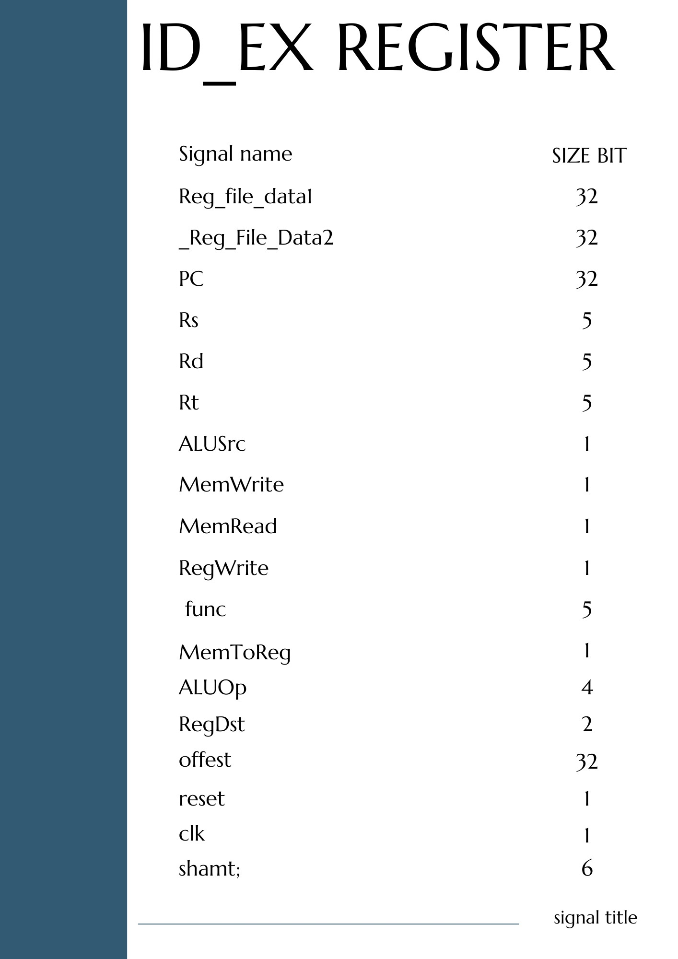

### EX_MEM register

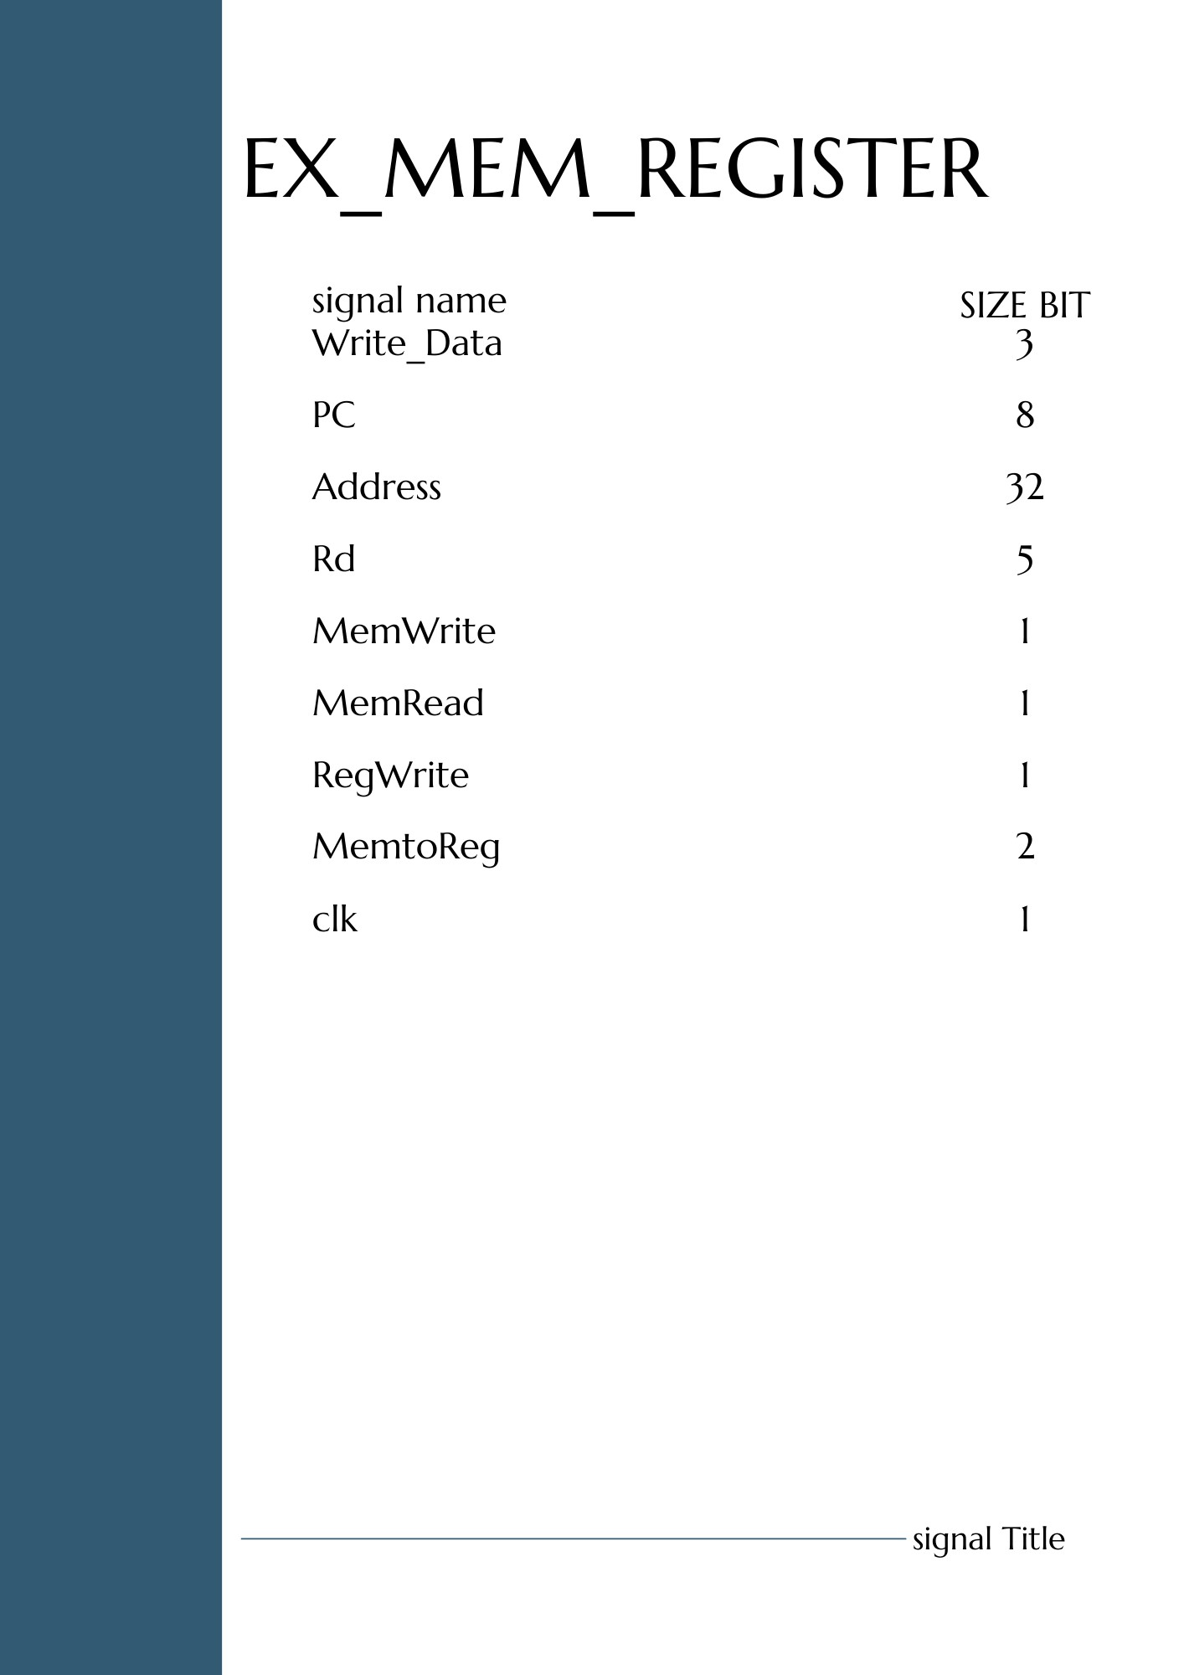

### MEM_WB register

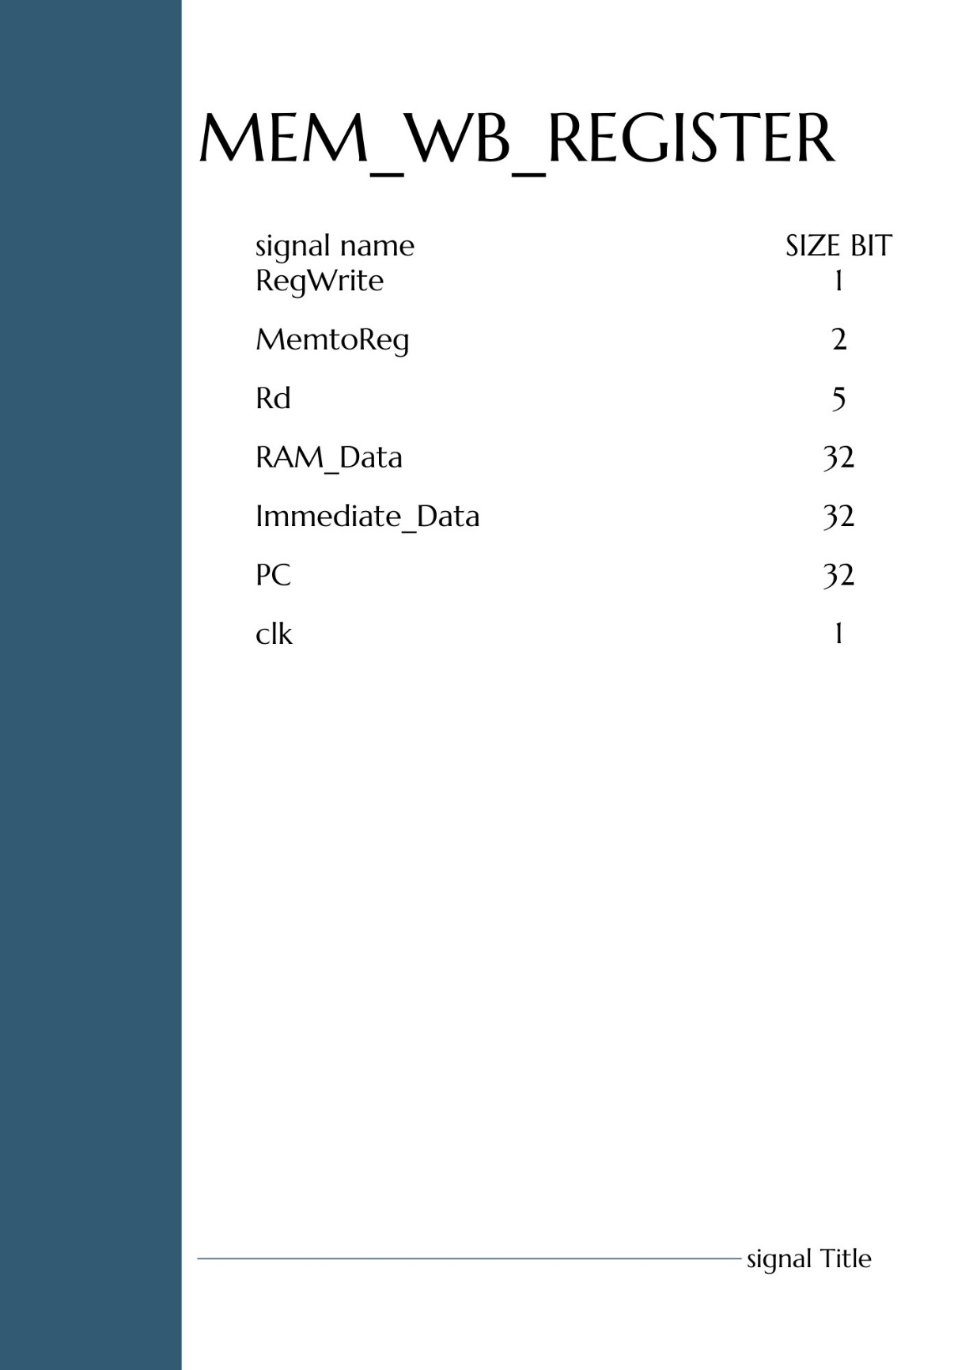

## MIPS DATAPATH

### Phase1

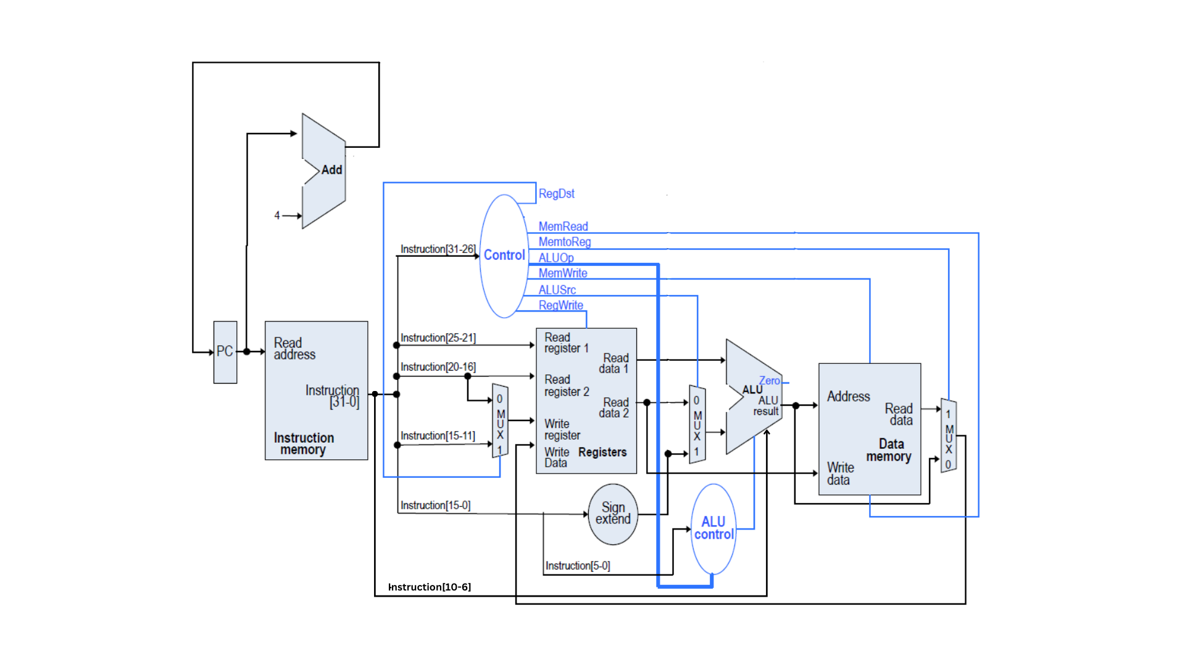

### Phase 2

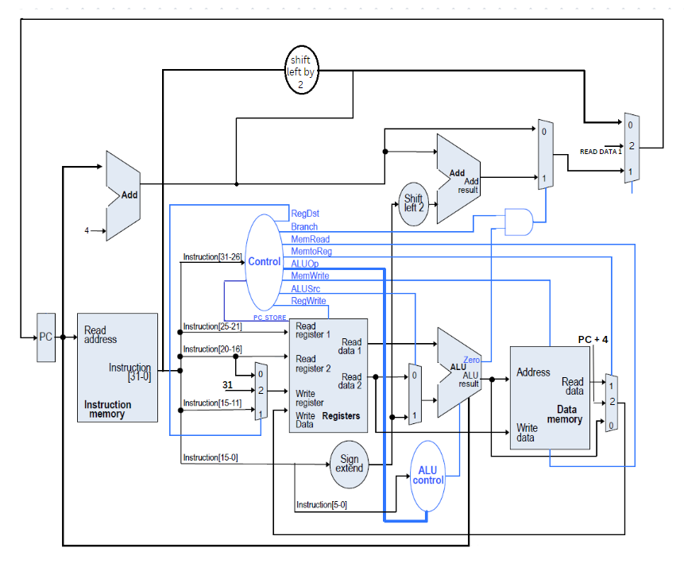

### Phase 3

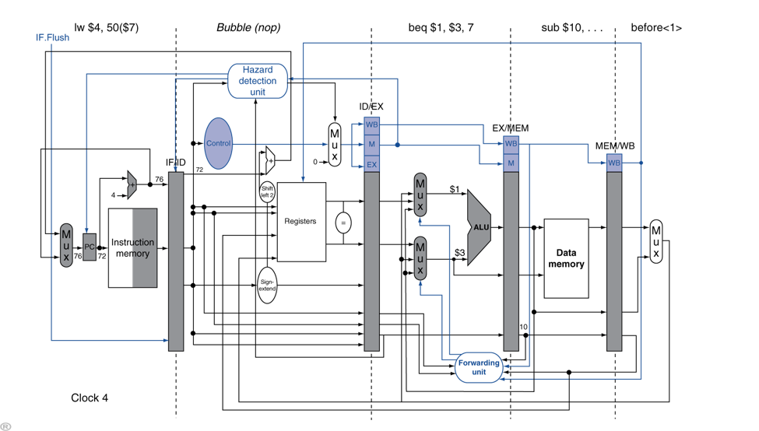

## MIPS instruction execution phase

## Coding and Software Development

### Tools

### In the development and verification of our single cycle CPU, we employed a combination of industry-standard tools to ensure accuracy, efficiency, and compatibility. We used **Verilog** as our hardware description language, a popular choice for its expressive syntax and powerful capabilities in modeling complex digital systems. Verilog facilitated a clear representation of our design, allowing for systematic testing and debugging of individual modules and their integration. Complementing this, **Quartus** served as our primary platform for synthesis, placement, routing, and simulation. Its comprehensive suite of tools enabled us to transform our Verilog code into gate-level representations, ensuring that our design meets the desired performance and resource criteria. Furthermore, Quartus provided a conducive environment for iterative design optimization, ensuring that our CPU design was not only functional but also efficient in terms of resource usage and speed. The synergy between Verilog and Quartus was instrumental in realizing a robust and reliable single cycle CPU.

### Challenging

1. . We face challenges due to limited online learning resources and the complexities of optimization. To address this, we seek guidance from our university professors.
2. We improved the performance of our design by 1. increasing the clock speed and 2. minimizing the area.
3. Detecting overflow in the ALU and providing the correct overflow output, **Detection of Overflow in the ALU**:
   * **For Addition**:
     + Overflow occurs if:
       - Both operands are positive, but the result is negative.
       - Both operands are negative, but the result is positive.
     + In terms of bit operations, consider the sign bits (most significant bit, MSB) of operands A and B and the result R. Overflow is detected if:
       - A's MSB is 0, B's MSB is 0, but R's MSB is 1.
       - A's MSB is 1, B's MSB is 1, but R's MSB is 0.
   * **For Subtraction**: Since subtraction is the same as adding a negative number in two's complement arithmetic, the rules for addition apply here too.

**Handling Overflow in the ALU**:

* + **Overflow Flag**: The ALU can set an overflow flag (often denoted as the 'V' flag in many architectures) whenever overflow occurs. This flag can be checked by subsequent instructions, and based on its value, certain actions can be taken, such as branching to error-handling routines.

consumption. There are a number of things that can be done to prevent timing violations, including careful design, the use of buffers, clock gating, and testing.

1. **FPGA**

1. Our university currently lacks access to the latest FPGA units, resulting in extended waiting periods until new FPGA resources are made available through competition allocations.

2. We had no idea how to implement our design on an FPGA, so if consume a lot of time to only know how implement our design in FPGA

1. **Stack Memory**

One of the primary challenges we confront is the limited availability of resources discussing this topic and providing implementation guidance, primarily due to its close association with the operating system (OS). Additionally, implementing this challenge requires linking it to work seamlessly with the Register File and RAM without introducing any additional Control Unit Signals or Data bus modifications.

### Instruction set architecture

#### Before (phase one)

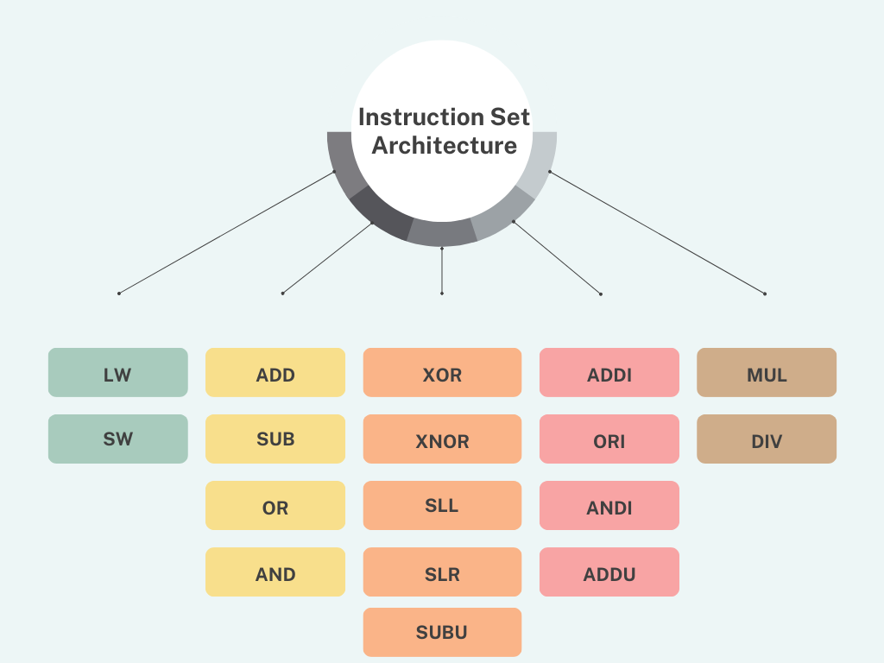

#### phase two

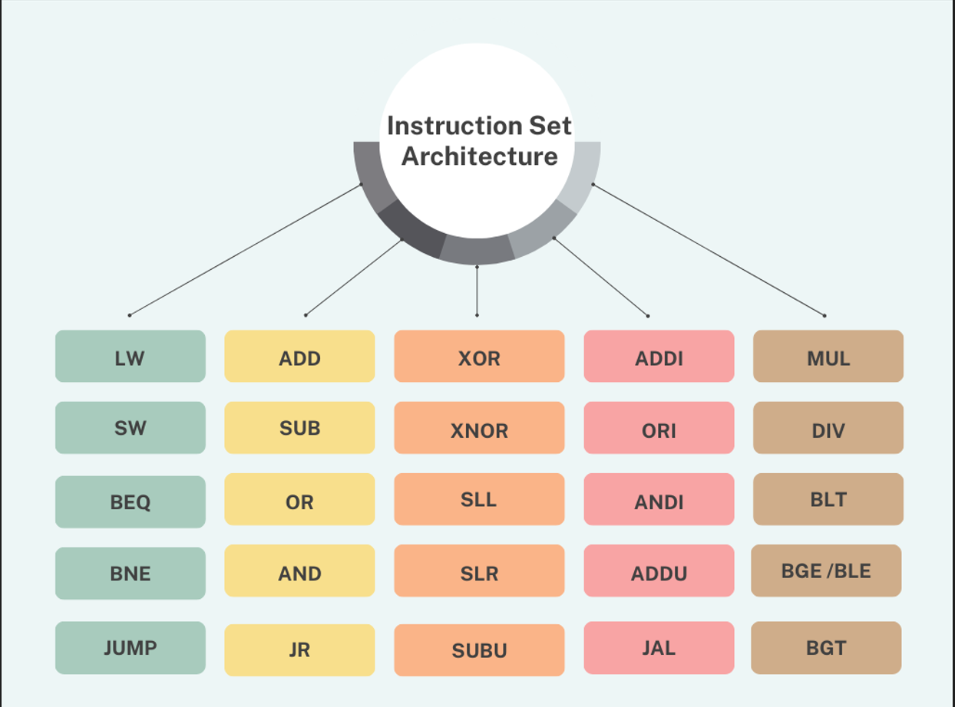

#### phase 3

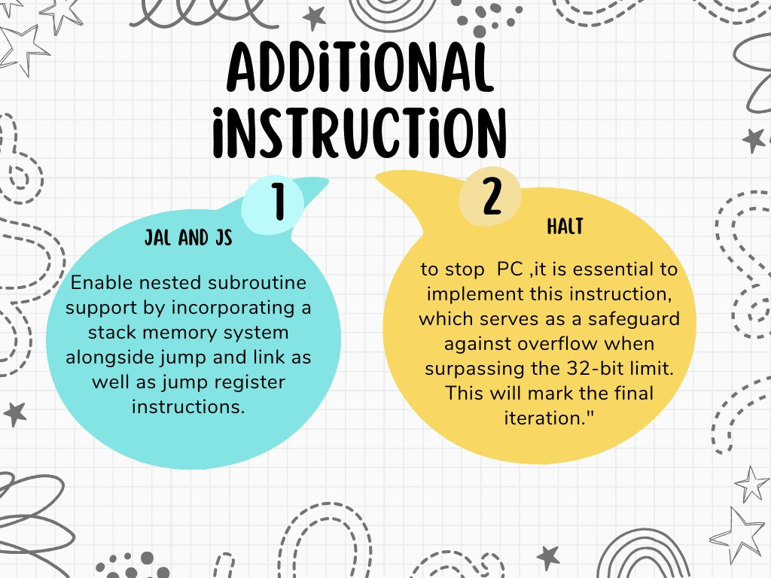

# Results

## FPGA

**Note**: In every FPGA benchmark image, the first two bits represent the register number, while the remaining bits represent the register value.

### Benchmark one

#### Register 10 ( the first two bit is register number ,other is register value)

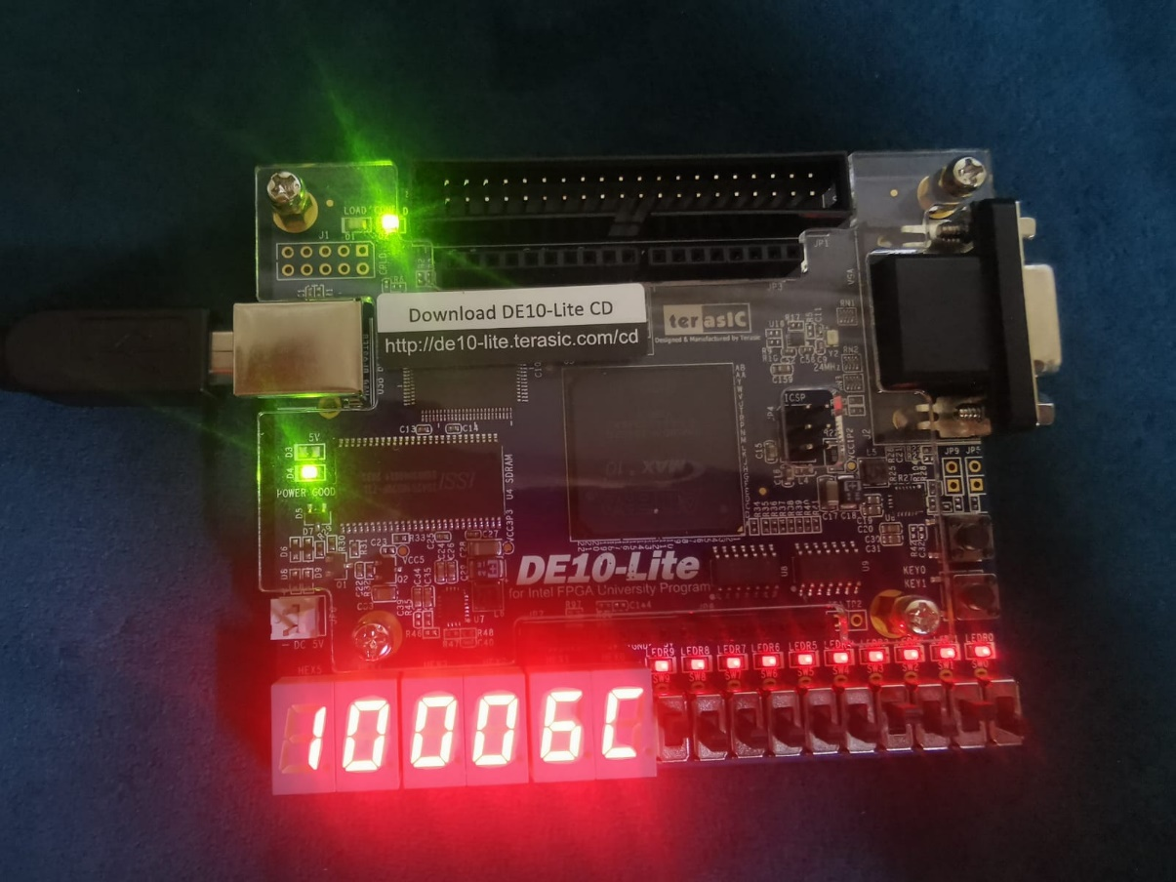

#### Register 8

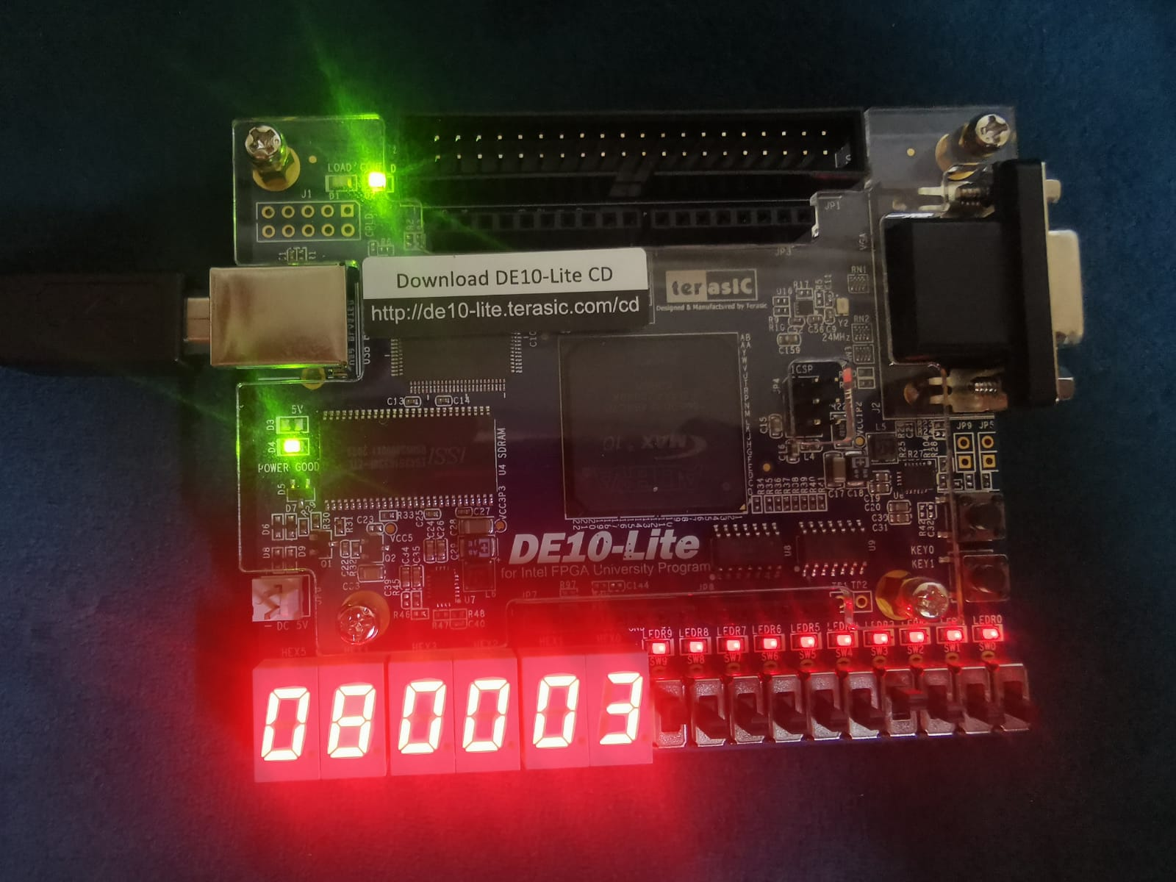

#### Register 9

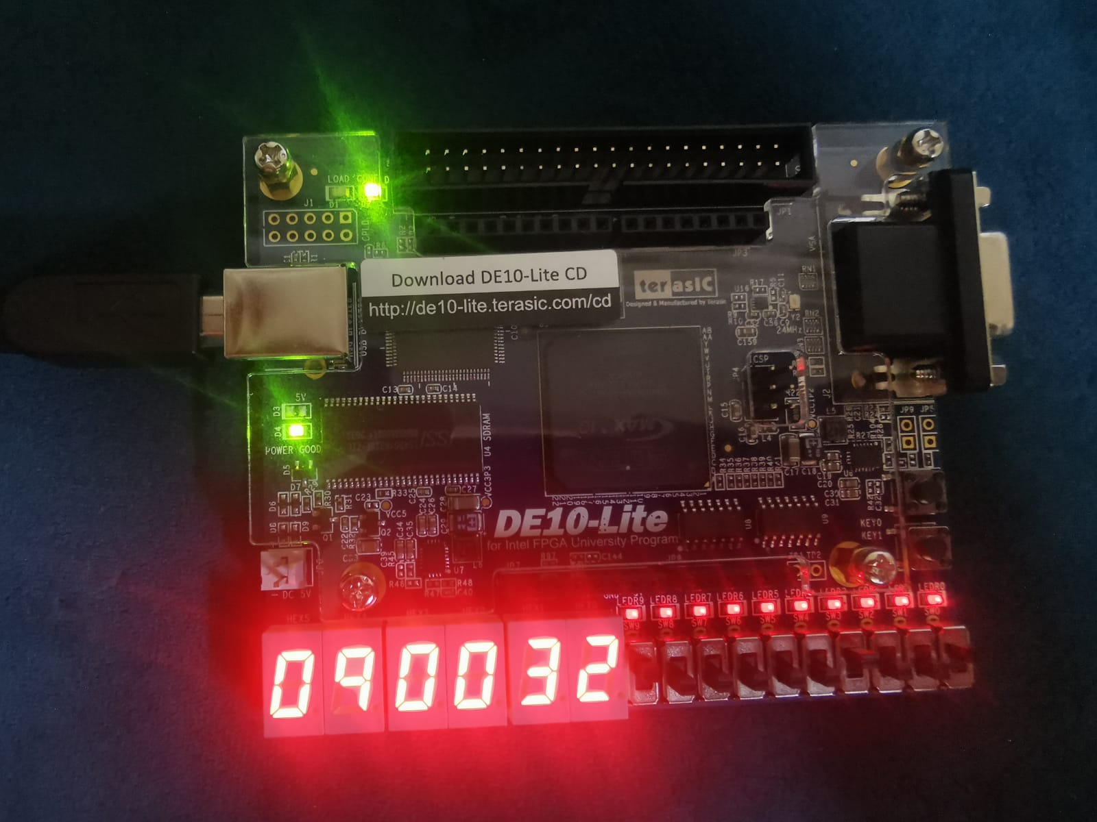

#### Register 11

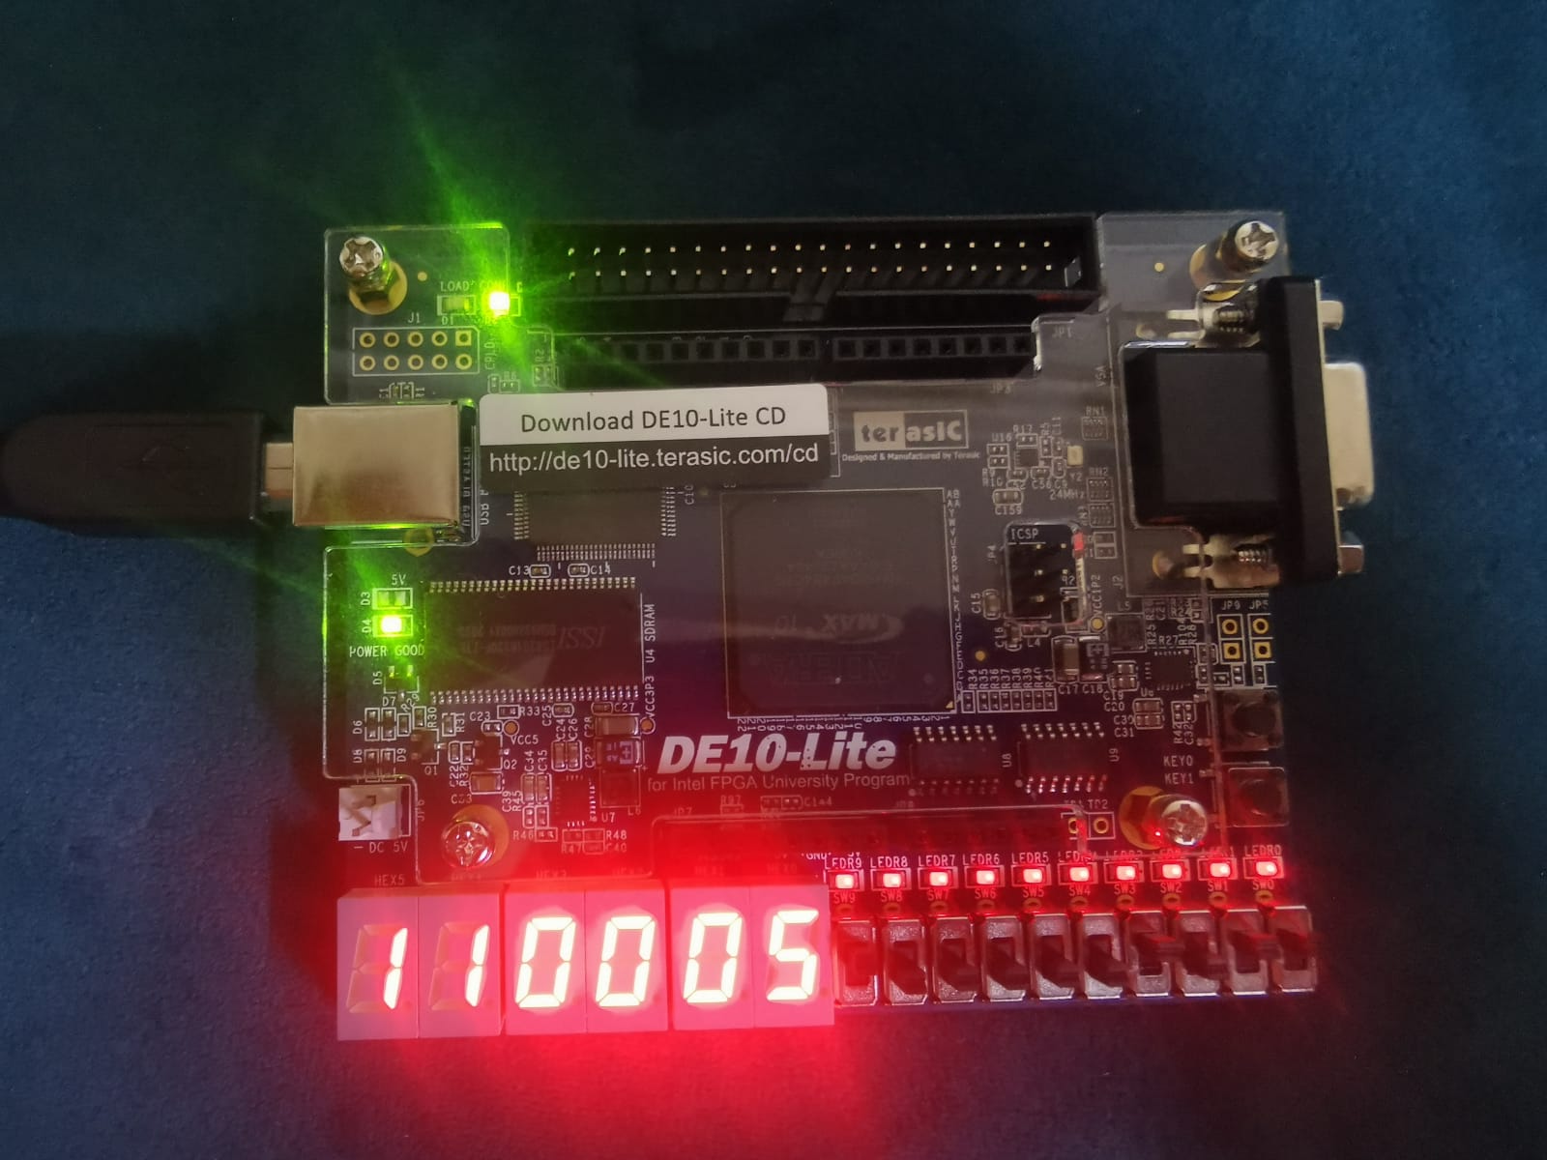

### Testcase 2

#### Register 1

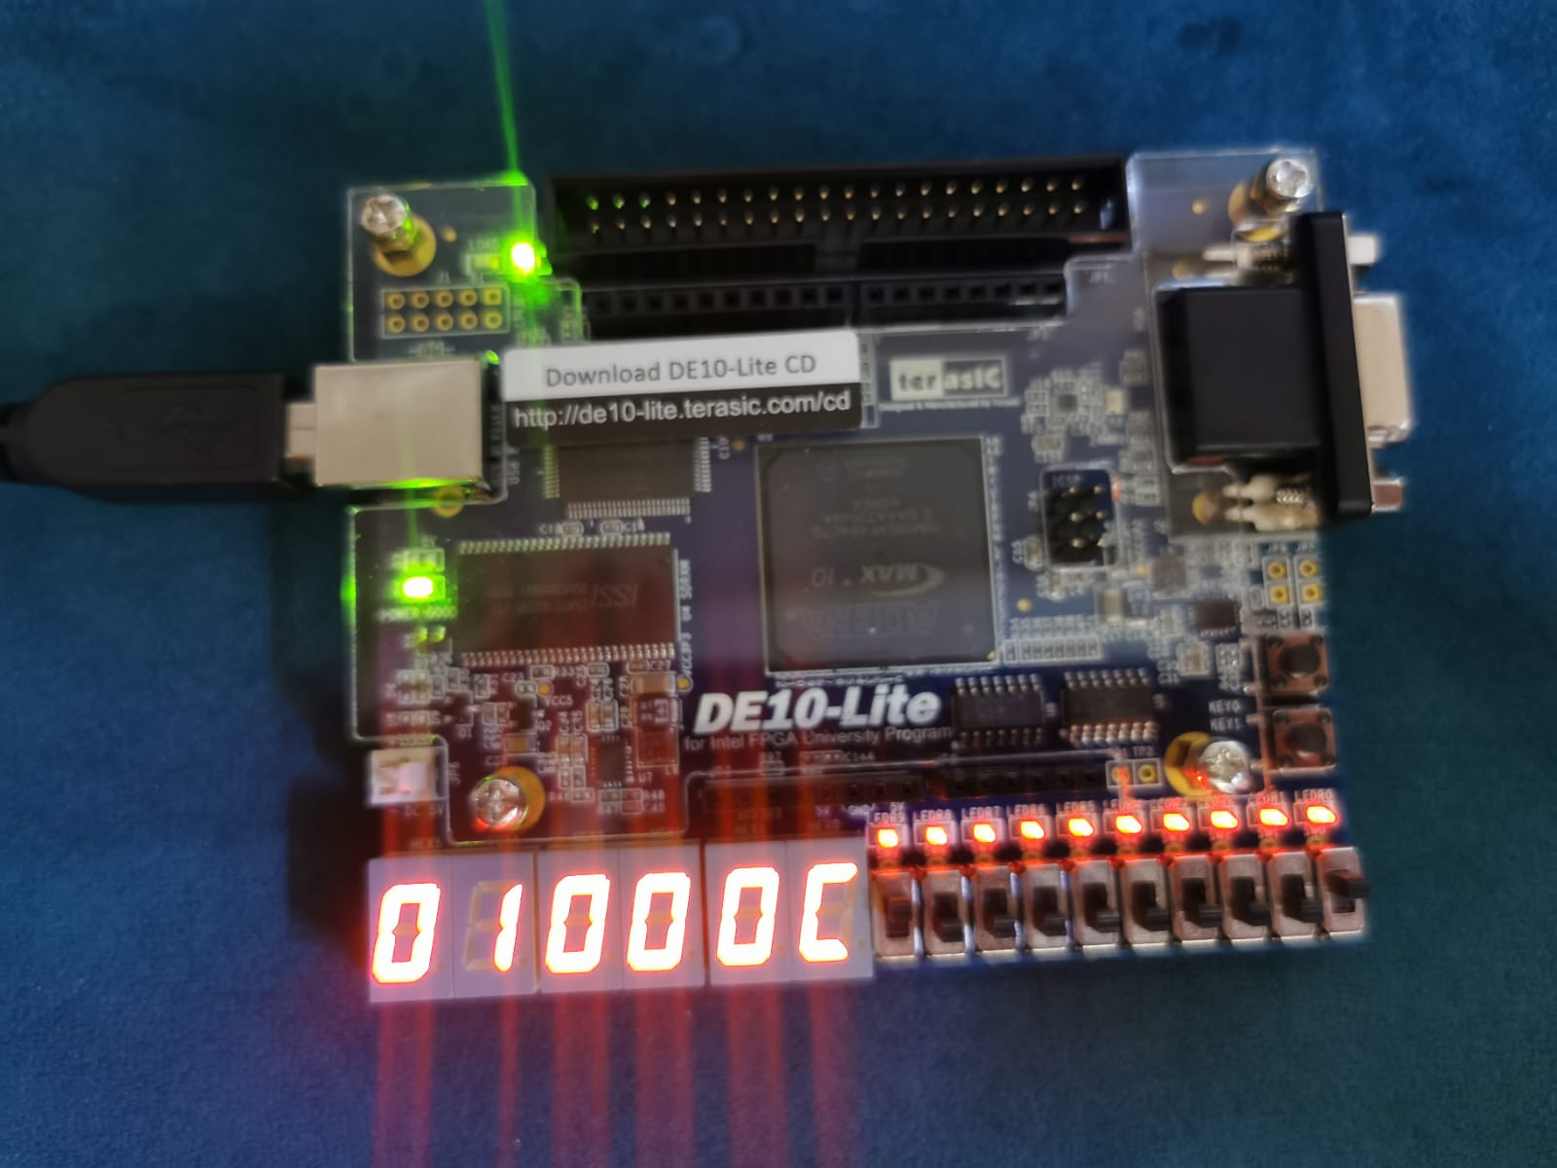

#### Register 2

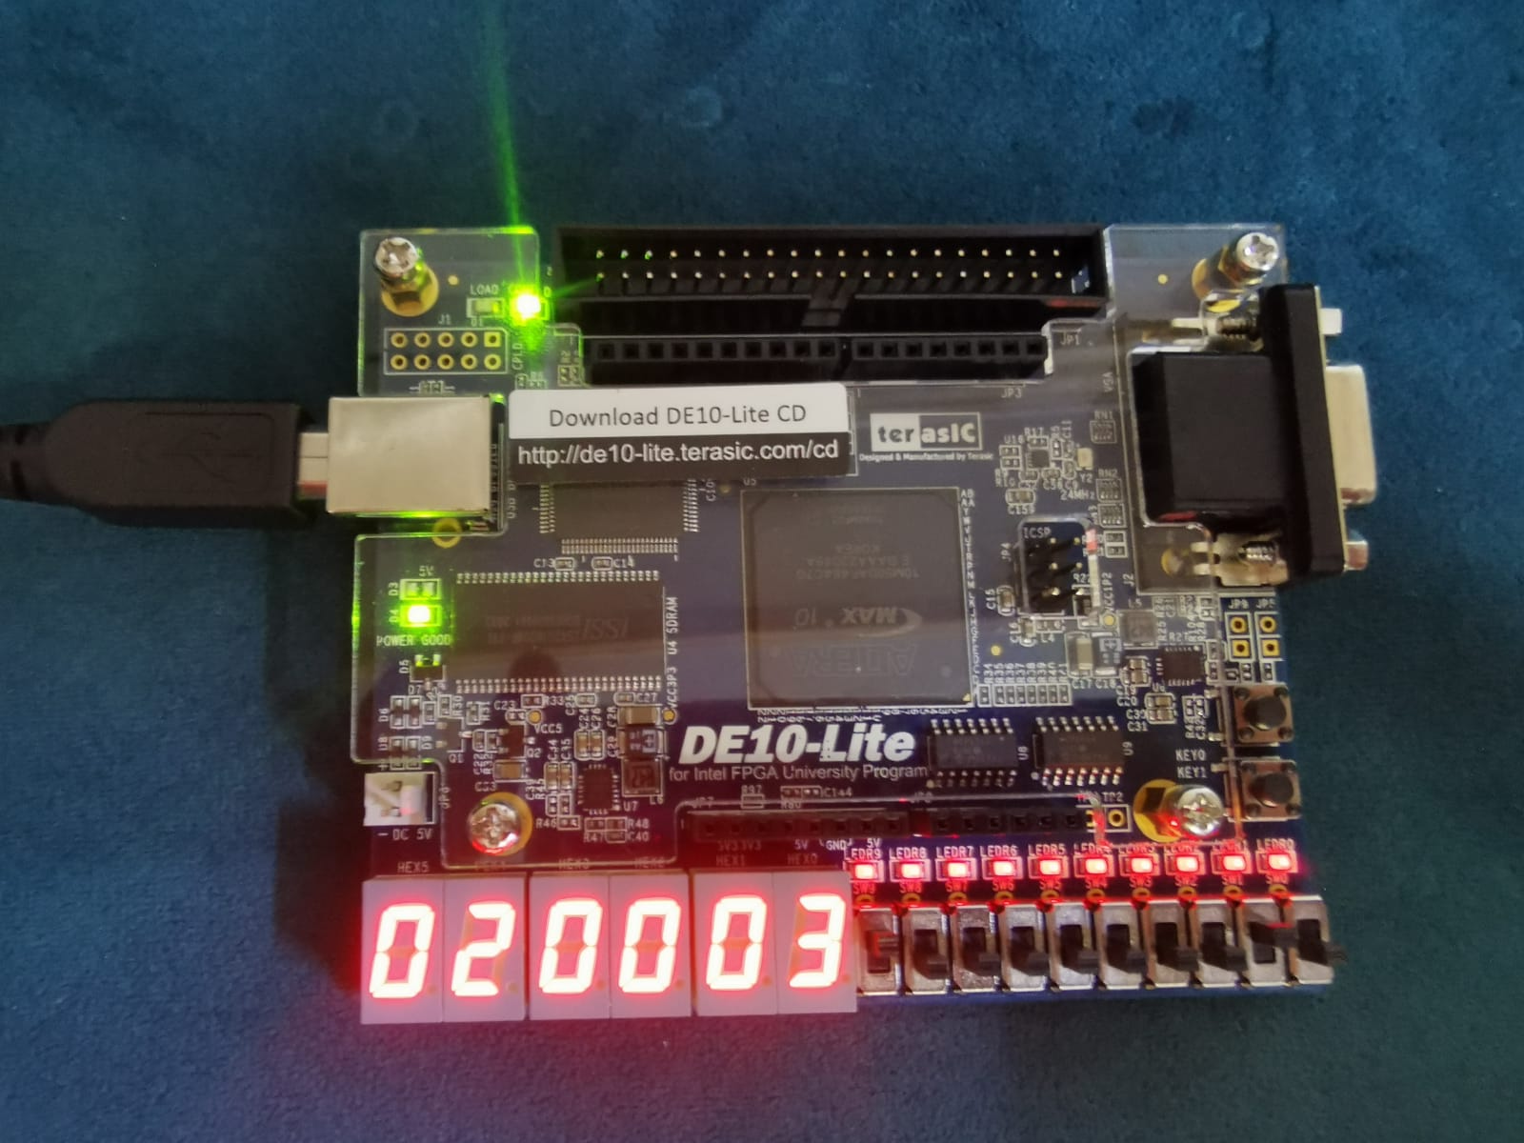

#### Register 3

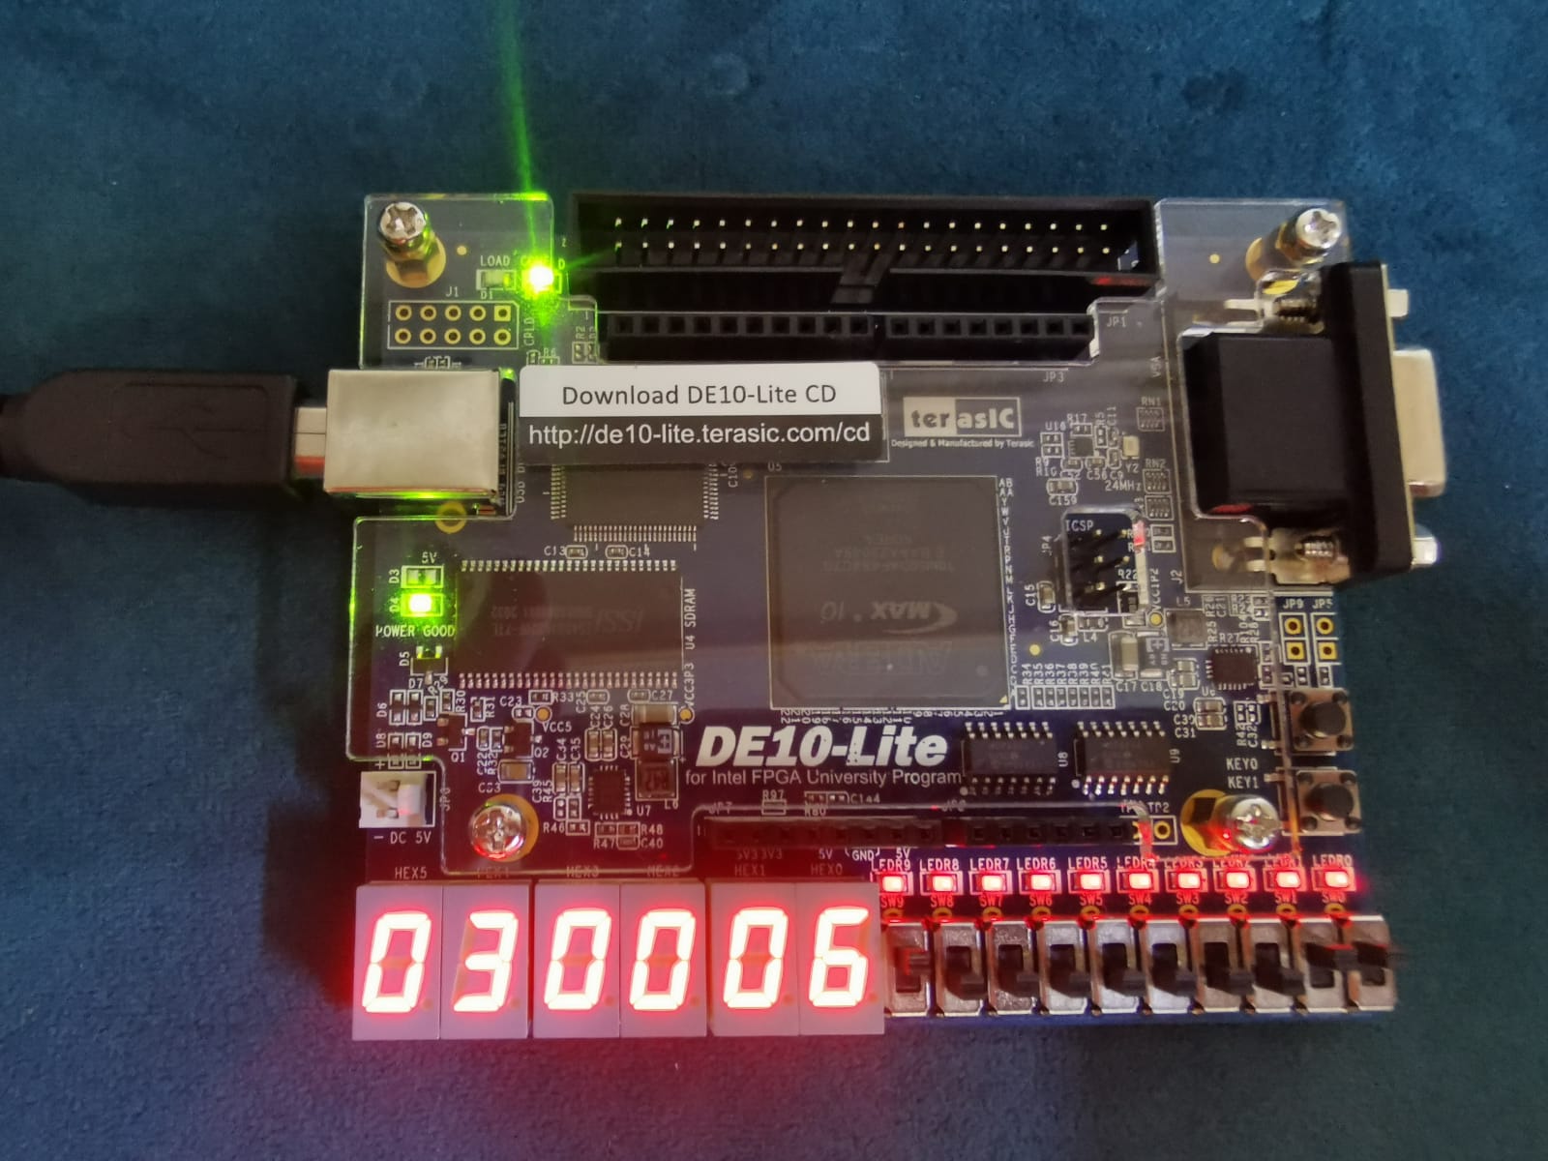

#### Register 4

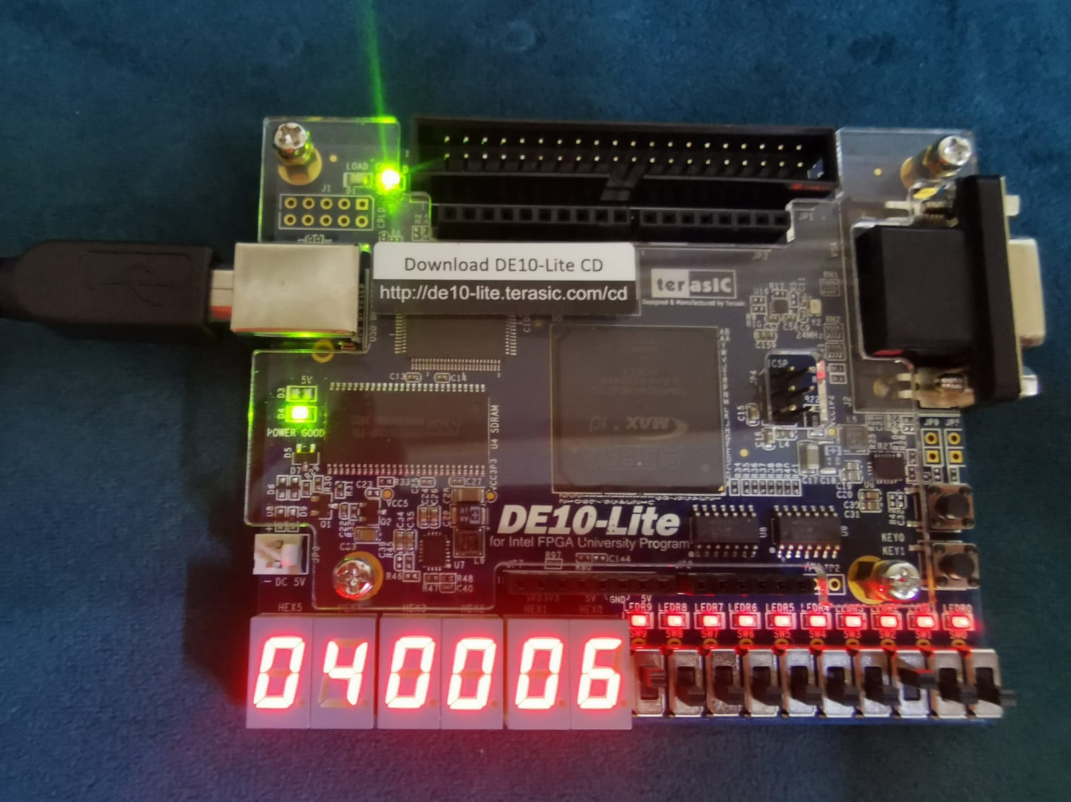

### Testcase 3

#### Register 10

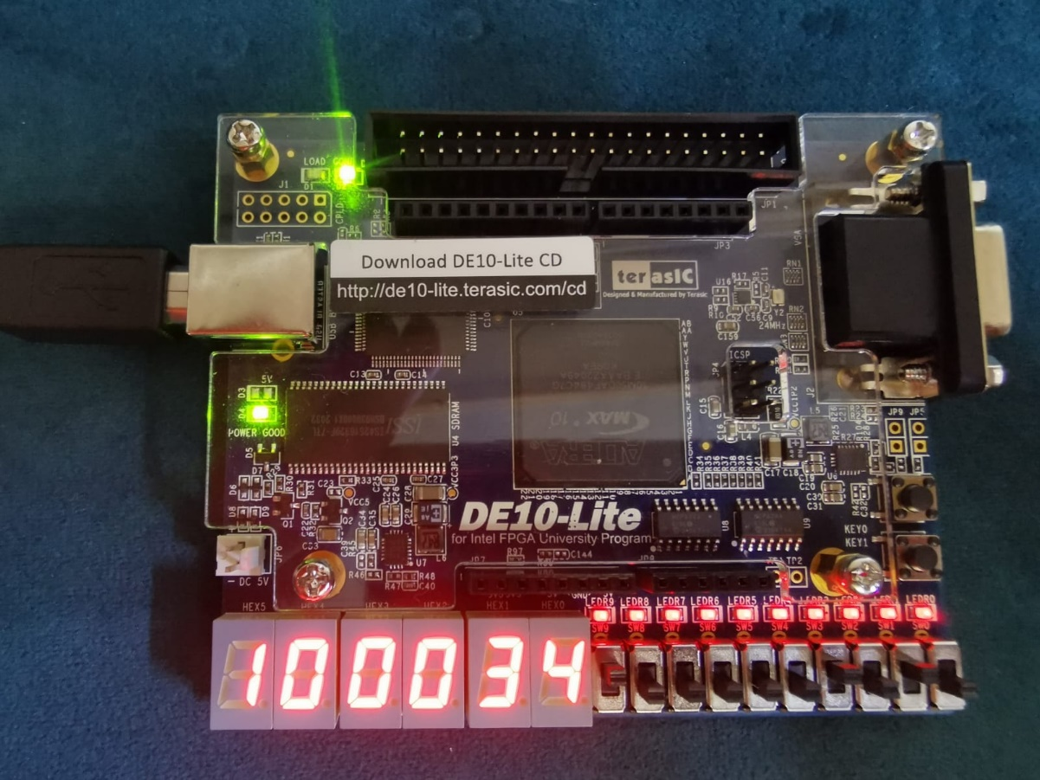

#### Register 28

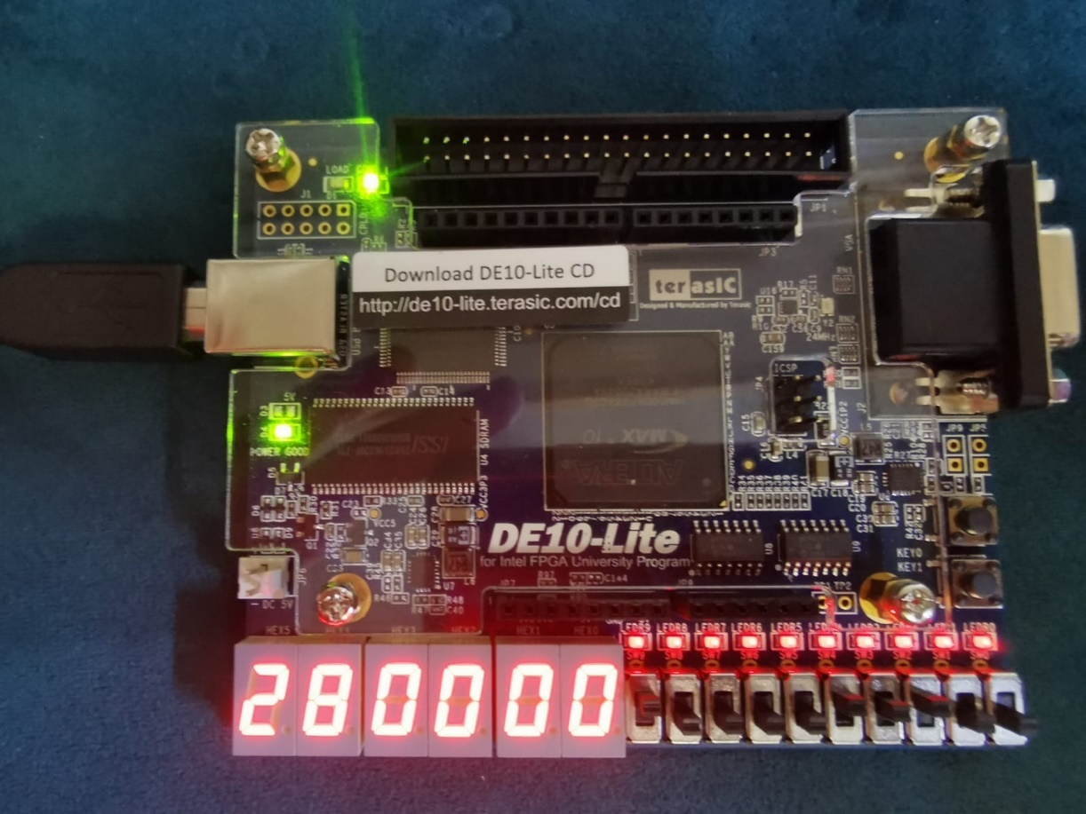

#### Register 8

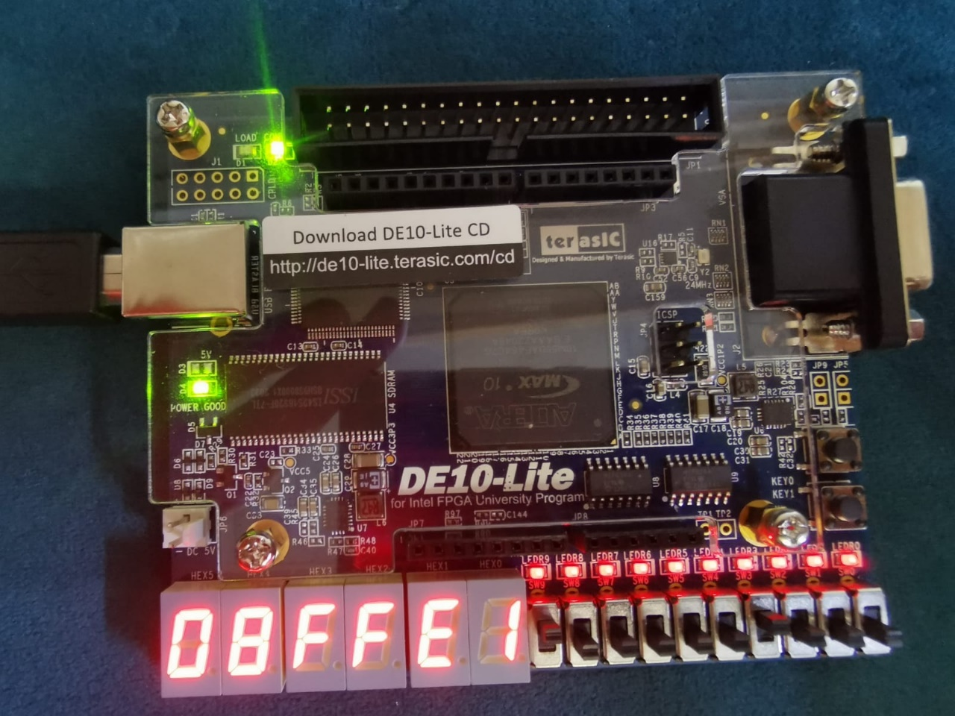

#### Register 8 upper

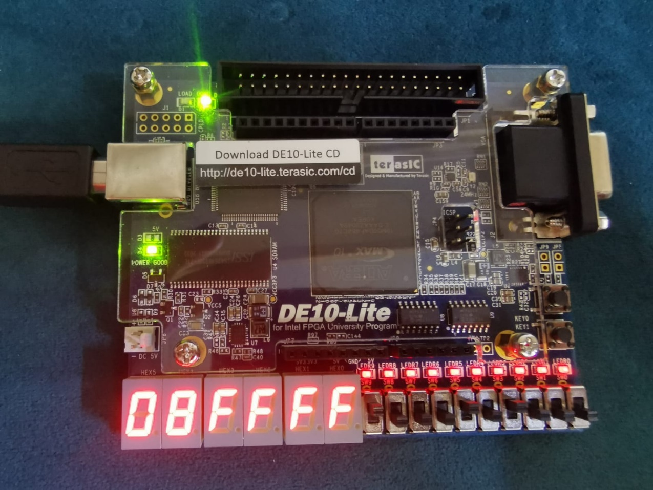

#### Register 9

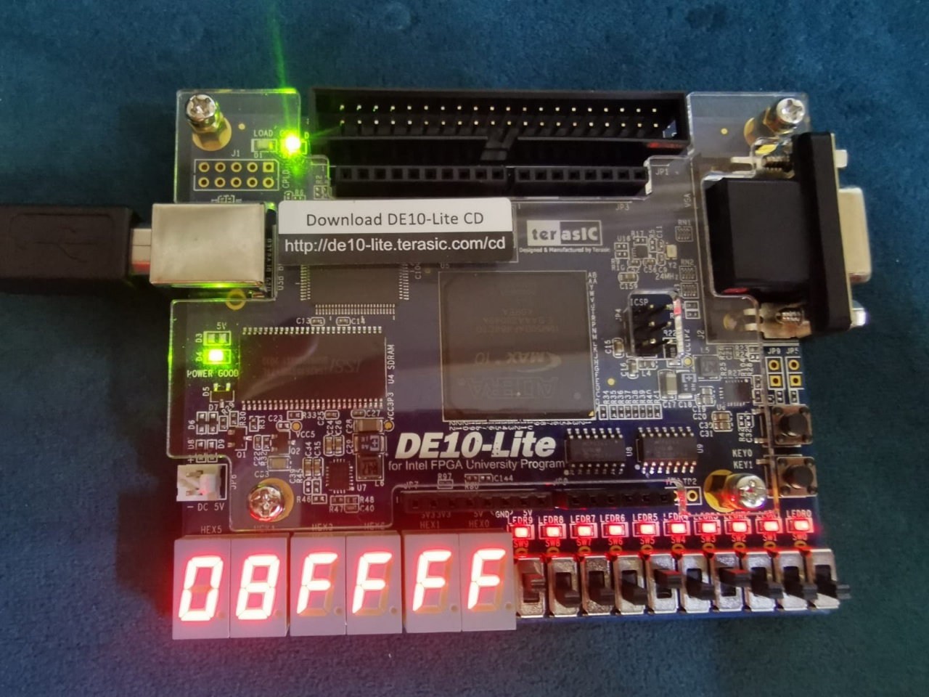

### Testcase 4

#### Register 10

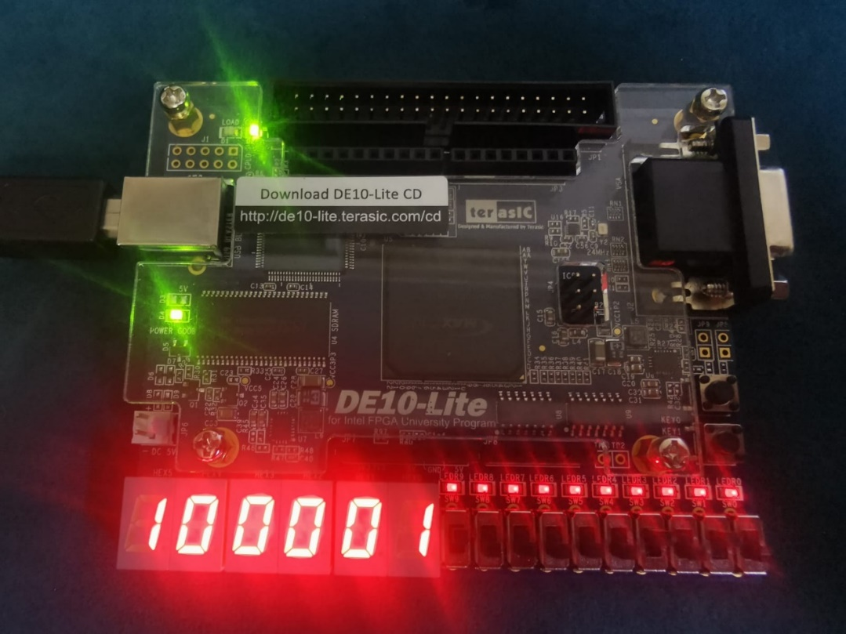

#### Register 12

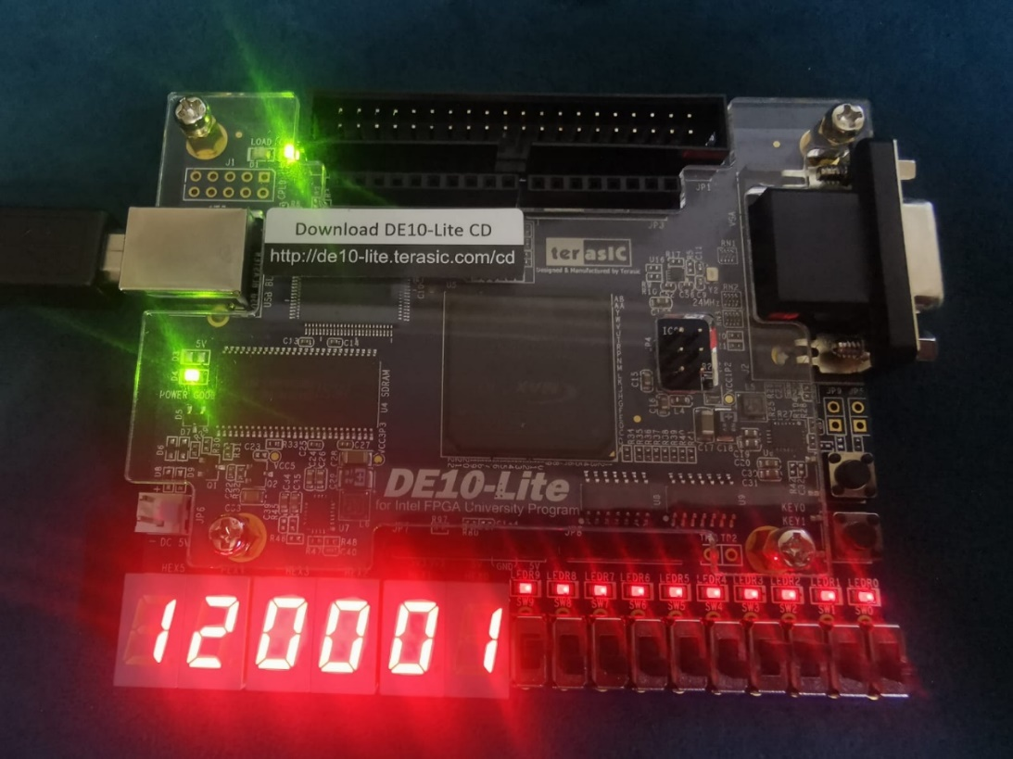

#### Register 13

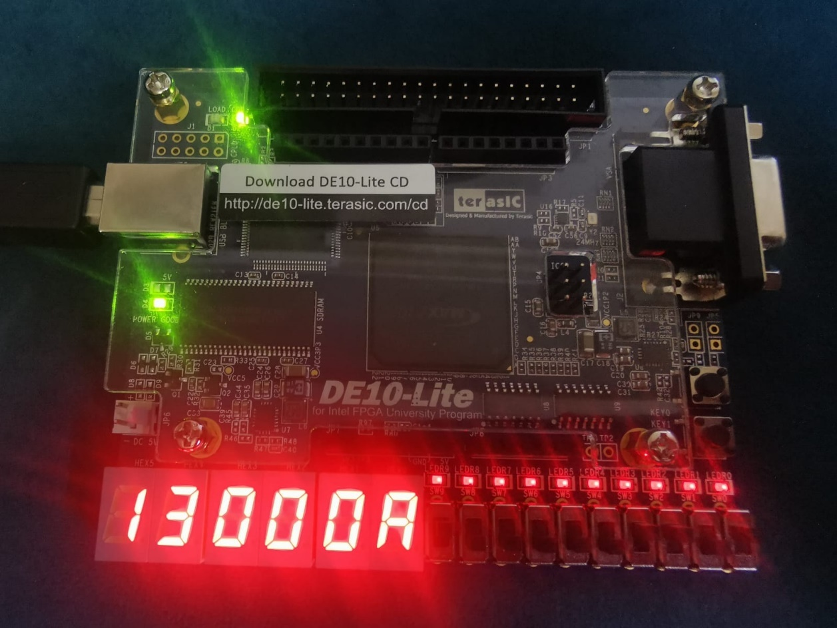

#### Register 14

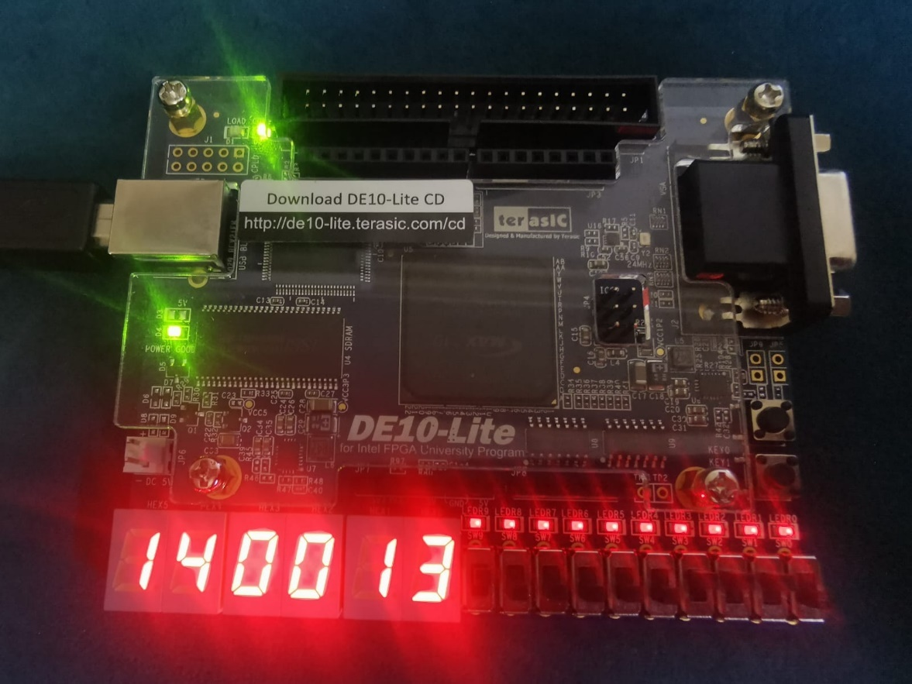

#### Register 8

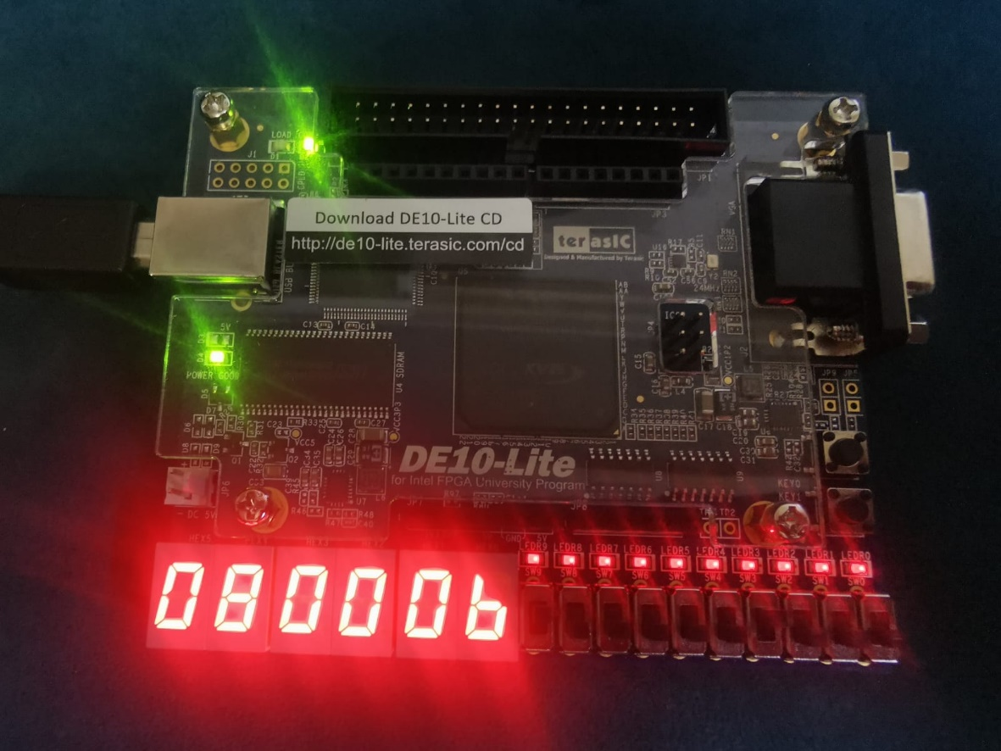

#### Register 9

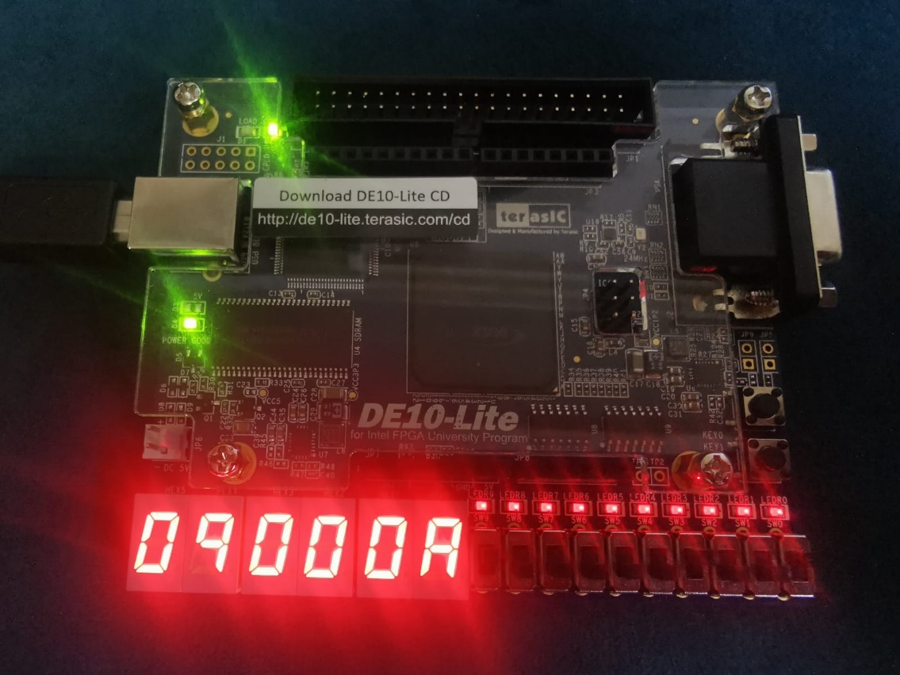

### Testcase 5

**When a=2**

#### Register 1

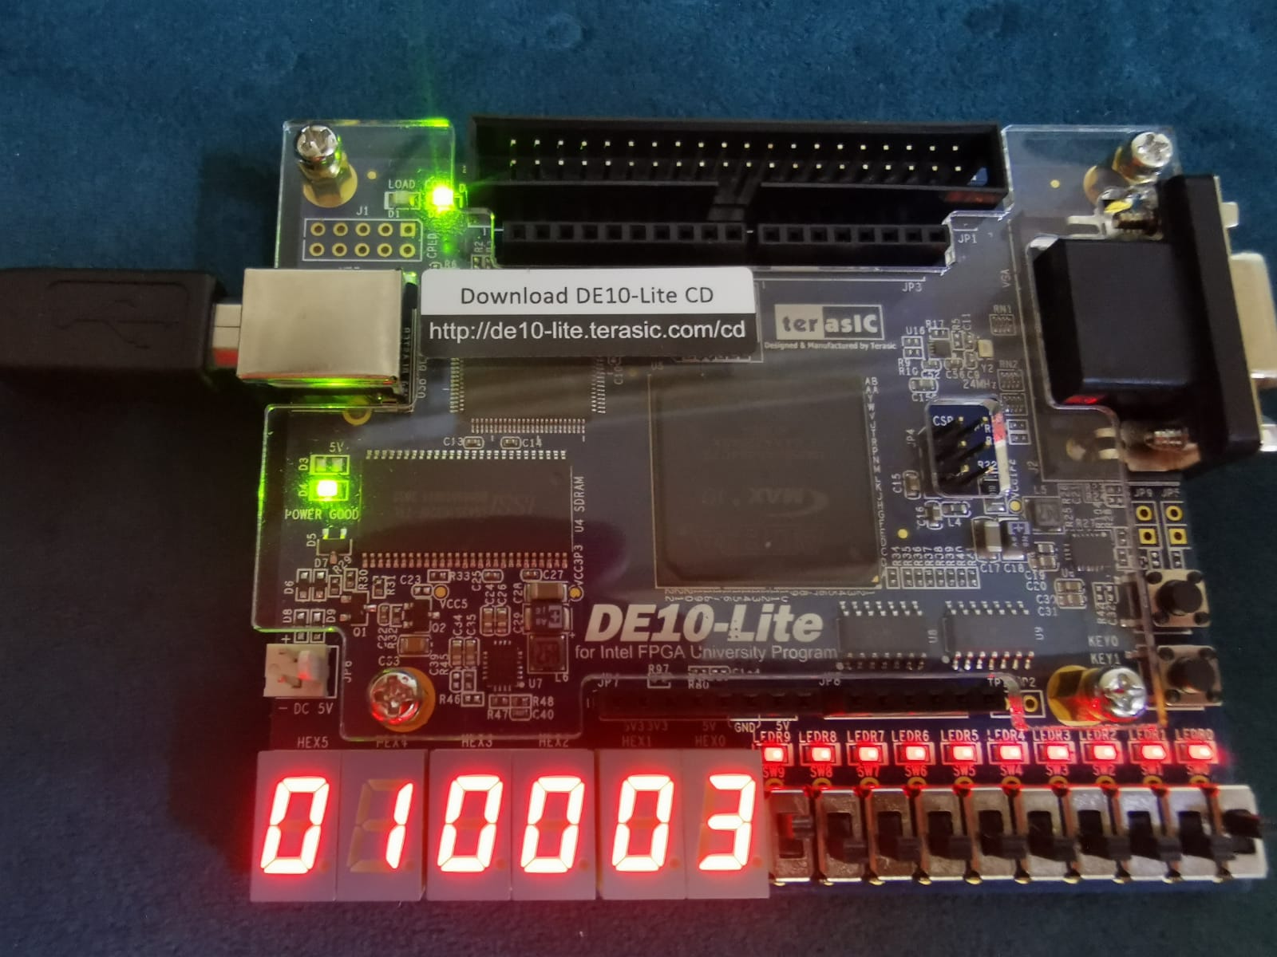

#### Register 2

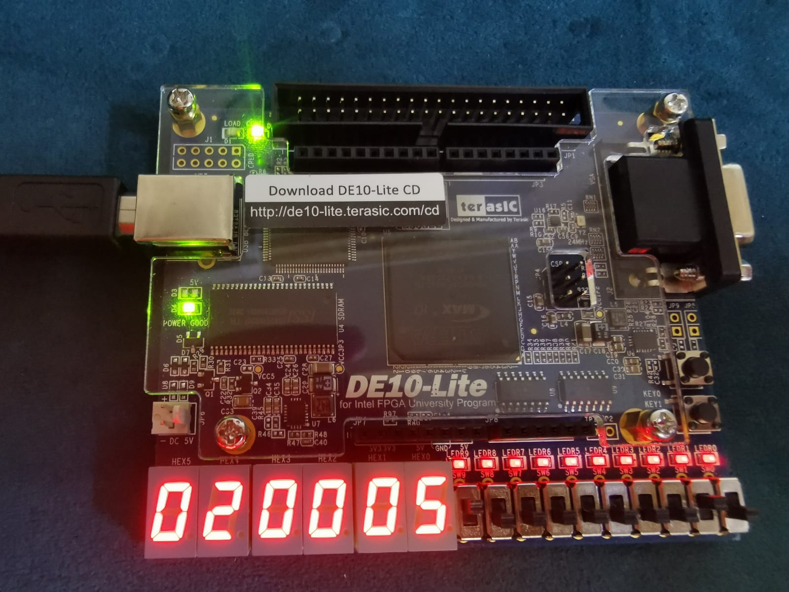

#### Register 3

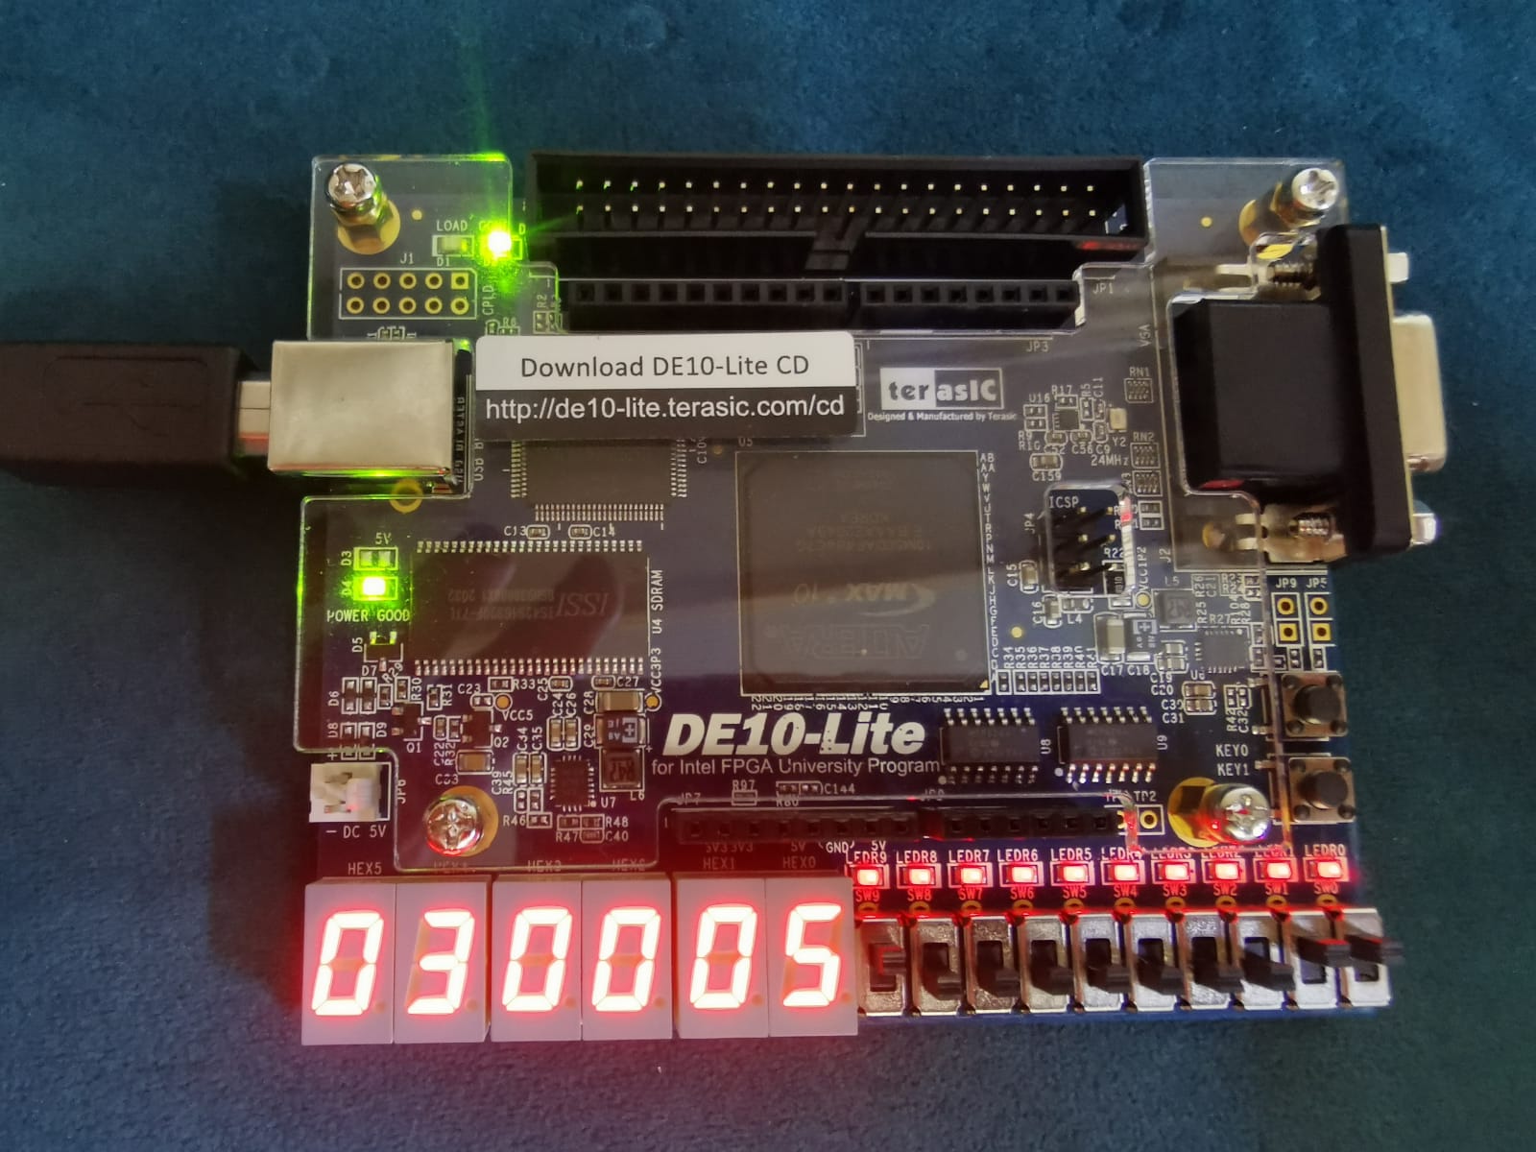

**When a =6**

#### Register 1

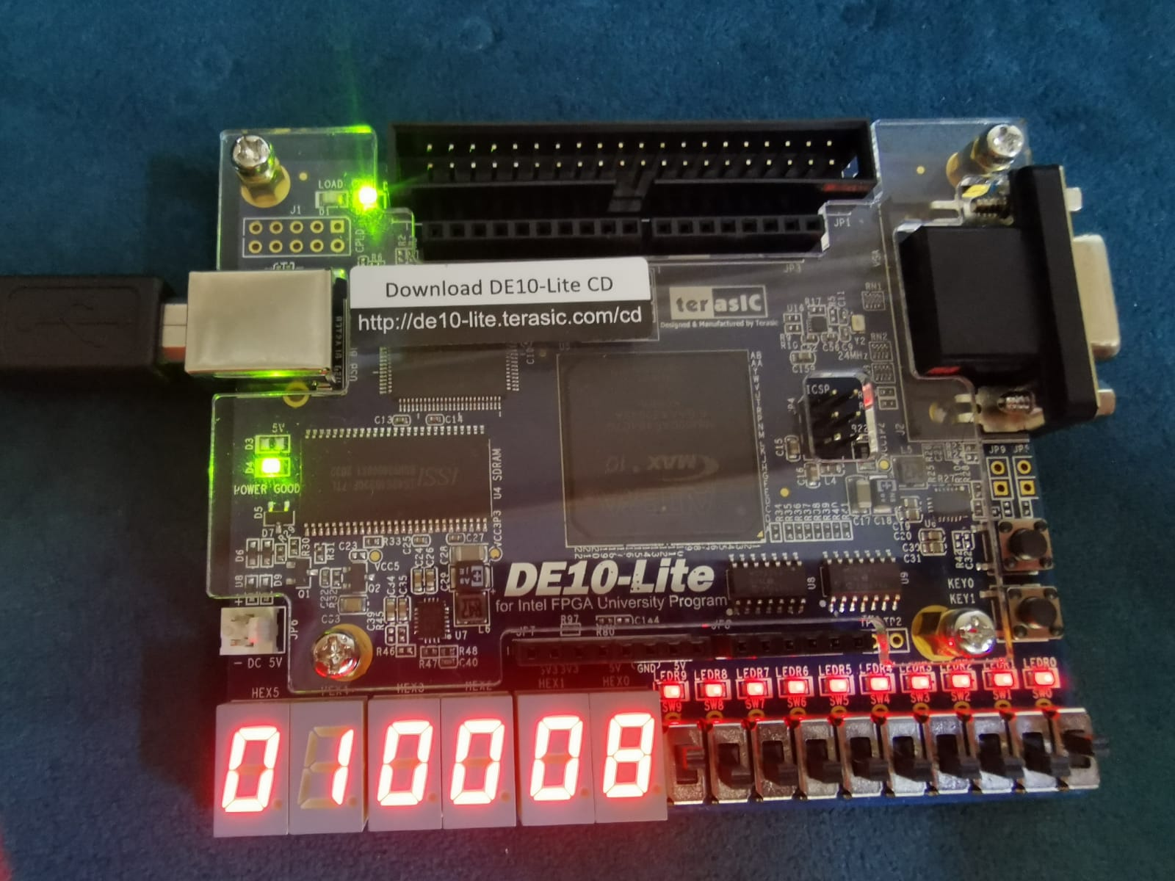

#### Register 2

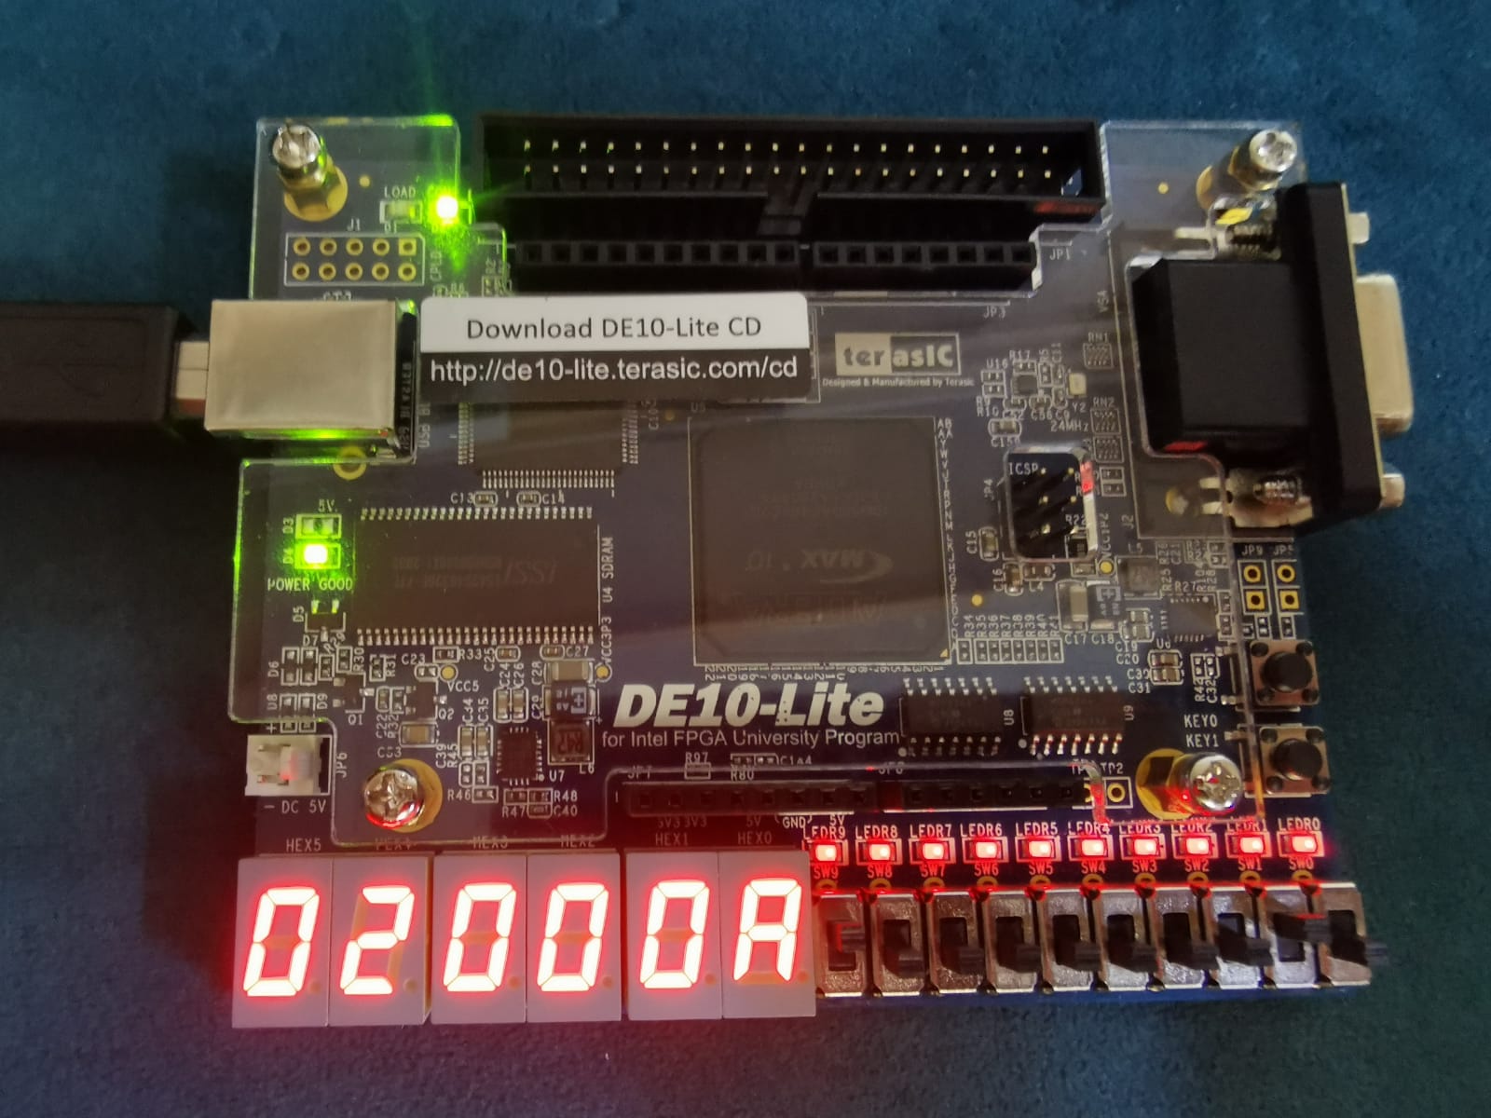

#### Register 3

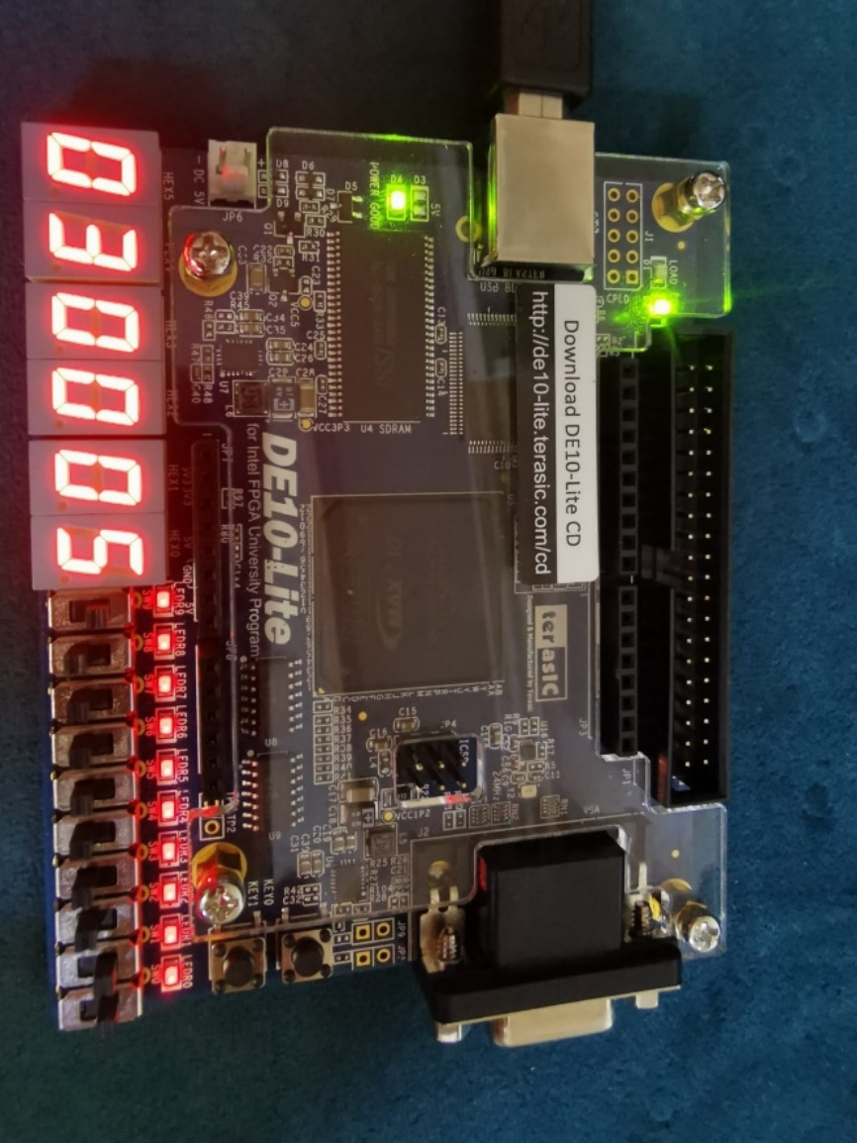

### Testcase 6

#### Register 1

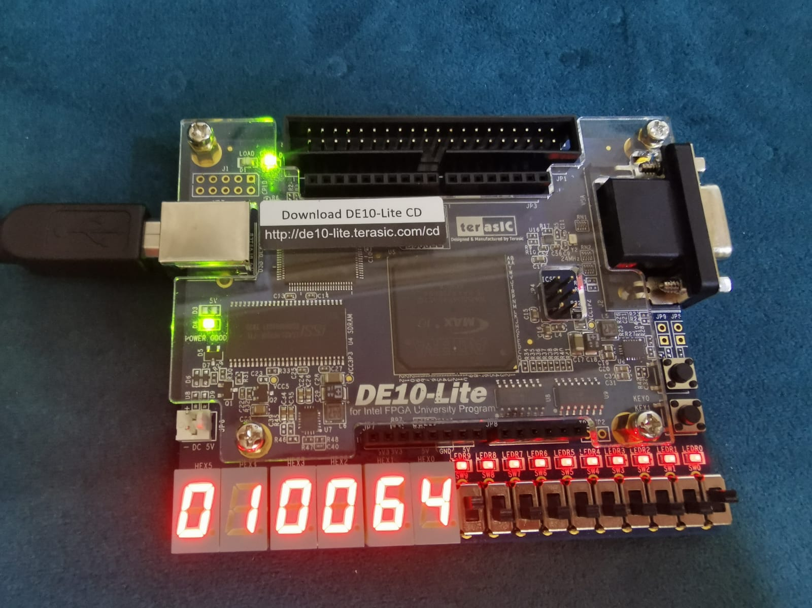

#### Register 3

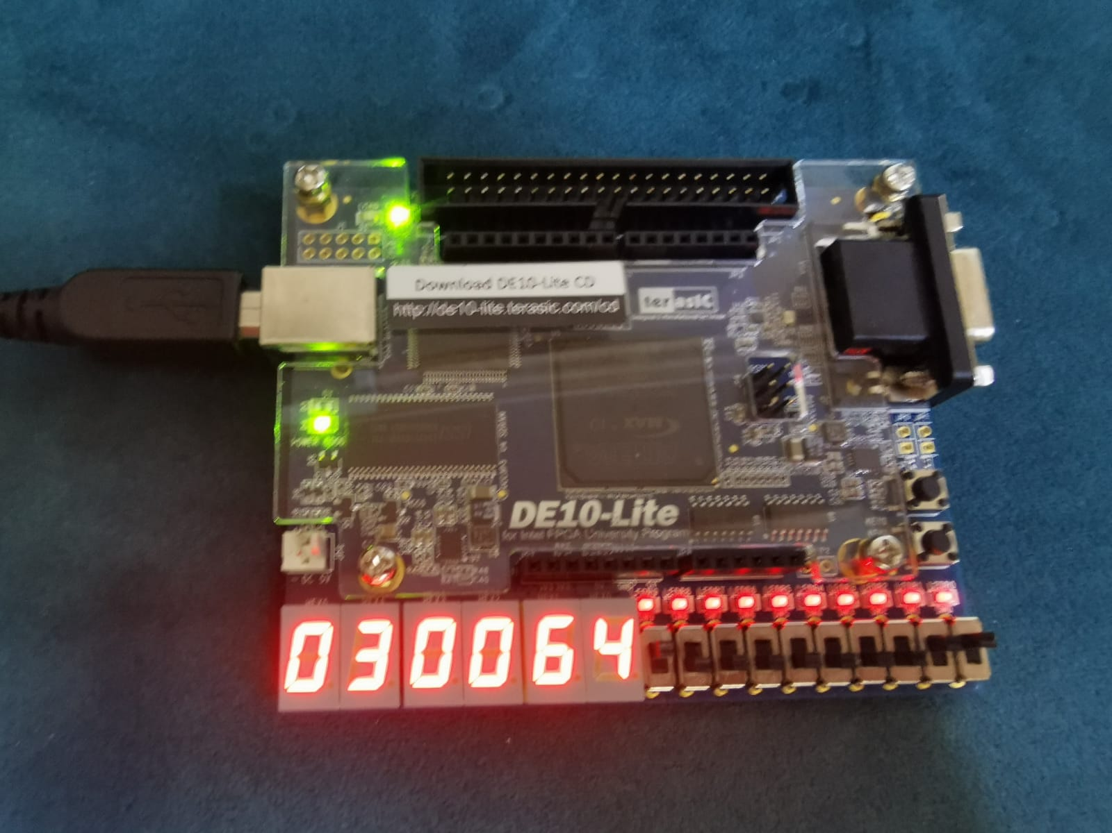

#### Register 9

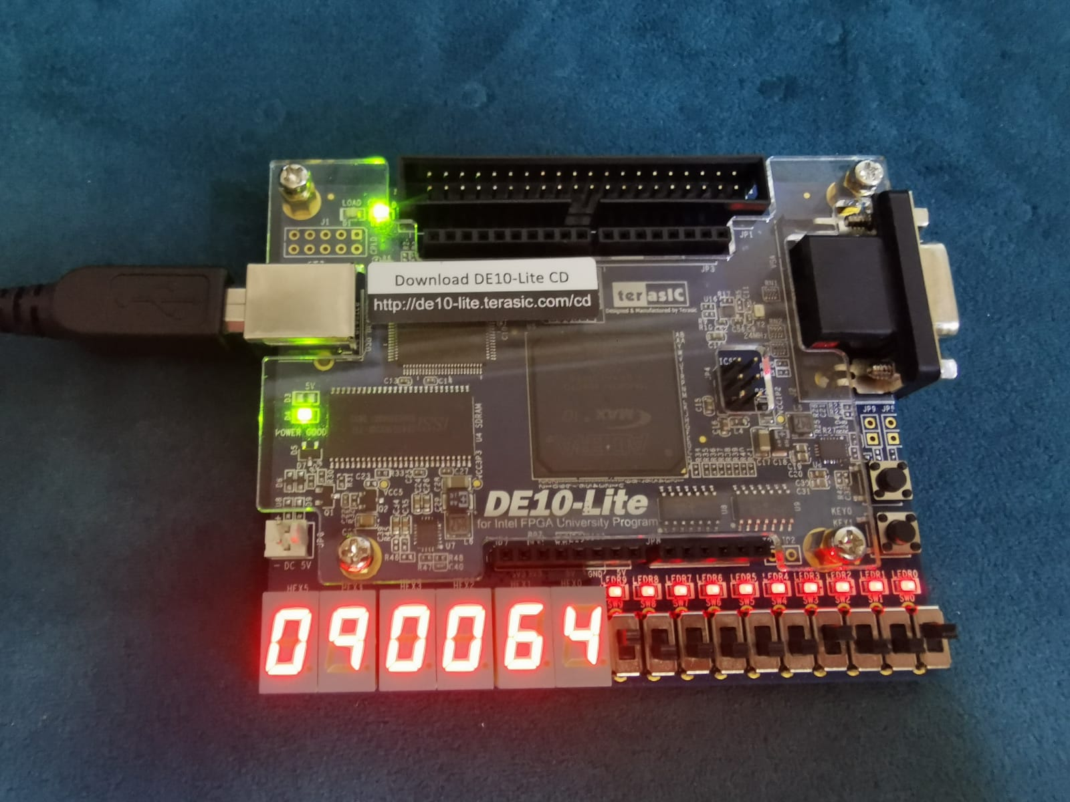

## Benchmark

### **Test case one**

#### Instruction memory and data memory

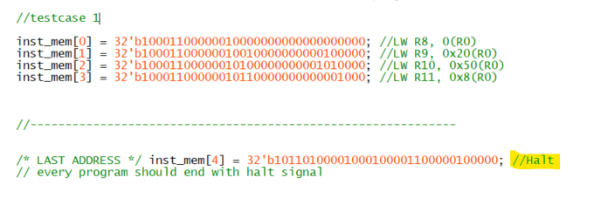

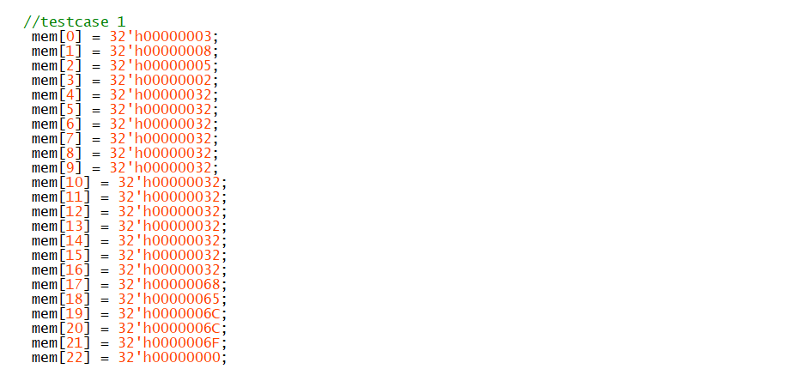

#### First interaction **LW R8, 0(R0) (CPU before execution**

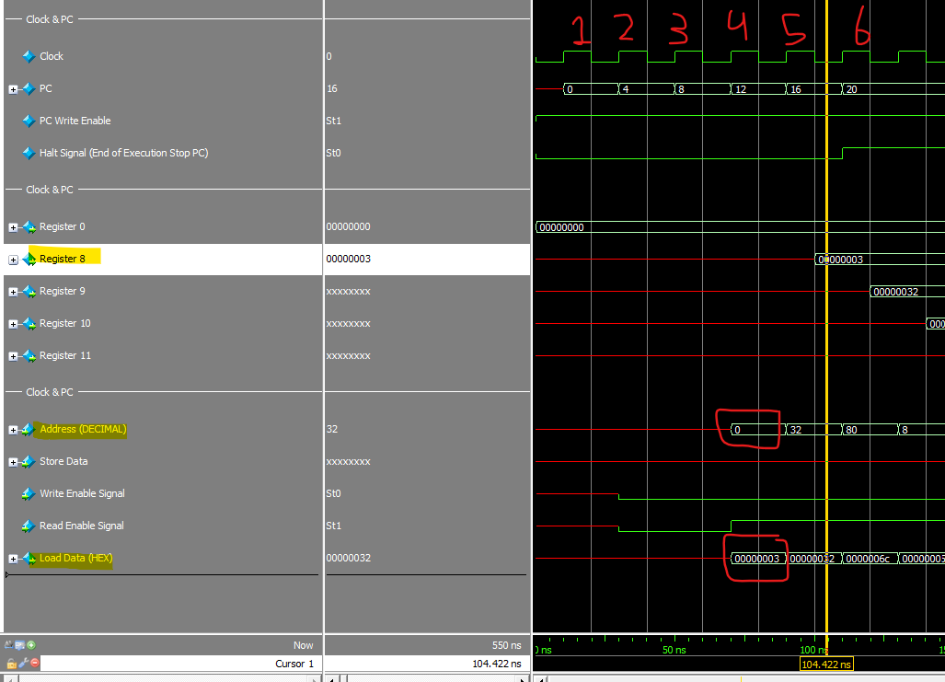

#### Halt

#### 

#### after execution the final values

#### 

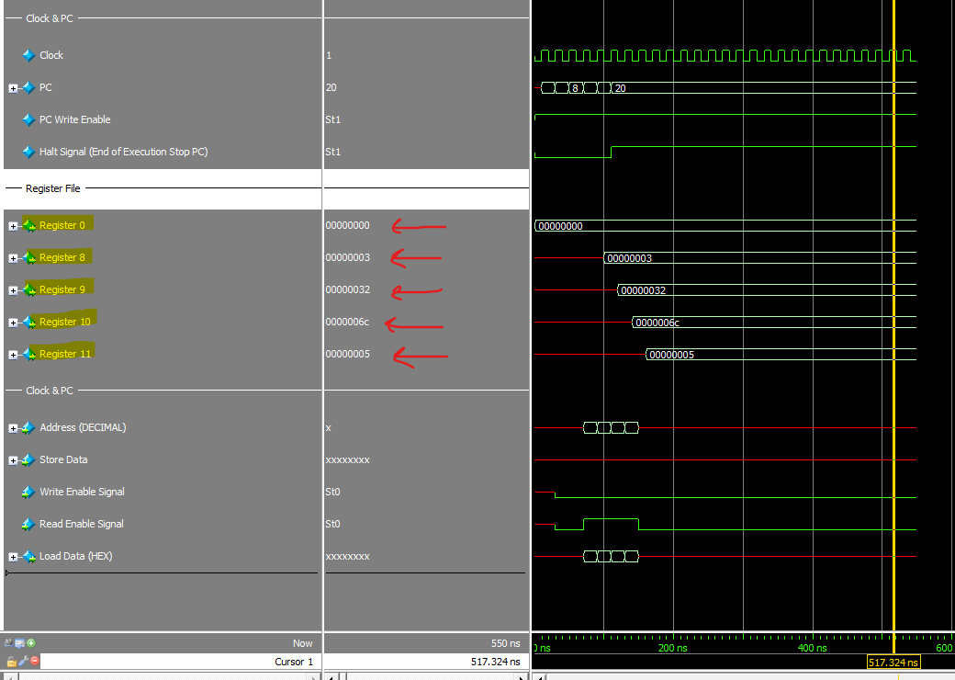

## **Test case 2**

### Data memory and instruction memory

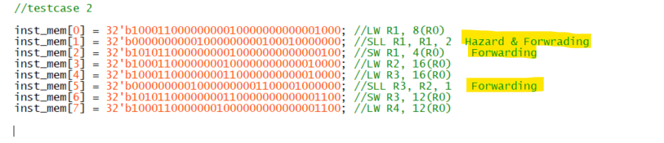

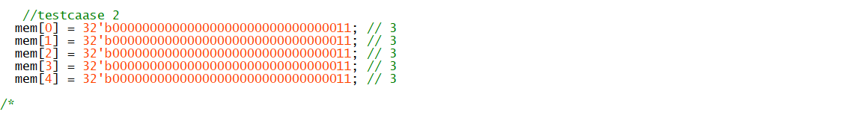

### Second Instruction SLL R1, R1, 2 Hazard Catch with stall cycle

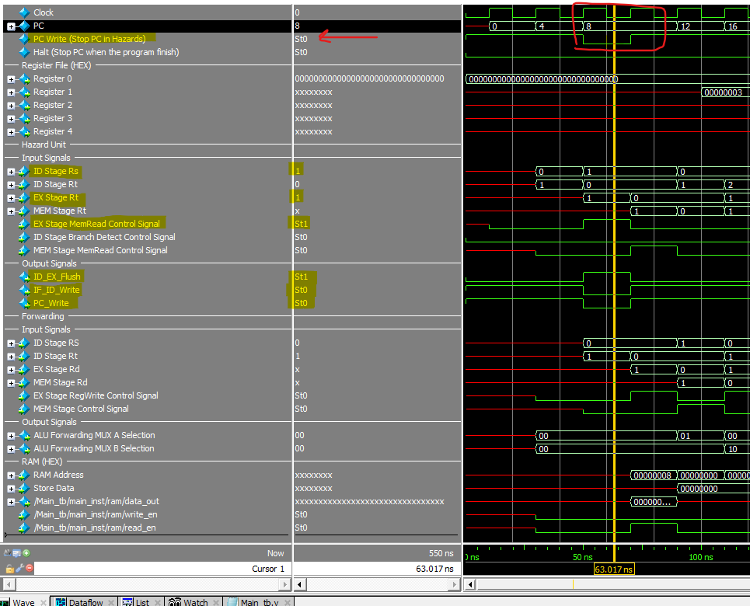

### Second Instruction SLL R1, R1, 2 MEM Stage Forwarding Catch

## 

### CPU Stage After Execution

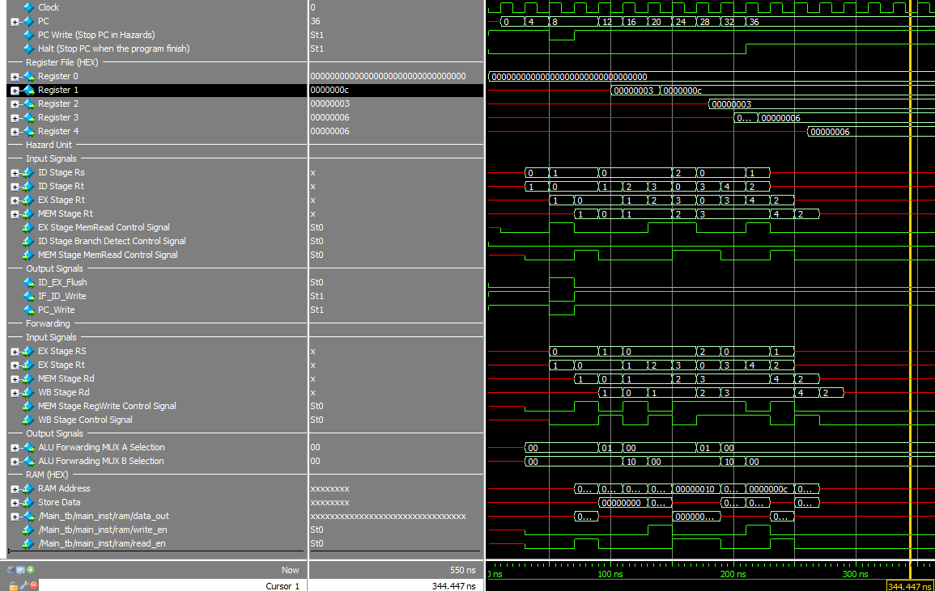

## Test case 3

### Instruction memory and data memory

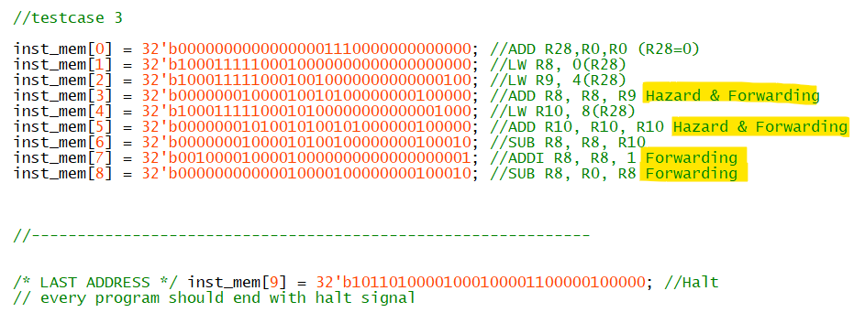

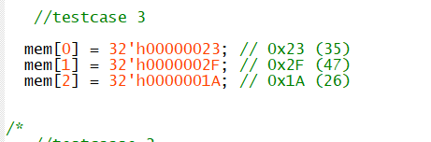

### First Three Instruction Execution.

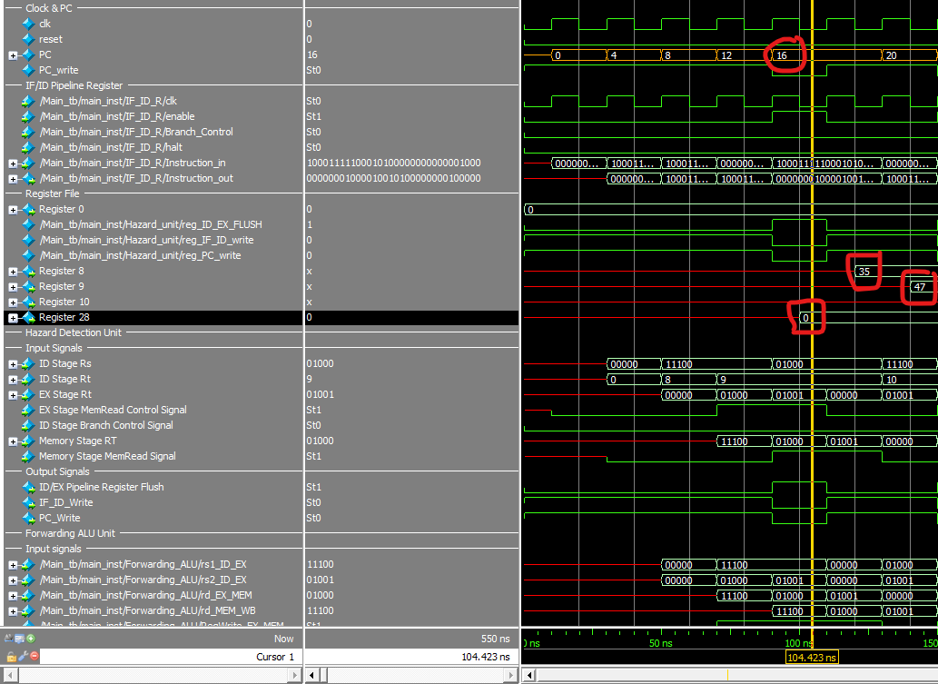

### Fourth Instruction ADD R8, R8, R9 Load_Use_Hazard Catch

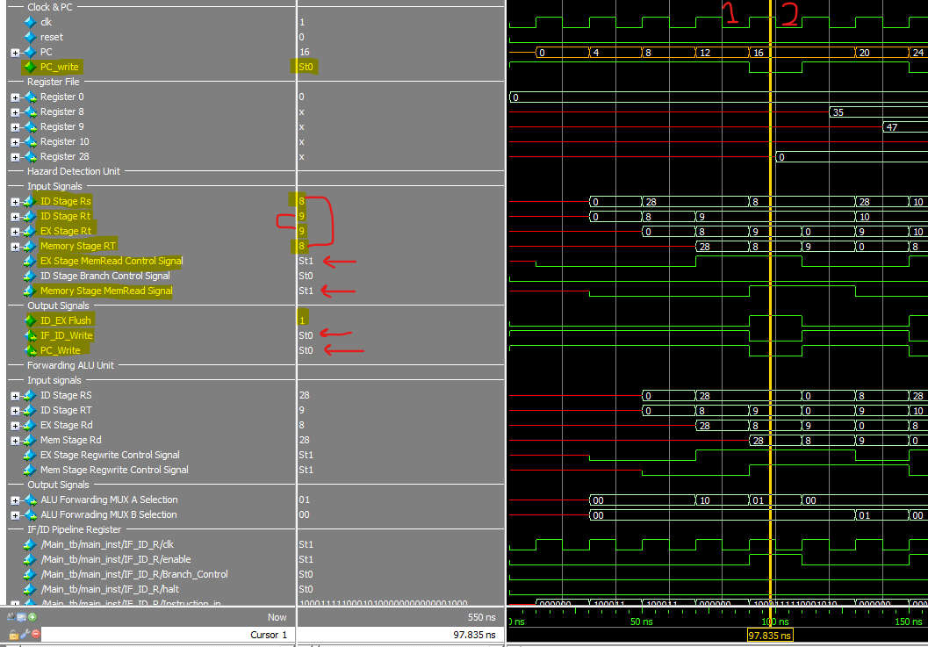

### Fourth Instruction Hazard End

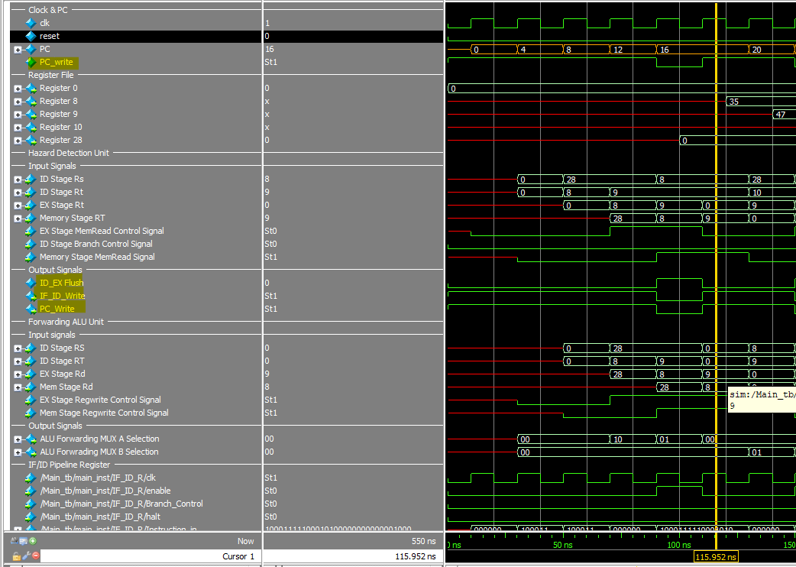

### eighth instruction ADDI R8, R8, 1 Forwarding EX Stage ALU Forwarding.

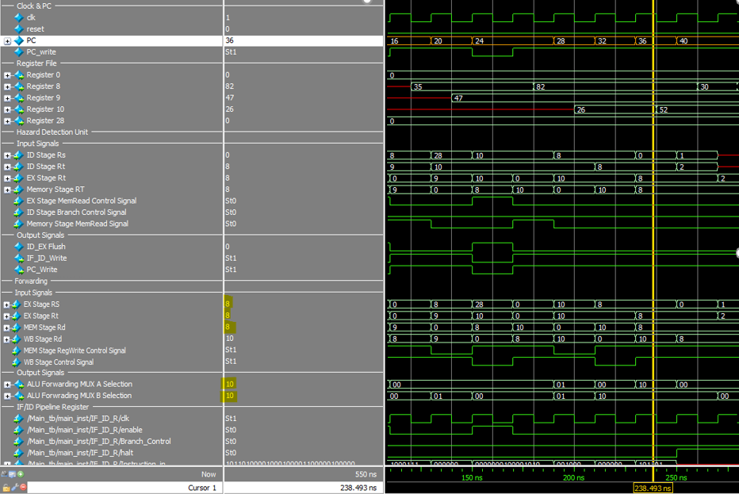

### the CPU after execution

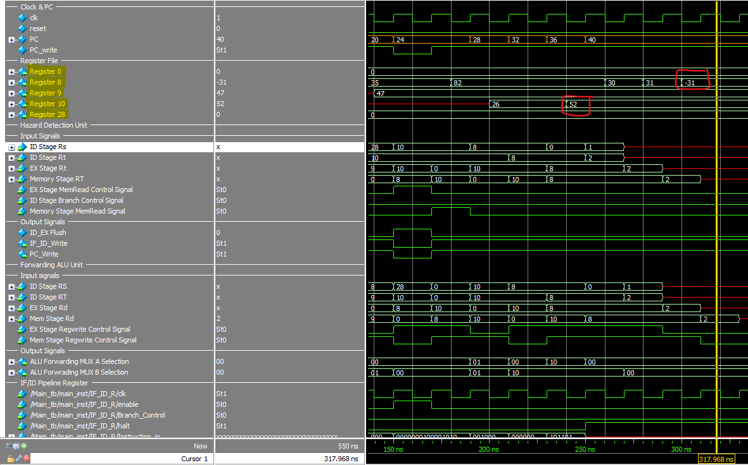

## **Test case 4**

### Instruction memory and data memory

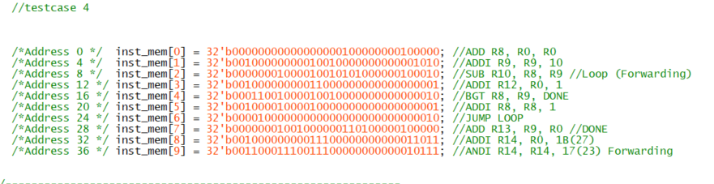



### First Jump Instruction Branch not Taken

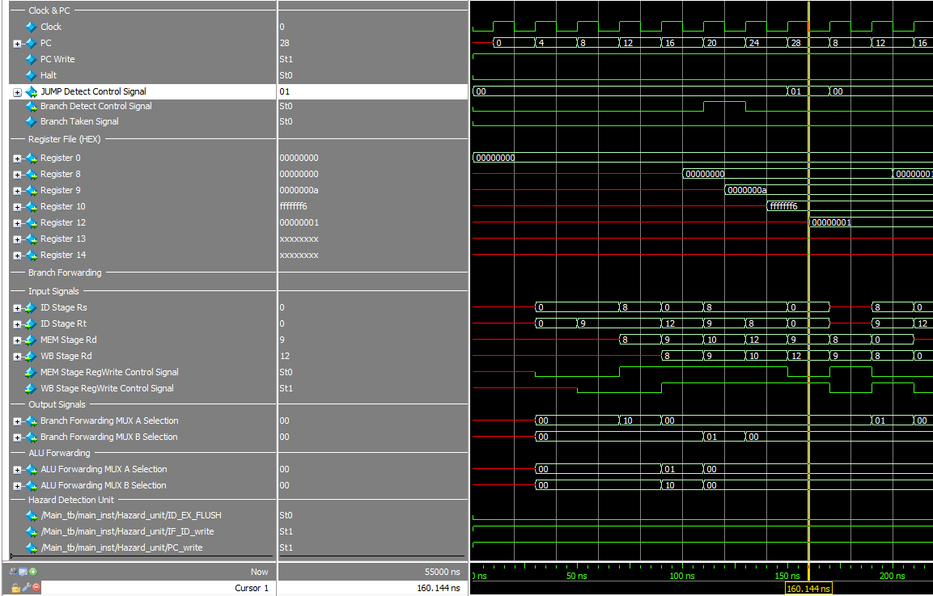

### Branch Taken last Branch Instruction

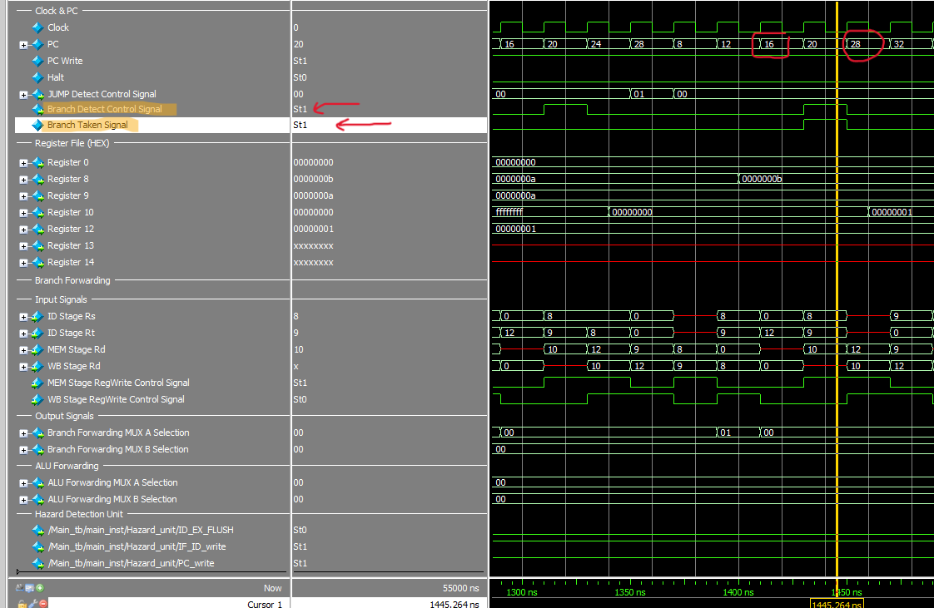

### CPU Status after execution

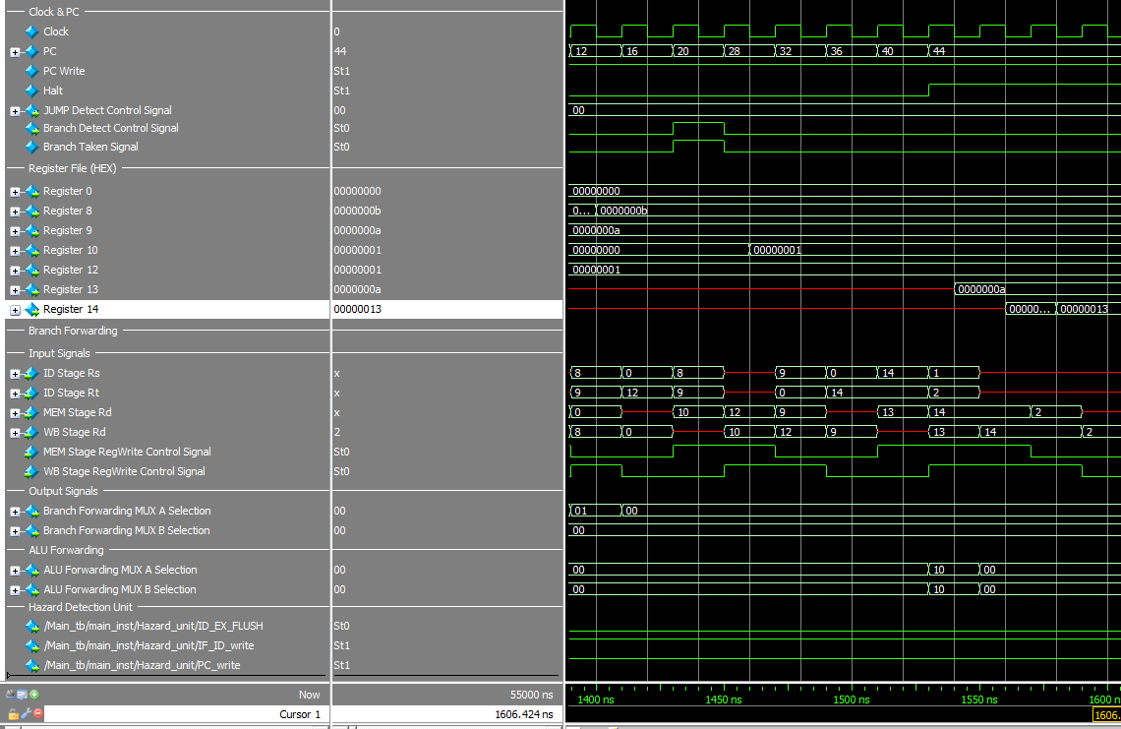

## **Test case 5**

### Instruction memory and data memory

### **No need for RAM**

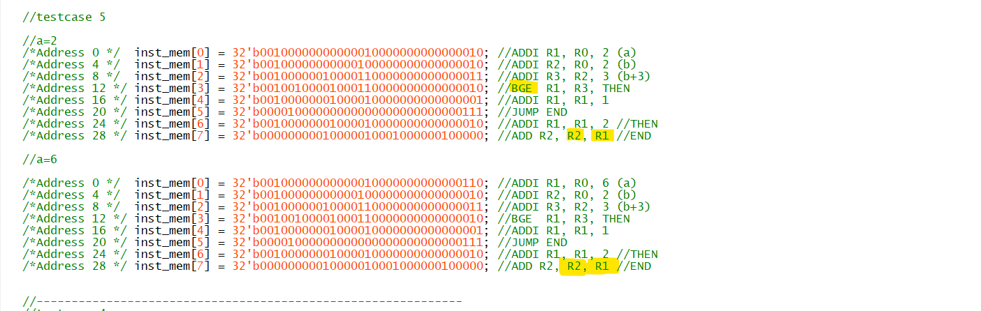

### When a =2

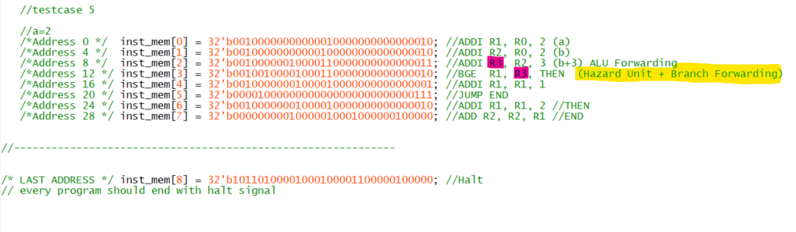

#### Fourth Instruction BGE R1, R3, THEN Hazard Detect

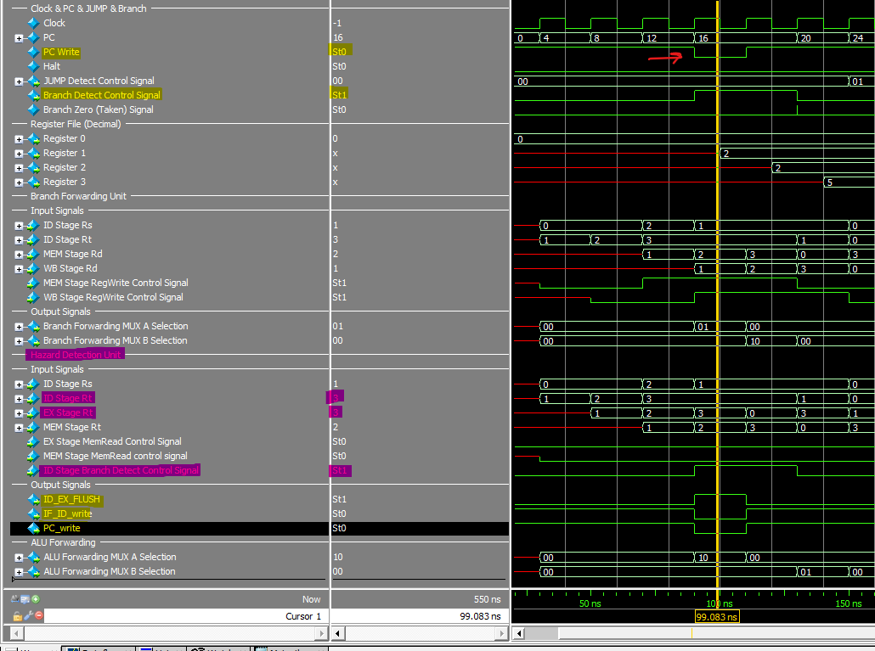

#### fourth Instruction BGE R1, R3, THEN Branch Not Taken with Branch Forwarding

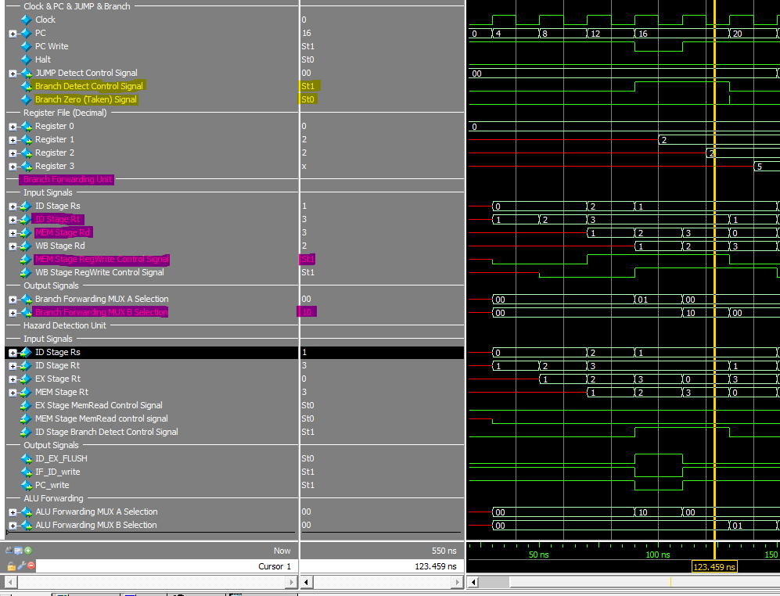

#### **CPU Status After execution**

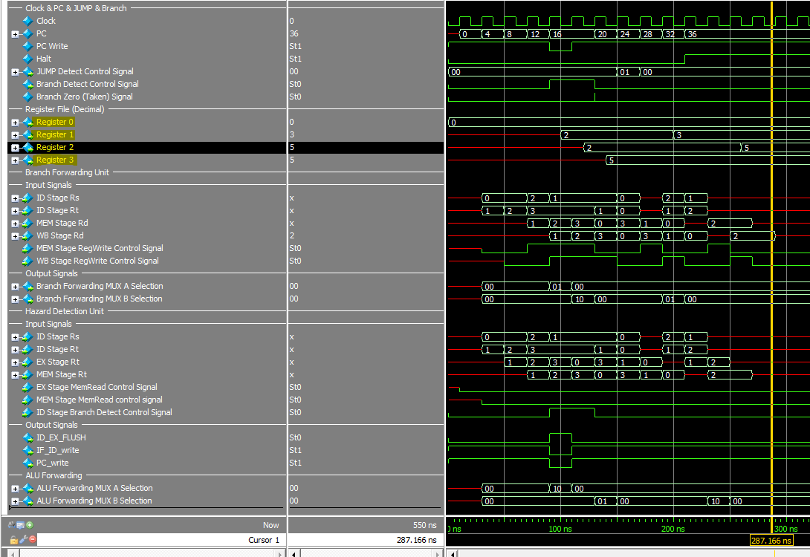

### When a =6

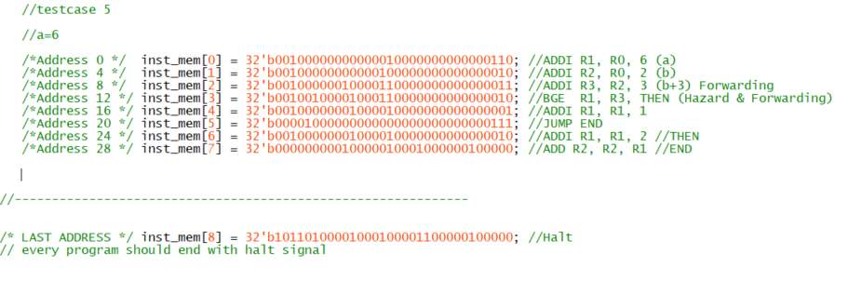

#### Fourth Instruction BGE R1,R3,Then Branch Taken Branch Forwarding Catch

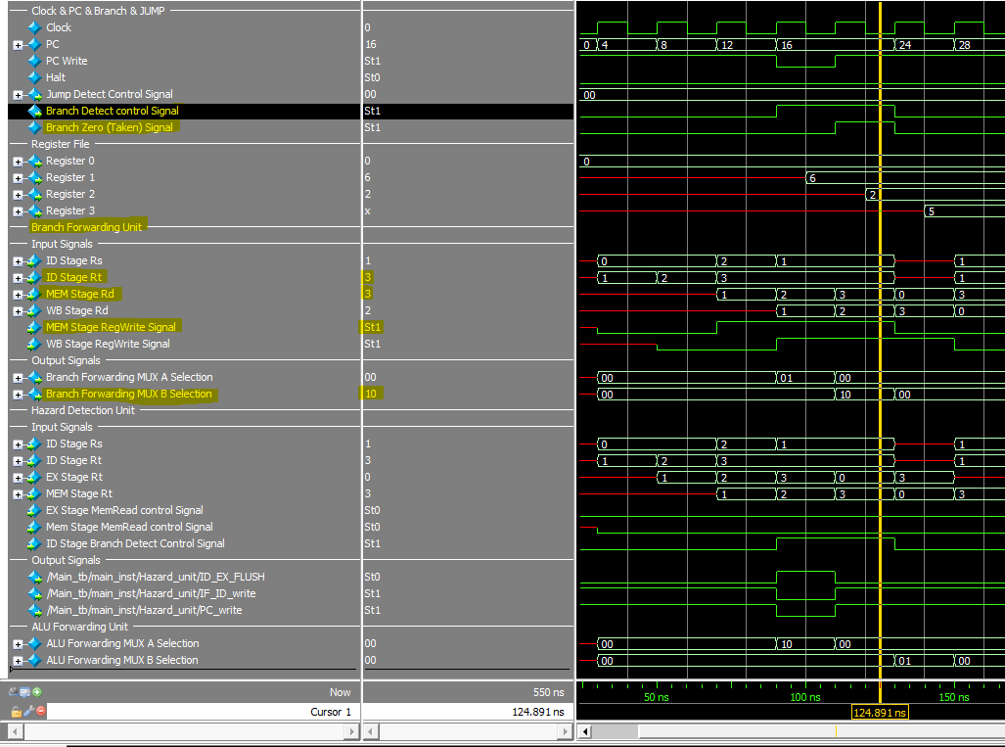

#### Fourth Instruction BGE R1, R3,THEN Hazard Catch

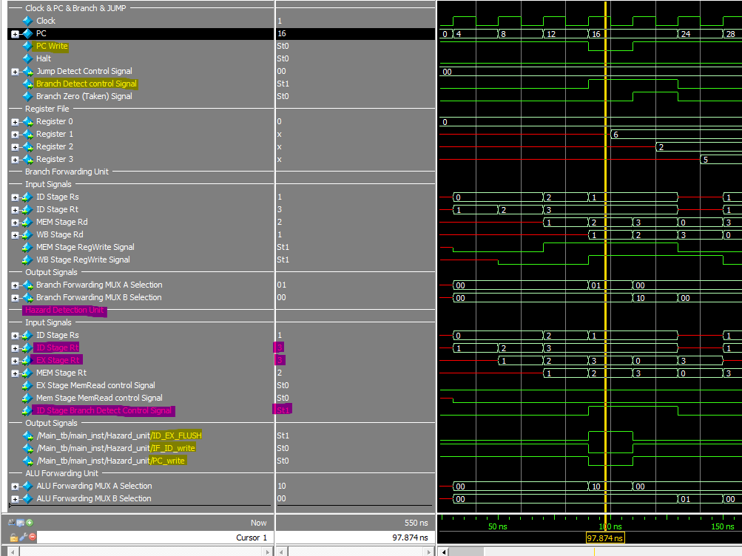

#### **CPU Status After execution**

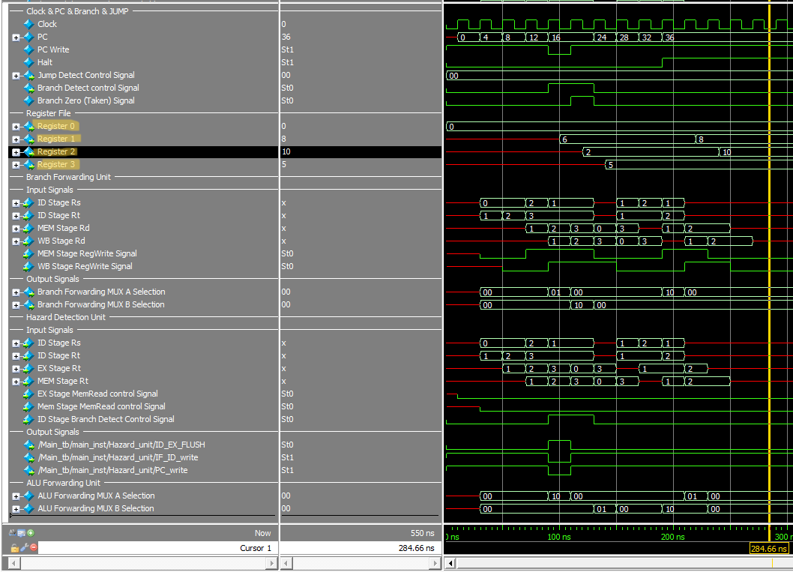

## **Test case 6**

### Instruction memory

**No need for RAM**

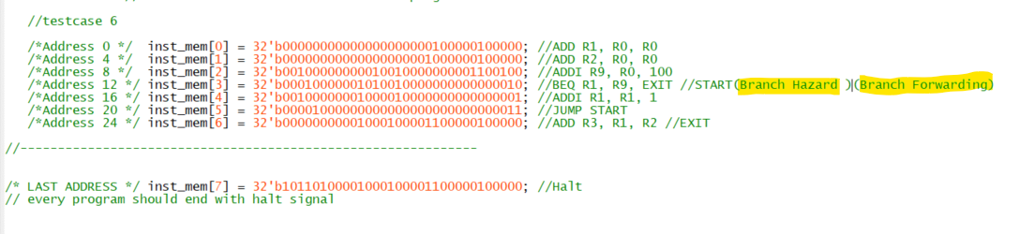

### First Branch BEQ R1, R9, EXIT Instruction Catch Branch Forwarding

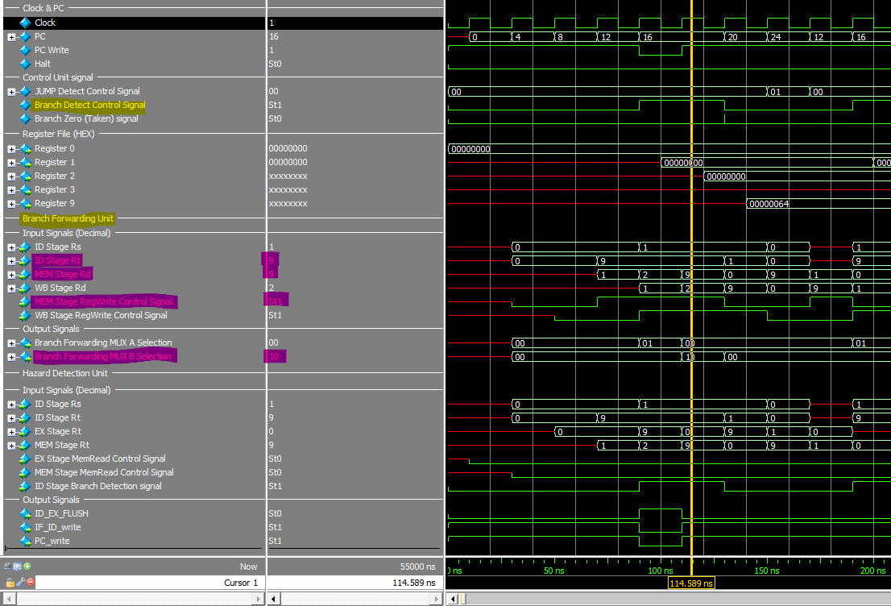

### First Branch BEQ R1, R9, EXIT Instruction Catch Branch Hazard

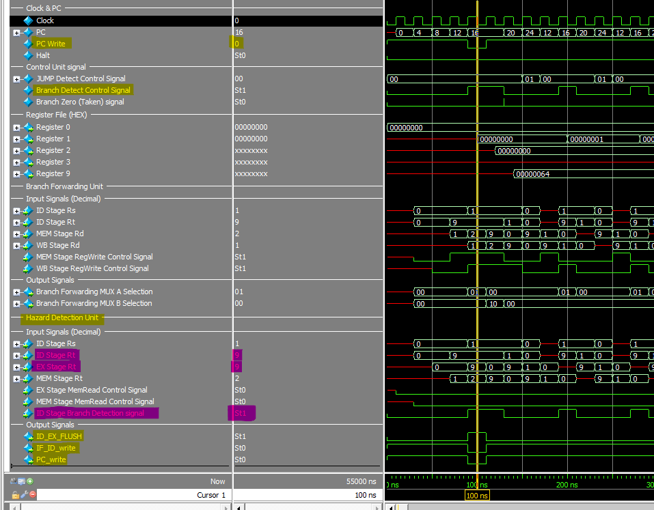

### the last Iteration Branch Taken.

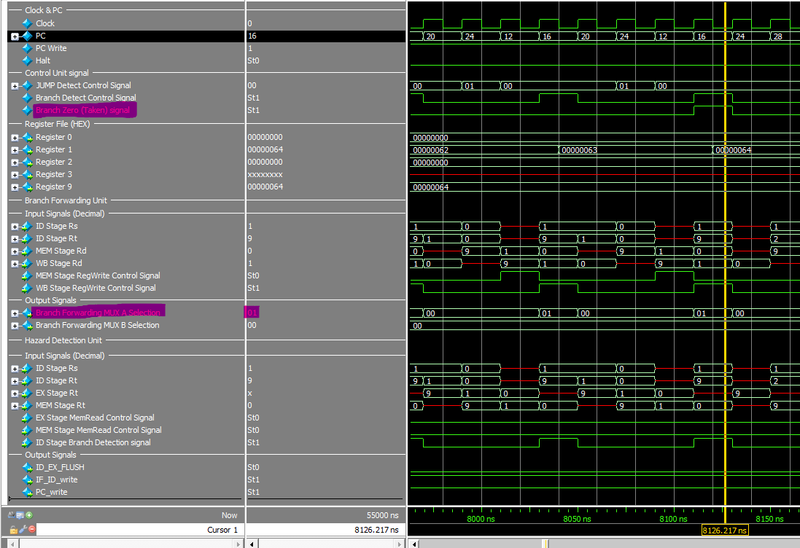

### The CPU Status After execution

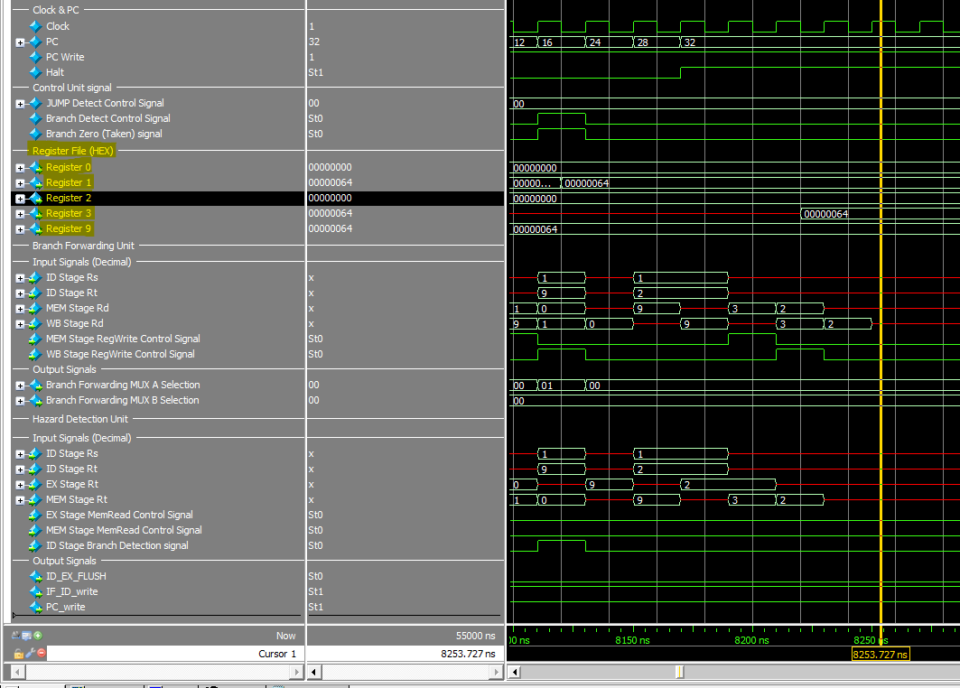

## special case JAL & JS

### Instruction Memory Values.

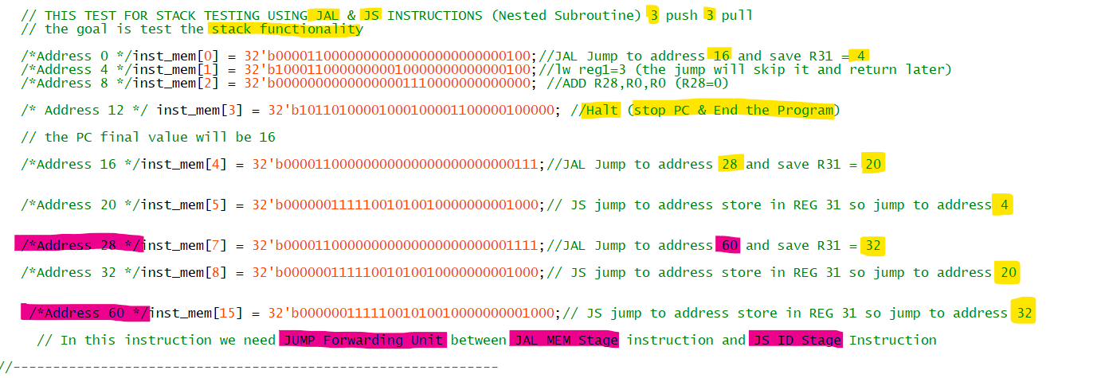

**Benchmark Description**: In this self-generated benchmark, we will assess the stack functionality and the Jump Forwarding unit. The benchmark involves executing three JAL instructions to reach address 60, followed by three JS instructions to return to address 4, ultimately reaching the Halt instruction located at address 12 to conclude the program.

### Initial Value First Cycle

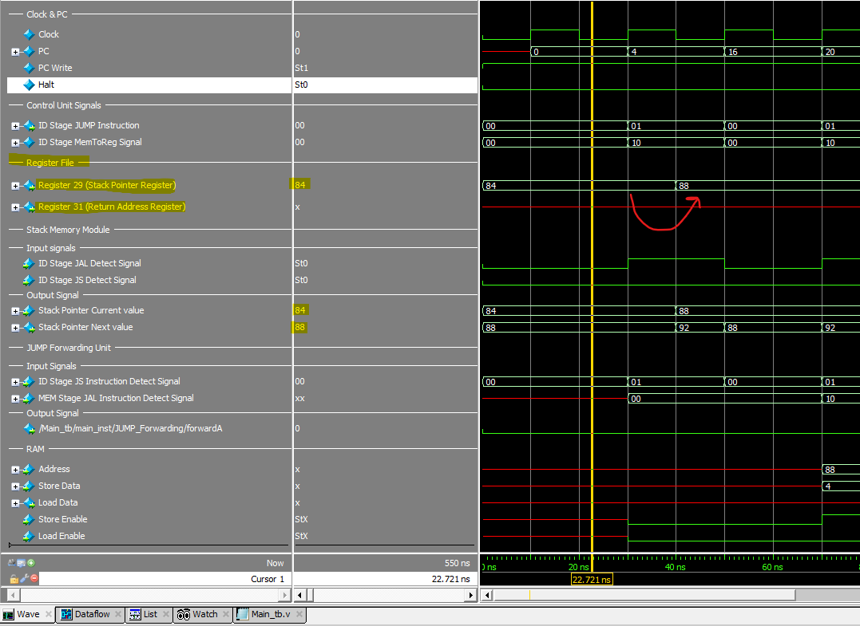

### First JAL Instruction

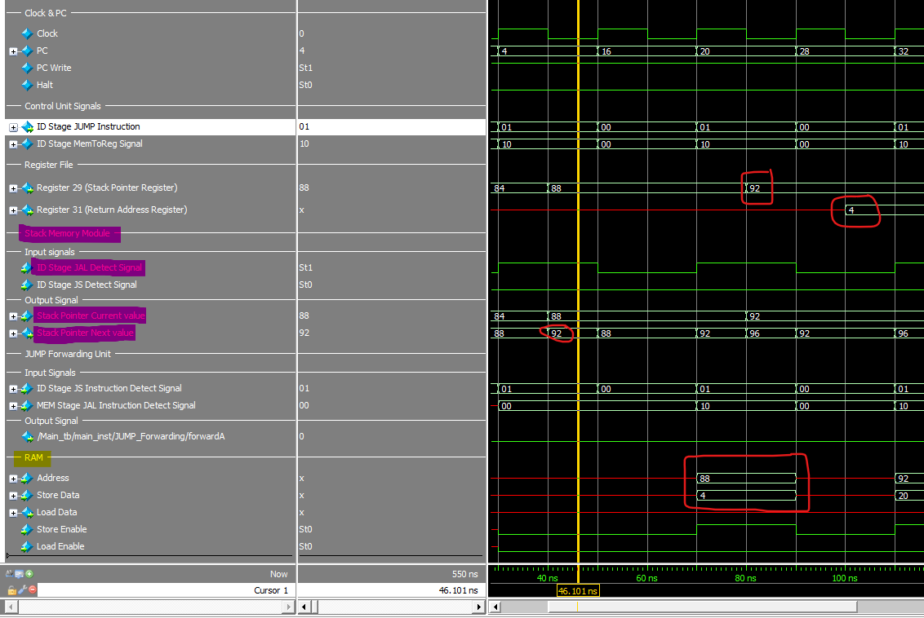

### First JS Instruction JUMP Forwarding

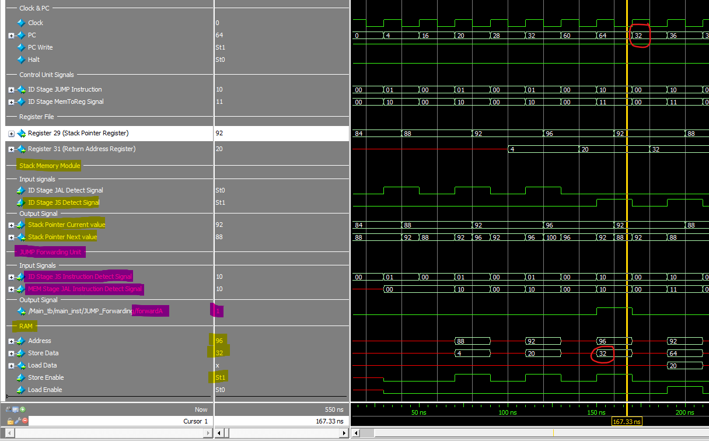

### First JAL Instruction



### Last JS Instruction

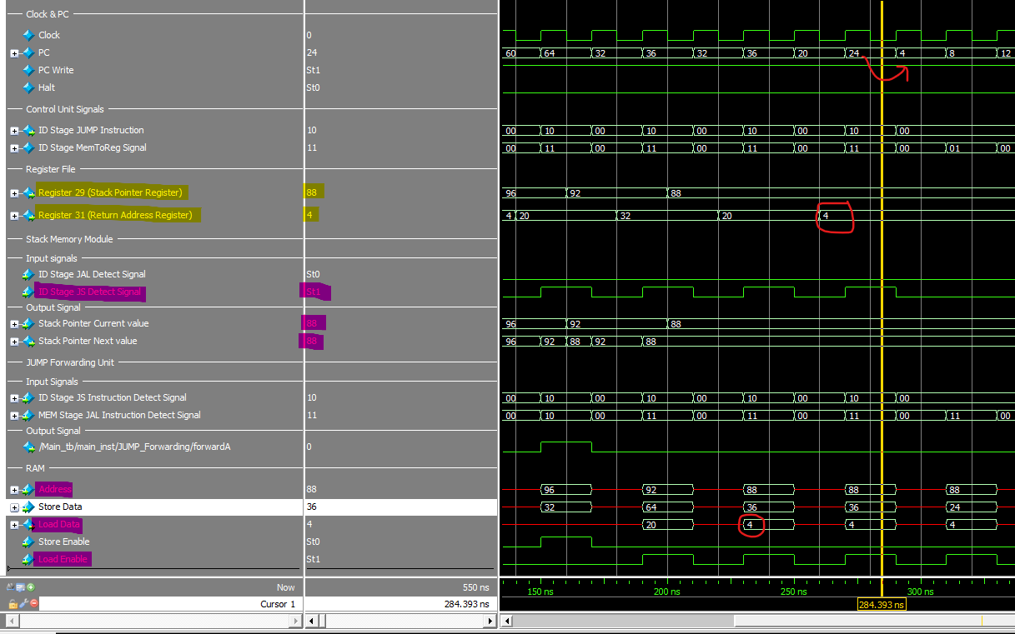

### CPU Status After Execution.

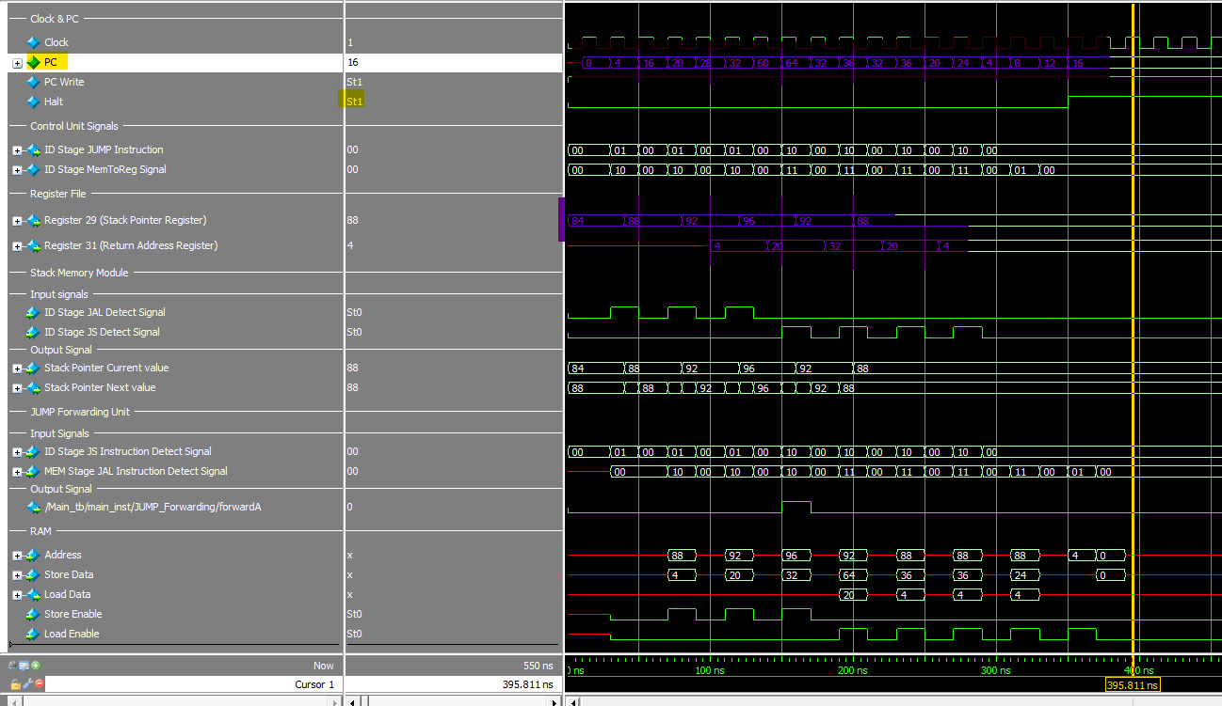

We have successfully finished the initial phase of constructing the single-cycle CPU. However, the branch component is still pending. We've complemented this phase with a robust test bench to ensure accuracy and functionality.

# Evaluation Sheet Statics

This table ensures that every benchmark, as discussed, successfully passes and yields the correct results in both simulation and FPGA implementation.

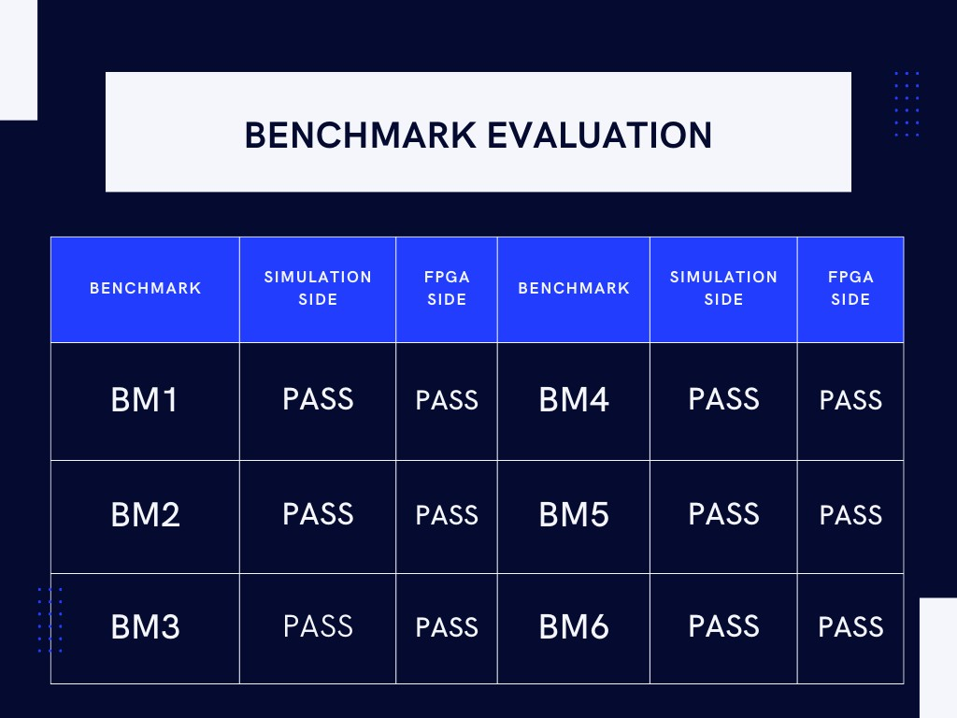

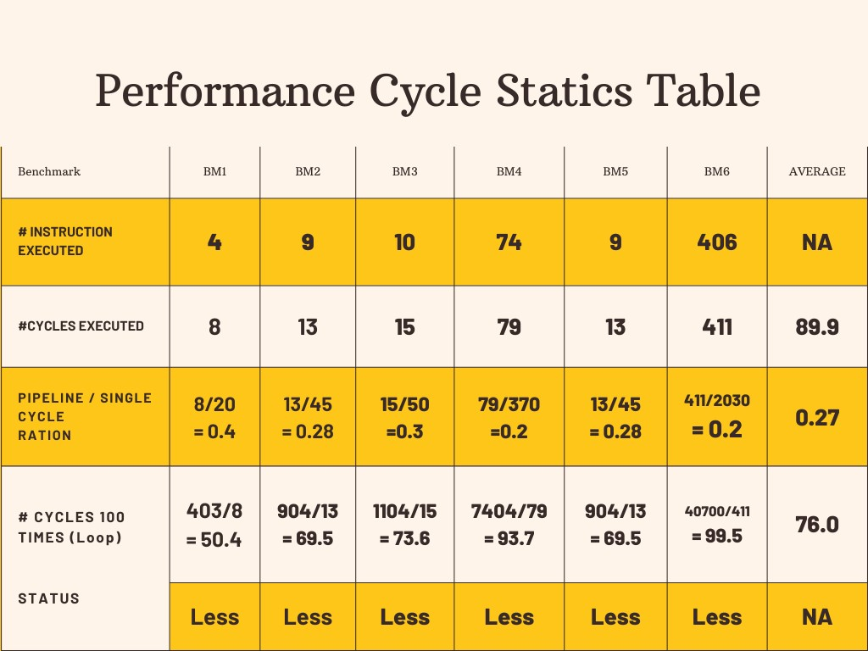

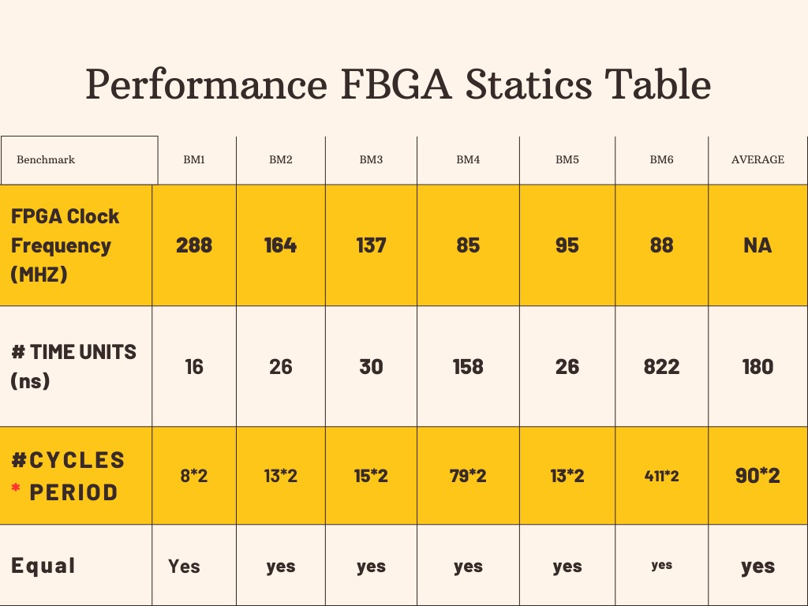

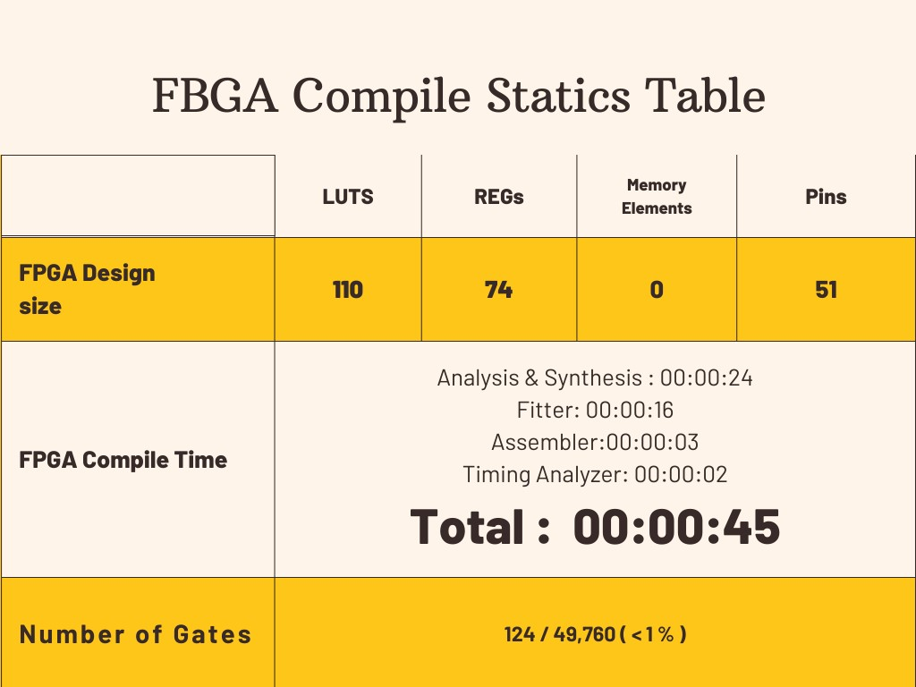

# Conclusion

The journey to design a pipeline CPU, inspired by the venerable MIPS architecture, has led us to a comprehensive exploration of computer architecture, instruction execution, and the intricacies of CPU design. This endeavor has not only enriched our understanding of these fundamental concepts but has also yielded insights and a valuable educational resource for students and enthusiasts alike.

### Key Findings and Implications

Through this project, we have made several key findings and drawn implications:

1. Educational Resource: We have successfully created an educational resource that unravels the intricacies of CPU design. The project offers a detailed, step-by-step account of how a single-cycle CPU operates, emphasizing simplicity and clarity, making it accessible to a broad audience.
2. Simplicity and Efficiency: The MIPS-inspired single-cycle design demonstrates the power of simplicity and efficiency in CPU architecture. We have observed that by adhering to a reduced instruction set and single-cycle execution, it is possible to achieve transparency in the execution of instructions.
3. Performance Analysis: Our performance analysis revealed that the single-cycle CPU's execution time is generally quicker compared to other designs. However, this speed comes at the expense of resource utilization, and it may not be the most efficient choice for all applications.

### Project’s objectives achieved.

While our project has achieved its primary objectives(**build pipeline cpu with good cycle time),** there are avenues for future work and exploration:

1. Advanced Instructions: Expanding the instruction set to include more complex operations, such as floating-point arithmetic or SIMD instructions, would further enrich the educational value of the CPU model.
2. Out of order processor: Out-of-order processors are often found in high-performance computing environments and modern microprocessors where speed and efficiency are paramount.

# Appendix A: CODE

## ALU

module ALU(

input clk,

input [31:0] A, // 32-bit input A

input [31:0] B, // 32-bit input B

input [3:0] ALUControl, // 4-bit ALU control

input [4:0] ShiftAmount, // 5-bit input for shift amount

input [2:0] branch_type,

output reg [31:0] ALUOut, // 32-bit output

output reg Zero // Zero flag

);

reg Overflow;

reg CarryOut;

//reg [31:0] ALUOut;

/*

addu

subu

*/

always @(*) begin

case(ALUControl)

4'b0000: ALUOut <= A + B; // Addition (signed)

4'b0001: ALUOut <= A - B; // Subtraction (signed)

4'b0010: ALUOut <= A * B; // Multiplication (signed)

4'b0011: ALUOut <= A / B; // Division (signed/unsigned)

4'b0100: ALUOut <= A << ShiftAmount; // Logical shift left

4'b0101: ALUOut <= A >> ShiftAmount; // Logical shift right

4'b0110: ALUOut <= A + B; // addu

4'b0111: ALUOut <= A - B; // subu

4'b1000: ALUOut <= A & B; // Logical AND

4'b1001: ALUOut <= A | B; // Logical OR

4'b1010: ALUOut <= A ^ B; // Logical XOR

4'b1011: ALUOut <= ~(A | B); // Logical NOR

4'b1100: ALUOut <= (branch_type == 3'b101) ? (A >= B) ? 32'b1 : 32'b0 :

(branch_type == 3'b110) ? (A <= B) ? 32'b1 : 32'b0 : 32'b0;

4'b1101: ALUOut <= (A < B) ? 32'b1 : 32'b0; // less than

4'b1110: ALUOut <= (A > B) ? 32'b1 : 32'b0; // greater than

default: ALUOut <= 32'b0; // Default operation

endcase

end

always @(*) begin

if (ALUControl == 4'b0000) begin // Addition (signed)

Overflow <= (A[31] == B[31] && A[31] != ALUOut[31]);

CarryOut <= (A[31] & B[31]) | (A[31] & ALUOut[31]) | (B[31] & ALUOut[31]);

end else if (ALUControl == 4'b0001) begin // Subtraction (signed)

Overflow <= (A[31] != B[31] && A[31] != ALUOut[31]);

CarryOut <= (A[31] & B[31]) | (A[31] & ALUOut[31]) | (B[31] & ALUOut[31]);

end else if (ALUControl == 4'b0010) begin // Multiplication (signed)

Overflow <= (A[31] == B[31] && A[31] != ALUOut[31]);

CarryOut <= 1'b0; // No carry-out for multiplication

end else if (ALUControl == 4'b0011) begin // Division (signed/unsigned)

Overflow <= (B == 32'b0); // Detect division by zero

CarryOut <= 1'b0;

end else if ((ALUOut < A) && (ALUOut < B) && (ALUControl == 4'b0110)) begin

Overflow <= 1'b0;

CarryOut <= 1'b1;

end else begin

Overflow <= 1'b0;

CarryOut <= 1'b0;

end

end

always @(*) begin

case(branch_type)

3'b001: Zero <= (ALUOut == 32'b0) ? 1'b1 : 1'b0; // beq

3'b010: Zero <= (ALUOut != 32'b0) ? 1'b1 : 1'b0; // bne

3'b011: Zero <= (ALUOut == 32'b1) ? 1'b1 : 1'b0; // bgt

3'b100: Zero <= (ALUOut == 32'b1) ? 1'b1 : 1'b0; // blt

3'b101: Zero <= (ALUOut == 32'b1) ? 1'b1 : 1'b0; // bge

3'b110: Zero <= (ALUOut == 32'b1) ? 1'b1 : 1'b0; // ble

default: Zero <= 1'b0;

endcase

end

endmodule

## branch

module Branch(

input Branch_Flag,

input [3:0] ALUOp,

input [31:0] Data1,

input [31:0] Data2,

input [15:0] Target,

input [31:0] next_pc,

output reg [31:0] Branch_address,

output reg zero

);

always @(*) begin

zero = 0 ;

Branch_address [15:0] = Target [15:0] ;

Branch_address [31:16] = {16{Target[15]}};

Branch_address = Branch_address * 4 ;

Branch_address = Branch_address + next_pc;

if(Branch_Flag) begin

if(ALUOp == 4'b0100)begin // beq

if (Data1 == Data2)begin

zero = 1 ;

end

end

else if(ALUOp == 4'b0101)begin // bne

if (Data1 != Data2)begin

zero = 1 ;

end

end

else if(ALUOp == 4'b0110)begin // bgt

if (Data1 > Data2)begin

zero = 1 ;

end

end

else if(ALUOp == 4'b0111)begin // blt

if (Data1 < Data2)begin

zero = 1 ;

end

end

else if(ALUOp == 4'b1000)begin // bge

if (Data1 >= Data2)begin

zero = 1 ;

end

end

else if(ALUOp == 4'b1001)begin // ble

if (Data1 <= Data2)begin

zero = 1 ;

end

end

end

end

endmodule

## control unit

module ControlUnit(Clock,Reset,opcode,RegDst,ALUSrc,MemtoReg,MemWrite,MemRead,ALUOp,RegWrite,Branch,Jump,funct,halt);

input wire [5:0] opcode;

input Clock , Reset ; // Reset : 1 --> on | 0--> off

input wire [5:0] funct;

// wires

output wire ALUSrc,MemWrite,MemRead,RegWrite,Branch;

output wire [3:0] ALUOp;

output wire [1:0] Jump;

output wire [1:0] MemtoReg;

output wire [1:0] RegDst;

output wire halt;

// reg type

reg reg_ALUSrc,reg_MemWrite,reg_MemRead,reg_RegWrite,reg_Branch;

reg [3:0] reg_ALUOp;

reg [1:0] reg_Jump;

reg [1:0] reg_MemtoReg;

reg [1:0] reg_RegDst;

reg [5:0] reset_opcode ;

reg reg_halt;

//************************** Singnal classification ********************************

// opcode, // 6-bit opcode from the instruction

// RegDst, // Control signal for selecting the destination register

// ALUSrc, // Control signal for ALU source selection (0 for register, 1 for immediate)

// MemWrite, // Control signal for memory write

// MemRead, // Control signal for memory read

// Branch, // Control signal for branching

// ALUOp, // Control signal for ALU operation

// RegWrite // Control signal for register write

// reset_reg // will handle the default value if the reset is on

// pc_load ( 0->stall),(1->load)

// pc_Store // to enable REG 31 to store the return address when using JAL Instruction

// JUMP[1:0] // (MSB) --> is to indicate JS Instruction with Pull the stack (LSB) --> indicate jump instruction

// MemToReg[1:0] // MSB) --> is to indicate JAL Instruction with Push the stack

// (LSB) --> Control signal for selecting the source for register write data

//*********************************************************************************************************************

always @(*)

begin

if(Reset==1'b1)

reset_opcode <=6'b111000; // this bits will call the default value and make the control unit reset

else

reset_opcode <=opcode;

end

//101101 halt opcode

always @(*)

if(Reset==1'b1)begin

// defualt value we can use it if we will implement reset or unsupported instructions

reg_ALUSrc = 1'b0;

reg_RegWrite = 1'b0;

reg_MemtoReg = 2'b00;

reg_MemWrite = 1'b0;

reg_MemRead = 1'b0;

reg_ALUOp = 4'b0000;

reg_RegDst = 2'b00;

reg_Branch = 1'b0;

reg_Jump = 2'b00;

reg_halt = 1'b0;

end

else begin

case(opcode)

6'b000000:begin

if(funct == 6'b001000)begin

//Jump Register (JS) instruction

reg_ALUSrc = 1'b0;

reg_RegWrite = 1'b1;// for Stack Implementation

reg_MemtoReg = 2'b11; // for Stack implementation (customize only for JS function to be MemToReg[1]=1 same as JAL Instruction)

reg_MemWrite = 1'b0;

reg_MemRead = 1'b1;// for Stack Implementation

reg_ALUOp = 4'b0000;

reg_RegDst = 2'b00;

reg_Branch = 1'b0;

reg_Jump = 2'b10;

reg_halt = 1'b0;

end

else begin

// R-type instruction

reg_ALUSrc = 1'b0;

reg_RegWrite = 1'b1;

reg_MemtoReg = 2'b00;

reg_MemWrite = 1'b0;

reg_MemRead = 1'b0;

reg_ALUOp = 4'b0010;

reg_RegDst = 2'b01;

reg_Branch = 1'b0;

reg_Jump = 2'b00;

reg_halt = 1'b0;

end

end

6'b100011:begin

// load instruction

reg_ALUSrc = 1'b1;

reg_RegWrite = 1'b1;

reg_MemtoReg = 2'b01;

reg_MemWrite = 1'b0;

reg_MemRead = 1'b1;

reg_ALUOp = 4'b0000;

reg_RegDst = 2'b00;

reg_Branch = 1'b0;

reg_Jump = 2'b00;

reg_halt = 1'b0;

end

6'b101011:begin

// store instruction

reg_ALUSrc = 1'b1;

reg_RegWrite = 1'b0;

reg_MemtoReg = 2'b00;

reg_MemWrite = 1'b1;

reg_MemRead = 1'b0;

reg_ALUOp = 4'b0000;

reg_RegDst = 2'b00;

reg_Branch = 1'b0;

reg_Jump = 2'b00;

reg_halt = 1'b0;

end

6'b001000:begin

//immediate instruction (addi)

reg_ALUSrc = 1'b1;

reg_RegWrite = 1'b1;

reg_MemtoReg = 2'b00;

reg_MemWrite = 1'b0;

reg_MemRead = 1'b0;

reg_ALUOp = 4'b0000;

reg_RegDst = 2'b00;

reg_Branch = 1'b0;

reg_Jump = 2'b00;

reg_halt = 1'b0;

end

6'b001100:begin

//immediate instruction (andi)

reg_ALUSrc = 1'b1;

reg_RegWrite = 1'b1;

reg_MemtoReg = 2'b00;

reg_MemWrite = 1'b0;

reg_MemRead = 1'b0;

reg_ALUOp = 4'b0001;

reg_RegDst = 2'b00;

reg_Branch = 1'b0;

reg_Jump = 2'b00;

reg_halt = 1'b0;

end

6'b001101:begin

//immediate instruction (ori)

reg_ALUSrc = 1'b1;

reg_RegWrite = 1'b1;

reg_MemtoReg = 2'b00;

reg_MemWrite = 1'b0;

reg_MemRead = 1'b0;

reg_ALUOp = 4'b0011;

reg_RegDst = 2'b00;

reg_Branch = 1'b0;

reg_Jump = 2'b00;

reg_halt = 1'b0;

end

6'b000010:begin

//Jump instruction (j)

reg_ALUSrc = 1'b0;

reg_RegWrite = 1'b0;

reg_MemtoReg = 2'b00;

reg_MemWrite = 1'b0;

reg_MemRead = 1'b0;

reg_ALUOp = 4'b0000;

reg_RegDst = 2'b00;

reg_Branch = 1'b0;

reg_Jump = 2'b01;

reg_halt = 1'b0;

end

6'b000011:begin

//Jump and link instruction (jal)

reg_ALUSrc = 1'b0;

reg_RegWrite = 1'b1;

reg_MemtoReg = 2'b10;// for JAL instruction

reg_MemWrite = 1'b1; // for Stack implemntation

reg_MemRead = 1'b0;

reg_ALUOp = 4'b0000;

reg_RegDst = 2'b10;

reg_Branch = 1'b0;

reg_Jump = 2'b01;// for JS Instruction

reg_halt = 1'b0;

end

6'b000100:begin

//branch equal

reg_ALUSrc = 1'b0;

reg_RegWrite = 1'b0;

reg_MemtoReg = 2'b00;

reg_MemWrite = 1'b0;

reg_MemRead = 1'b0;

reg_ALUOp = 4'b0100;

reg_RegDst = 2'b00;

reg_Branch = 1'b1;

reg_Jump = 2'b00;

reg_halt = 1'b0;

end

6'b000101:begin

//branch not equal

reg_ALUSrc = 1'b0;

reg_RegWrite = 1'b0;

reg_MemtoReg = 2'b00;

reg_MemWrite = 1'b0;

reg_MemRead = 1'b0;

reg_ALUOp = 4'b0101;

reg_RegDst = 2'b00;

reg_Branch = 1'b1;

reg_Jump = 2'b00;

reg_halt = 1'b0;

end

6'b000110:begin

//branch greater than

reg_ALUSrc = 1'b0;

reg_RegWrite = 1'b0;

reg_MemtoReg = 2'b00;

reg_MemWrite = 1'b0;

reg_MemRead = 1'b0;

reg_ALUOp = 4'b0110;

reg_RegDst = 2'b00;

reg_Branch = 1'b1;

reg_Jump = 2'b00;

reg_halt = 1'b0;

end

6'b000111:begin

//branch less than

reg_ALUSrc = 1'b0;

reg_RegWrite = 1'b0;

reg_MemtoReg = 2'b00;

reg_MemWrite = 1'b0;

reg_MemRead = 1'b0;

reg_ALUOp = 4'b0111;

reg_RegDst = 2'b00;

reg_Branch = 1'b1;

reg_Jump = 2'b00;

reg_halt = 1'b0;

end

6'b001001:begin

//branch greater or equal

reg_ALUSrc = 1'b0;

reg_RegWrite = 1'b0;

reg_MemtoReg = 2'b00;

reg_MemWrite = 1'b0;

reg_MemRead = 1'b0;

reg_ALUOp = 4'b1000;

reg_RegDst = 2'b00;

reg_Branch = 1'b1;

reg_Jump = 2'b00;

reg_halt = 1'b0;

end

6'b001010:begin

//branch less or equal

reg_ALUSrc = 1'b0;

reg_RegWrite = 1'b0;

reg_MemtoReg = 2'b00;

reg_MemWrite = 1'b0;

reg_MemRead = 1'b0;

reg_ALUOp = 4'b1001;

reg_RegDst = 2'b00;

reg_Branch = 1'b1;

reg_Jump = 2'b00;

reg_halt = 1'b0;

end

// halt instruction

6'b101101:begin

reg_ALUSrc = 1'b0;

reg_RegWrite = 1'b0;

reg_MemtoReg = 2'b00;

reg_MemWrite = 1'b0;

reg_MemRead = 1'b0;

reg_ALUOp = 1'b0;

reg_RegDst = 2'b00;

reg_Branch = 1'b0;

reg_Jump = 2'b00;

reg_halt = 1'b1;

end

// 6'b111000:begin

// //branch less or equal

// reg_ALUSrc = 1'b0;

// reg_RegWrite = 1'b0;

// reg_MemtoReg = 2'b00;

// reg_MemWrite = 1'b0;

// reg_MemRead = 1'b0;

// reg_ALUOp = 4'b0000;

// reg_RegDst = 2'b00;

// reg_Branch = 1'b0;

// reg_Jump = 2'b00;

// reg_halt = 1'b1;

//

// end

//

default : begin

// defualt value we can use it if we will implement reset or unsupported instructions

reg_ALUSrc = 1'b0;

reg_RegWrite = 1'b0;

reg_MemtoReg = 2'b00;

reg_MemWrite = 1'b0;

reg_MemRead = 1'b0;

reg_ALUOp = 4'b0000;

reg_RegDst = 2'b00;

reg_Branch = 1'b0;

reg_Jump = 2'b00;

reg_halt = 1'b0;

end

endcase

end

// assign the output wires

assign RegDst = reg_RegDst;

assign ALUSrc = reg_ALUSrc;

assign MemtoReg = reg_MemtoReg;

assign MemWrite = reg_MemWrite;

assign MemRead = reg_MemRead;

assign RegWrite = reg_RegWrite;

assign ALUOp = reg_ALUOp;

assign Branch= reg_Branch;

assign Jump = reg_Jump;

assign halt = reg_halt;

endmodule

## EX_MEM_Register

module EX_MEM_Register (

// input signals

clk,In_Address,In_Write_Data, In_Rd,

// output signals

Out_Address,Out_Write_Data, Out_Rd,

// control unit input signals

// MEM signals

In_MemWrite,In_MemRead,

// WB signals

In_RegWrite, In_MemtoReg,

// control unit output signals

// MEM signals

Out_MemWrite,Out_MemRead,

// WB signals

Out_RegWrite, Out_MemtoReg,

In_PC,Out_PC

);

input clk ;

input [31:0] In_Address,In_Write_Data,In_PC ; // this refer to ALU reselt as an address and Read data 2 from register file as an write data to store in memory

input [4:0] In_Rd; // the values come from the instruction in ID stage

input In_MemWrite,In_MemRead,In_RegWrite;

input [1:0] In_MemtoReg;

output reg [31:0] Out_Address,Out_Write_Data,Out_PC ;

output reg [4:0] Out_Rd;

output reg Out_MemWrite,Out_MemRead,Out_RegWrite;

output reg [1:0] Out_MemtoReg;

always @(posedge clk)

begin

Out_Address <= In_Address;

Out_Write_Data <= In_Write_Data;

Out_Rd <=In_Rd;

Out_MemWrite <= In_MemWrite;

Out_MemRead <= In_MemRead;

Out_RegWrite <= In_RegWrite;

Out_MemtoReg<=In_MemtoReg;

Out_PC<=In_PC;

end

endmodule

## ForwardingUnit

module ForwardingUnit (

input [4:0] rs1_ID_EX,

input [4:0] rs2_ID_EX,

input [4:0] rd_EX_MEM,

input [4:0] rd_MEM_WB,

input RegWrite_EX_MEM,

input RegWrite_MEM_WB,

output reg [1:0] forwardA,

output reg [1:0] forwardB

);

// Forwarding logic for ALU inputs

always@(*)

begin

// Default: No forwarding

forwardA = 2'b00;

forwardB = 2'b00;

// Forwarding for rs1

if (RegWrite_EX_MEM && (rd_EX_MEM != 0) && (rd_EX_MEM == rs1_ID_EX)) begin

forwardA = 2'b10; // Forward from EX/MEM

end else if (RegWrite_MEM_WB && (rd_MEM_WB != 0) && (rd_MEM_WB == rs1_ID_EX)) begin

forwardA = 2'b01; // Forward from MEM/WB

end

// Forwarding for rs2

if (RegWrite_EX_MEM && (rd_EX_MEM != 0) && (rd_EX_MEM == rs2_ID_EX)) begin

forwardB = 2'b10; // Forward from EX/MEM

end else if (RegWrite_MEM_WB && (rd_MEM_WB != 0) && (rd_MEM_WB == rs2_ID_EX)) begin

forwardB = 2'b01; // Forward from MEM/WB

end

end

endmodule

## Hazard unit

module Hazard_Unit(D_rs,D_rt,EX_rt,EX_MemRead,ID_EX_FLUSH,IF_ID_write,PC_write,ID_Branch,MEM_rt,MEM_MemRead);

input [4:0] D_rs, D_rt ; // this signals is rs and rt for the instruction in ID stage

input [4:0] EX_rt ; input EX_MemRead;// this signals is rt and Memory read control signal for instruction EX stage (first preceding)

input ID_Branch ; // this a control signal from the id Unit to determin if we have a branch instruction in id stage or not

input [4:0] MEM_rt ; // this signal is rt for the instruction in Mem stage (second preceding instruction)

input MEM_MemRead ; // this signal is memory read control signal for instruction in Memory stage to determin if is load instruction

output wire ID_EX_FLUSH ,IF_ID_write , PC_write ;// this signals is to implement the stall

reg reg_ID_EX_FLUSH ,reg_IF_ID_write , reg_PC_write ;

always@(*)

begin

// first type of hazard is load-use hazard that occure when we find a depandancy between load instruction and its followed instruction

reg_ID_EX_FLUSH <= 0; // to solve test case 5 bug

reg_IF_ID_write <= 1;

reg_PC_write <= 1;

if((EX_MemRead == 1'b1) && (ID_Branch == 1'b0))

begin

if((D_rs == EX_rt) || (D_rt == EX_rt))

begin

reg_ID_EX_FLUSH <= 1; //(Reset for ID_EX_REG) to select zeroes for the control mux that control the flow of ID/EX register

reg_IF_ID_write <= 0; // to disable the the IF/ID register so he can't load new values and keep his old value

reg_PC_write <= 0; // to disable the the PC so he can't load new values and keep his old value

end

end

//second type hazard is Data hazards for branches that occur when we find a depandancy between branch and first preceding or second preceding if is it a load instruction

else

begin

if (ID_Branch == 1'b1)

begin

if ( ((D_rs == EX_rt) || (D_rt == EX_rt)) || ( (MEM_MemRead == 1'b1) && ( (D_rs == MEM_rt) || (D_rt == MEM_rt) ) ))

begin

reg_ID_EX_FLUSH <= 1; // to select zeroes for the control mux that control the flow of ID/EX register

reg_IF_ID_write <= 0; // to disable the the IF/ID register so he can't load new values and keep his old value

reg_PC_write <= 0; // to disable the the PC so he can't load new values and keep his old value

end

end

else

begin

reg_ID_EX_FLUSH <= 0;

reg_IF_ID_write <= 1;

reg_PC_write <= 1;

end

end

end

// assign output wires

assign ID_EX_FLUSH = reg_ID_EX_FLUSH;

assign IF_ID_write = reg_IF_ID_write;

assign PC_write = reg_PC_write;

endmodule

## ID_EX_Register

module ID_EX_Register (

// input signals

clk,reset

,In_Reg_File_Data1,In_Reg_File_Data2,

In_offset,In_Rs,In_Rt,In_Rd,

// output signals

Out_Reg_File_Data1,Out_Reg_File_Data2,

Out_offset,Out_Rs,Out_Rt,Out_Rd,

// control unit input signals

// EX signals

In_ALUSrc, In_ALUOp ,In_RegDst,In_func, In_shamt,

// MEM signals

In_MemWrite,In_MemRead,

// WB signals

In_RegWrite, In_MemtoReg,

// control unit output signals

// EX signals

Out_ALUSrc, Out_ALUOp ,Out_RegDst,Out_func, Out_shamt,

// MEM signals

Out_MemWrite,Out_MemRead,

// WB signals

Out_RegWrite, Out_MemtoReg,

// JAL PC WB Value

In_PC,Out_PC

);

input clk , reset ; // reset is active when we catch a hazard in decode we use it instead of a mux to make all the values equal zeroes

input [31:0] In_Reg_File_Data1,In_Reg_File_Data2,In_offset,In_PC ; // the data come from the register file and the offset from the sign extend

input [4:0] In_Rs,In_Rt,In_Rd; // the values come from the instruction in ID stage

input In_ALUSrc,In_MemWrite,In_MemRead,In_RegWrite;

input [3:0] In_ALUOp;

input [1:0] In_MemtoReg;

input [1:0] In_RegDst;

input [5:0] In_func;

input [4:0] In_shamt;

output reg [31:0] Out_Reg_File_Data1, Out_Reg_File_Data2, Out_offset,Out_PC ;

output reg [4:0] Out_Rs , Out_Rt , Out_Rd;

output reg Out_ALUSrc,Out_MemWrite,Out_MemRead,Out_RegWrite;

output reg [3:0] Out_ALUOp;

output reg [1:0] Out_MemtoReg;

output reg [1:0] Out_RegDst;

output reg [5:0] Out_func;

output reg [5:0] Out_shamt;

always @(posedge clk)

begin

if(reset == 1'b1) // if it one so we catch a hazard

begin

Out_Reg_File_Data1<=32'b0;

Out_Reg_File_Data2<=32'b0;

Out_offset<=32'b0;

Out_Rs <=5'b0;

Out_Rt <=5'b0;

Out_Rd <=5'b0;

Out_ALUSrc <= 1'b0;

Out_MemWrite <= 1'b0;

Out_MemRead <= 1'b0;

Out_RegWrite <= 1'b0;

Out_ALUOp<=4'b0;

Out_MemtoReg<=2'b0;

Out_RegDst<=2'b0;

Out_func<=6'b000000;

Out_shamt<=5'b00000;

Out_PC<=32'b0;

end

else

begin

Out_Reg_File_Data1<= In_Reg_File_Data1;

Out_Reg_File_Data2<= In_Reg_File_Data2;

Out_offset<= In_offset;

Out_Rs <=In_Rs;

Out_Rt <=In_Rt;

Out_Rd <=In_Rd;

Out_ALUSrc <= In_ALUSrc;

Out_MemWrite <= In_MemWrite;

Out_MemRead <= In_MemRead;

Out_RegWrite <= In_RegWrite;

Out_ALUOp<=In_ALUOp;

Out_MemtoReg<=In_MemtoReg;

Out_RegDst<=In_RegDst;

Out_func<=In_func;

Out_shamt<=In_shamt;

Out_PC<=In_PC;

end

end

endmodule

## ID_EX_Register

module IF_ID_Register (clk,reset,enable,Instruction_in,PC_in,Branch_Control,Instruction_out,PC_out, opcode,rs,rt,rd,shamt,funct,addr,jump,halt);

input clk ;

input reset; // 0-->1 to delete the previous instruction and store a nop instruction (flush) with opcode 111000 according to our control unit default value

//we use it in branch miss prediction this signal come from zero in branch alu

input enable; // 0-->1 to enable the register to received new instruction we use

//it in hazard detection to make flush and the output opcode is 111000 it comes only from the hazard detection unit

input halt ; // 0 ---> stop pc and regenerate halt instruction to control unit

input [31:0] Instruction_in; // the instruction come from fetch stage

input [31:0] PC_in; // the value of pc+4 come from fetch stage

input Branch_Control; // to know if the function cause reset (zero signal) is from branch instruction in ID stage

output reg [31:0] Instruction_out; // the instruction output to decode stage

output reg [5:0] opcode;

output reg [4:0] rs;

output reg [4:0] rt;

output reg [4:0] rd;

output reg [4:0] shamt;

output reg [5:0] funct;

output reg [15:0] addr;

output reg [25:0] jump;

output reg [31:0] PC_out ; // the pc output to decode stage

always@(posedge clk)

begin

if((enable == 1'b0) )

begin

if((reset == 1'b1) || (Branch_Control == 1'b1) )

// case 3 : when to flush the register in reset status or when we catch a branch miss predict

begin

Instruction_out <=32'b11100000000000000000000000000000; // nop

opcode <= 6'b111000;

rs <= 5'bx;

rt <= 5'bx;

rd <= 5'bx;

shamt <= 5'bx;

funct <= 6'bx;

addr <= 16'bx;

jump <= 26'bx;

PC_out <= PC_in;

end

else

begin

// case 2 : when we do not have any problem

Instruction_out <=Instruction_in;

opcode <= Instruction_in [31:26];

rs <= Instruction_in [25:21];

rt <= Instruction_in [20:16];

rd <= Instruction_in [15:11];

shamt <= Instruction_in [10:6];

funct <= Instruction_in [5:0];

addr <= Instruction_in [15:0];

jump <= Instruction_in [25:0];

PC_out <= PC_in;

end

if((halt == 1'b1))

begin

// to stop the pc

Instruction_out <=32'b10110100000000000000000000000000; // nop

opcode <= 6'b101101;

rs <= 5'bx;

rt <= 5'bx;

rd <= 5'bx;

shamt <= 5'bx;

funct <= 6'bx;

addr <= 16'bx;

jump <= 26'bx;

PC_out <= PC_in;

end

end

end

endmodule

## instruction memory

module INST_MEM #(

parameter size = 32,

parameter data_width = 32

)(

// input clk,

input reset,

input [31:0] address,

output reg [31:0] inst_out

);

reg [31:0] inst_mem [0:size - 1];

integer i;

// endmodule

reg state = 1'b0;

//

always @(*) begin

if (reset) begin

for (i = 0; i < size; i = i + 1) begin

inst_mem[i] <= 32'b0;

end

end else begin

case (state)

1'b0: begin

state <= 1'b1;

// Enter here the Instructions of the program

// THIS TEST FOR STACK TESTING USING JAL & JS INSTRUCTIONS (Nested Subroutine) 3 push 3 pull

// the goal is test the stack functionality

/*Address 0 */inst_mem[0] = 32'b00001100000000000000000000000100;//JAL Jump to address 16 and save R31 = 4

/*Address 4 */inst_mem[1] = 32'b10001100000000010000000000000100;//lw reg1=3 (the jump will skip it and return later)

/*Address 8 */inst_mem[2] = 32'b00000000000000001110000000000000; //ADD R28,R0,R0 (R28=0)

/* Address 12 */ inst_mem[3] = 32'b10110100001000100001100000100000; //Halt (stop PC & End the Program)

// the PC final value will be 16

/*Address 16 */inst_mem[4] = 32'b00001100000000000000000000000111;//JAL Jump to address 28 and save R31 = 20

/*Address 20 */inst_mem[5] = 32'b00000011111001010010000000001000;// JS jump to address store in REG 31 so jump to address 4

/*Address 28 */inst_mem[7] = 32'b00001100000000000000000000001111;//JAL Jump to address 60 and save R31 = 32

/*Address 32 */inst_mem[8] = 32'b00000011111001010010000000001000;// JS jump to address store in REG 31 so jump to address 20

/*Address 60 */inst_mem[15] = 32'b00000011111001010010000000001000;// JS jump to address store in REG 31 so jump to address 32

// In this instruction we need JUMP Forwarding Unit between JAL MEM Stage instruction and JS ID Stage Instruction

//-------------------------------------------------------------

//

///* LAST ADDRESS */ inst_mem[3] = 32'b10110100001000100001100000100000; //Halt

// every program should end with halt signal

end

1'b1: begin

inst_out <= inst_mem[address >> 2];

end

endcase

end

end

endmodule

## JUMP

module JUMP(

input JUMP_FLAG,

input [25:0] jump_offset,

input [31:0] next_pc,

output reg [31:0] JUMP_address

);

always @(*)

begin

if(JUMP_FLAG)

begin

JUMP_address = {next_pc[31:28], jump_offset, 2'b00};

end

else

begin

JUMP_address =32'bx;

end

end

endmodule

## MEM_WB

module MEM_WB_Register (

// input signals

clk,In_RAM_Data,In_Immediate_Data, In_Rd,

// output signals

Out_RAM_Data,Out_Immediate_Data, Out_Rd,

// control unit input signals

// WB signals

In_RegWrite, In_MemtoReg,

// control unit output signals

// WB signals

Out_RegWrite, Out_MemtoReg,

In_PC,Out_PC

);

input clk ;

input [31:0] In_RAM_Data,In_Immediate_Data,In_PC ; // this refer to RAM output data and Immediate data

input [4:0] In_Rd; // the values come from the instruction in ID stage

input In_RegWrite;

input [1:0] In_MemtoReg;

output reg [31:0] Out_RAM_Data,Out_Immediate_Data,Out_PC ;

output reg [4:0] Out_Rd;

output reg Out_RegWrite;

output reg [1:0] Out_MemtoReg;

always @(posedge clk)

begin

Out_RAM_Data <= In_RAM_Data;

Out_Immediate_Data <= In_Immediate_Data;

Out_Rd <=In_Rd;

Out_RegWrite <= In_RegWrite;

Out_MemtoReg<=In_MemtoReg;

Out_PC<=In_PC;

end

## Main

module Main (

input clk,

input reset

);

//**********************************************************************************************************************

// **************************************** Fetch Stage **************************************************************************

// ******************************************************************************************************************

wire Branch_Zero_Signal ; // we will use it in pc load

//PC

wire [31:0] pc_final;//input

wire [31:0] pc_out;//output

wire [31:0] next_pc;//pc+4

wire [31:0] pc_inc;//4

assign pc_inc = 32'b00000000000000000000000000000100;// constant value(4)

wire PC_write;//control

// for halt instruction implementation

wire halt; // to end the program last instruction in every program

PC #(.first_address(0), .pc_inc(4) )

pc_inst (

.clk(clk),

.reset(reset),

.target(pc_final),

.pc_load(PC_write && ~halt), //second edition come from hazard detection unit

.pc(pc_out)

);

//end of PC

//------------------------------------

adder add(

.a(pc_inc),

.b(pc_out),

.c(next_pc)

);

//------------------------------------

//inst_mem

wire[31:0] inst_out;

INST_MEM #(.size(32),.data_width(32) )

inst_mem (

.reset(reset),

.address(pc_out),

.inst_out(inst_out)

);

// End of Instruction Memory ---------------------------------------

// IF_ID_Register

// Outputs

wire [31:0] IF_ID_Instruction_out;

wire [31:0] IF_ID_PC_out;

// to split it from Instruction memory signal

wire [5:0] IF_ID_opcode;

wire [4:0] IF_ID_rs;

wire [4:0] IF_ID_rt;

wire [4:0] IF_ID_rd;

wire [4:0] IF_ID_shamt;

wire [5:0] IF_ID_funct;

wire [15:0] IF_ID_addrs;

wire [25:0] IF_ID_jump_offset;

wire [1:0] Jump_signal;//Jump_signal[0] really jump signal

wire IF_ID_write ,Branch ; // the enable signal that come from hazard unit and branch signal from control Unit

IF_ID_Register IF_ID_R (

.clk(clk),

.reset(reset),

.enable(~(IF_ID_write)),// it designed to be negative because the case of first instruction when no instruction is in ID stage

.Instruction_in(inst_out), // the output instruction from Instruction Memory

.PC_in(next_pc),

.Branch_Control((Branch & Branch_Zero_Signal)|(Jump_signal[0] | Jump_signal[1]) ), // if we catch branch depandancy

//or we find jump or jump and link instructions or JS --> Jump Register

.Instruction_out(IF_ID_Instruction_out),

.PC_out(IF_ID_PC_out),// Maybe I must implement the pc in every register but know I will not do it

.opcode(IF_ID_opcode),

.rs(IF_ID_rs),

.rt(IF_ID_rt),

.rd(IF_ID_rd),

.shamt(IF_ID_shamt),

.funct(IF_ID_funct),

.addr(IF_ID_addrs),// use for calculate the branch target address

.jump(IF_ID_jump_offset),

.halt(halt)

);

// End of

//**************************************************************************************************************************************

//************************************************** Decode Stage **********************************************************************

//**************************************************************************************************************************************

//sign extend

wire [31:0] immediate_value;

wire [31:0] ID_EX_immediate_value;

sign_extend extender (

.extend(IF_ID_addrs),

.extended(immediate_value)

);

//end of sign extend

//------------------------------------

//ControlUnit

wire ALUSrc, MemWrite, MemRead, RegWrite;

wire [3:0] ALUOp;

wire [1:0] RegDst;

wire [1:0] MemtoReg;

//wire halt;

// we don't need pc_load and pc_store signal anymore (useless) (clear phase)

ControlUnit control_inst (

.Clock(clk),

.Reset(reset),

.opcode(IF_ID_opcode),

.RegDst(RegDst),

.ALUSrc(ALUSrc),

.MemtoReg(MemtoReg),

.MemWrite(MemWrite),

.MemRead(MemRead),

.RegWrite(RegWrite),

.ALUOp(ALUOp),

.Branch(Branch),

.Jump(Jump_signal),

.funct(IF_ID_funct),

.halt(halt)

);

//end of ControlUnit

//------------------------------------

// Reg_File

wire [4:0] write_reg_input;

wire [31:0] WB_Writedata; // we use it to hold the data from wb to register file to write it in addition we use it in forwarding Unit

wire [4:0] MEM_WB_rd;

wire MEM_WB_RegWrite;

wire [31:0] ReadData1;

wire [31:0] ReadData2;

wire [1:0] MEM_WB_MemtoReg;// we use it in implementation of JAL Instruction as enable to register 31

RegisterFile reg_file_inst (

.Clock(clk),// we make the the register file write on the negative edge so we can write on a register and read his data in same clock

.Reset(reset),

.ReadReg1(IF_ID_rs),

.ReadReg2(IF_ID_rt),

.WriteReg(MEM_WB_rd),

.Reg_write_Control(MEM_WB_RegWrite),// we must take it from WB Stage

.WriteData(WB_Writedata),

.ReadData1(ReadData1),

.ReadData2(ReadData2),

.PC_Store(MEM_WB_MemtoReg[1]),// to indicate JAL OR JS Instruction in WB Stage to store the Return address that come from RAM

// must update in pull operation

.PUSH_Stack(MemtoReg[1] && ~MemtoReg[0]),// to indicate JAL Instruction with Stack

.PULL_Stack(Jump_signal[1]) // to indicate JS Instruction with Stack

);

wire [31:0] Branch_address;

// End of Register File ------------------------------------------------------

// implement the branch forwarding Unit

wire [4:0] EX_MEM_rd,ID_EX_rd; // we need to use the rd in branch forwarding;

wire ID_EX_RegWrite , EX_MEM_RegWrite;

wire [1:0] Branch_Select_Forward_A ,Branch_Select_Forward_B;

wire [31:0] EX_MEM_ALU_Result ;

wire [31:0] MEM_WB_RAM_Data;

wire [31:0] Final_Branch_ReadData1;

wire [31:0] Final_Branch_ReadData2;// the output of forwarding MUXES

ForwardingUnit Forwarding_Branch (

.rs1_ID_EX(IF_ID_rs),

.rs2_ID_EX(IF_ID_rt),

.rd_EX_MEM(EX_MEM_rd),

.rd_MEM_WB(MEM_WB_rd),

.RegWrite_EX_MEM(EX_MEM_RegWrite),

.RegWrite_MEM_WB(MEM_WB_RegWrite),

.forwardA(Branch_Select_Forward_A),

.forwardB(Branch_Select_Forward_B)

);

MUX4_1 Branch_Forwarding_A_MUX(

.a(ReadData1),

.b(WB_Writedata),

.c(EX_MEM_ALU_Result),// EX_MEM

.select(Branch_Select_Forward_A),

.out(Final_Branch_ReadData1)

);

MUX4_1 Branch_Forwarding_B_MUX(

.a(ReadData2),

.b(WB_Writedata),

.c(EX_MEM_ALU_Result),

.select(Branch_Select_Forward_B),

.out(Final_Branch_ReadData2)

);

// implement branch and jump unit with PC MUXES

Branch Branch_Unit (

.Branch_Flag(Branch),

.ALUOp(ALUOp),

.Data1(Final_Branch_ReadData1),// There is a forwarding on this signal

.Data2(Final_Branch_ReadData2),// There is a forwarding on this signal

.Target(IF_ID_addrs),

.next_pc(IF_ID_PC_out),

.Branch_address(Branch_address),

.zero(Branch_Zero_Signal)

);

// JUMP (JS) Forwarding Unit

// implement the branch forwarding Unit

wire JUMP_Select_Forward_A;

wire [1:0] EX_MEM_MemtoReg;

wire [31:0] Final_JUMP_ReadData;

wire [31:0] EX_MEM_PC_out;

ForwardingUnit_JUMP JUMP_Forwarding (

.JS_JUMP(Jump_signal),

.EX_MEM_MemtoReg(EX_MEM_MemtoReg),

. forwardA(JUMP_Select_Forward_A)

);

MUX2_1 JUMP_Forwarding_MUX(

.a(ReadData1),

.b(EX_MEM_PC_out),

.select(JUMP_Select_Forward_A),

.out(Final_JUMP_ReadData)

);

// Calculate PC Target Address

wire [31:0] pc_branch , JUMP_Target_address;

MUX2_1 pc_target(

.a(next_pc),

.b(Branch_address),

.select((Branch & Branch_Zero_Signal)),

.out(pc_branch)

);

// implement jump here

JUMP Jump_Unit (

.JUMP_FLAG(Jump_signal[0]),

.jump_offset(IF_ID_jump_offset),

.next_pc(next_pc),

.JUMP_address(JUMP_Target_address)

);

MUX4_1 pc_final_main(

.a(pc_branch),

.b(JUMP_Target_address),// I don't know where is he

.c(Final_JUMP_ReadData),// must be the output from JS Instruction Forwarding MUX

.select(Jump_signal),

.out(pc_final)

);

// end branch and Jump implementation

// Hazard dediction Unit

wire ID_EX_FLUSH , ID_EX_MemRead, EX_MEM_MemRead;

wire [4:0] ID_EX_rt;

Hazard_Unit Hazard_unit (

.D_rs(IF_ID_rs),

.D_rt(IF_ID_rt),

.EX_rt(ID_EX_rt),

.EX_MemRead(ID_EX_MemRead),

.ID_EX_FLUSH(ID_EX_FLUSH),

.IF_ID_write(IF_ID_write),// we use it as enable to IF_ID REG

.PC_write(PC_write),

.ID_Branch(Branch),

.MEM_rt(EX_MEM_rd),// we must implement it in EX/MEM REG

.MEM_MemRead(EX_MEM_MemRead)

);

// End of hazard detection Unit

// ID_EX_Pipeline_Register ----------------------------------------------

wire [31:0] ID_EX_Reg_File_Data1, ID_EX_Reg_File_Data2,ID_EX_PC_out;

wire [4:0] ID_EX_rs;

wire ID_EX_ALUSrc, ID_EX_MemWrite;

wire [3:0] ID_EX_ALUOp;

wire [1:0]ID_EX_MemtoReg, ID_EX_RegDst;

wire [5:0] ID_EX_func;

wire [4:0] ID_EX_shamt;

// Instantiate the module

ID_EX_Register ID_EX_R (

.clk(clk),

.reset(ID_EX_FLUSH),

.In_Reg_File_Data1(ReadData1),

.In_Reg_File_Data2(ReadData2),

.In_offset(immediate_value),

.In_PC(IF_ID_PC_out),

.In_Rs(IF_ID_rs),

.In_Rt(IF_ID_rt),

.In_Rd(IF_ID_rd),

.In_ALUSrc(ALUSrc),

.In_MemWrite(MemWrite),

.In_MemRead(MemRead),

.In_RegWrite(RegWrite),

.In_ALUOp(ALUOp),

.In_MemtoReg(MemtoReg),

.In_RegDst(RegDst),

.In_func(IF_ID_funct),

.In_shamt(IF_ID_shamt),

.Out_Reg_File_Data1(ID_EX_Reg_File_Data1),// may be the address of top of stack to store or load from Memory in JS or JAL Instructions

.Out_Reg_File_Data2(ID_EX_Reg_File_Data2),

.Out_offset(ID_EX_immediate_value),

.Out_PC(ID_EX_PC_out),

.Out_Rs(ID_EX_rs),

.Out_Rt(ID_EX_rt),

.Out_Rd(ID_EX_rd),

.Out_ALUSrc(ID_EX_ALUSrc),

.Out_MemWrite(ID_EX_MemWrite),

.Out_MemRead(ID_EX_MemRead),

.Out_RegWrite(ID_EX_RegWrite),

.Out_ALUOp(ID_EX_ALUOp),

.Out_MemtoReg(ID_EX_MemtoReg),

.Out_RegDst(ID_EX_RegDst),

.Out_func(ID_EX_func),

.Out_shamt(ID_EX_shamt)

);

// End of ID_EX_Register

//**************************************************************************************************************************************

//************************************************ Execution Stage *********************************************************************

//**************************************************************************************************************************************

wire [3:0] Operation;

wire [2:0] branch_type;

alu_control alu_ctrl (

.clk(clk),

.FuncField(ID_EX_func),

.ALUOp(ID_EX_ALUOp),

.Operation(Operation),

.branch_type(branch_type)

);

//end of alu_cntrl

// Determine RD write register

MUX5bit mux_inst (

.a(ID_EX_rt),

.b(ID_EX_rd),

.select(ID_EX_RegDst), // we must take it from EX Stage

.out(write_reg_input)

);

// END of Determine RD Register

//ALU Forwarding Unit

wire [1:0] ALU_Select_Forward_A ,ALU_Select_Forward_B;

wire [31:0] Final_ALU_ReadData1;

wire [31:0] Final_ALU_ReadData2;// the output of forwarding MUXES

ForwardingUnit Forwarding_ALU (

.rs1_ID_EX(ID_EX_rs),

.rs2_ID_EX(ID_EX_rt),

.rd_EX_MEM(EX_MEM_rd),

.rd_MEM_WB(MEM_WB_rd),

.RegWrite_EX_MEM(EX_MEM_RegWrite),

.RegWrite_MEM_WB(MEM_WB_RegWrite),

.forwardA(ALU_Select_Forward_A),

.forwardB(ALU_Select_Forward_B)

);

///// we are here

MUX4_1 ALU_Forwarding_A_MUX(

.a(ID_EX_Reg_File_Data1),

.b(WB_Writedata),

.c(EX_MEM_ALU_Result),// EX_MEM

.select(ALU_Select_Forward_A),

.out(Final_ALU_ReadData1)

);

MUX4_1 ALU_Forwarding_B_MUX(

.a(ID_EX_Reg_File_Data2),

.b(WB_Writedata),

.c(EX_MEM_ALU_Result),

.select(ALU_Select_Forward_B),

.out(Final_ALU_ReadData2)

);

//------------------------------------

// MUX2_1 alu_sec_input

wire [31:0] alu_second_input;

MUX2_1 alu_sec_input (

.a(Final_ALU_ReadData2),

.b(ID_EX_immediate_value),

.select(ID_EX_ALUSrc),

.out(alu_second_input)

);

//end of MUX2_1 alu_sec_input

//ALU --------------------------------------------------

wire [31:0] alu_output , Address;

wire zero ;

ALU alu (

.clk(clk),

.A(Final_ALU_ReadData1),

.B(alu_second_input),

.ALUControl(Operation),

.ShiftAmount(ID_EX_shamt),

.branch_type(branch_type),

.ALUOut(alu_output),

.Zero(zero)

);

// Determin the Final address From ALU or From Register file (Stack)

MUX2_1 Address_MUX (

.a(alu_output),

.b(ID_EX_Reg_File_Data2),

.select(ID_EX_MemtoReg[1]), // we want the second choice(ReadData1) in stack operations JAL --> Store or JS---->Load

.out(Address)

);

//end of ALU

//------------------------------------

// EX_MEM_Register

// Signals

wire [31:0] EX_MEM_Write_Data;

wire EX_MEM_MemWrite;

//ID_EX_PC_out

// Instantiate the module

EX_MEM_Register EX_MEM_R (

.clk(clk),

.In_Address(Address),

.In_Write_Data(Final_ALU_ReadData2),

.In_PC(ID_EX_PC_out),

.In_Rd(write_reg_input),

.In_MemWrite(ID_EX_MemWrite),

.In_MemRead(ID_EX_MemRead),

.In_RegWrite(ID_EX_RegWrite),

.In_MemtoReg(ID_EX_MemtoReg),

.Out_Address(EX_MEM_ALU_Result),

.Out_Write_Data(EX_MEM_Write_Data),

.Out_PC(EX_MEM_PC_out),

.Out_Rd(EX_MEM_rd),

.Out_MemWrite(EX_MEM_MemWrite),

.Out_MemRead(EX_MEM_MemRead),

.Out_RegWrite(EX_MEM_RegWrite),

.Out_MemtoReg(EX_MEM_MemtoReg)

);

// End of EX_MEM_Register

//------------------------------------

//**************************************************************************************************************************************

//************************************************ Memory Stage ************************************************************************

//**************************************************************************************************************************************

wire [31:0] Final_Data;

// Determin the Final Data From Normal operations or From PC (Stack)

MUX2_1 RAM_Data_MUX (

.a(EX_MEM_Write_Data),

.b(EX_MEM_PC_out),

.select(EX_MEM_MemtoReg[1]), // we want the second choice(ReadData1) in stack operations JAL --> Store or JS---->Load

.out(Final_Data)

);

// DATA MAM

wire [31:0] Read_data;

RAM #(

.size(32),

.data_width(32)

) ram (

.clk(clk),// I think we must edit it maybe we do it like register file

.reset(reset),

.address(EX_MEM_ALU_Result),

.data_write(Final_Data),

.write_en(EX_MEM_MemWrite),

.read_en(EX_MEM_MemRead),

.data_out(Read_data)

);

//end of DATA_MEM

//------------------------------------

//MEM_WB_Register

// Signals

wire [31:0] MEM_WB_ALU_Data,MEM_WB_PC_out;

// Instantiate the module

MEM_WB_Register MEM_WB_R (

.clk(clk),

.In_RAM_Data(Read_data),

.In_Immediate_Data(EX_MEM_ALU_Result),

.In_PC(EX_MEM_PC_out),

.In_Rd(EX_MEM_rd),

.In_RegWrite(EX_MEM_RegWrite),

.In_MemtoReg(EX_MEM_MemtoReg),

.Out_RAM_Data(MEM_WB_RAM_Data),

.Out_Immediate_Data(MEM_WB_ALU_Data),

.Out_PC(MEM_WB_PC_out),

.Out_Rd(MEM_WB_rd),

.Out_RegWrite(MEM_WB_RegWrite),

.Out_MemtoReg(MEM_WB_MemtoReg)

);

// End of MEM_WB_Register

//**********************************************************************************************************************************************

//**************************************************** Write Back Stage ************************************************************************

//**********************************************************************************************************************************************

//Write back

WB_MUX4_1 Write_back (

.a(MEM_WB_ALU_Data),

.b(MEM_WB_RAM_Data),

.c(MEM_WB_PC_out),// we will implement it in ID Stage so we need update the mem to reg control unit and invent a new signal for it

.d(MEM_WB_RAM_Data),// for JS instruction to write the previous subroutine on REG 31

.select(MEM_WB_MemtoReg),

.out(WB_Writedata)

);

## PC

module PC #(

parameter first_address = 0,

parameter pc_inc = 4

)(

input wire clk,

input wire reset,

input wire [31:0] target,

input wire pc_load,

output reg [31:0] pc

);

reg state = 1'b0;

always @(posedge clk or posedge reset) begin

if (reset) begin

pc <= 32'bxxxxxxxxxxxxxxxxxxxxxxxxxxxxxxxx;

state=1'b0;

end else begin

case (state)

1'b0: begin

state <= 1'b1;

pc <= first_address;

end

1'b1: begin

if (pc_load) begin

pc <= target;

end

end

default: begin

state <= 1'b0;

pc <= 32'h00000000;

end

endcase

end

end

endmodule

## RAM

module RAM #(

parameter size = 32,

parameter data_width = 32

)(

input clk,

input reset, // Reset signal

input [31:0] address,

input [data_width-1:0] data_write,

input write_en,

input read_en,

output wire [data_width-1:0] data_out

// output reg error

);

reg [31:0] mem [0:31];

reg error;

// Declare a memory array with parameterized size and data width.

// reg [data_width-1:0] mem [0:size - 1];

assign data_out=(read_en)? ((reset)?8'h00000000:mem[address >> 2]):32'bxxxxxxxxxxxxxxxxxxxxxxxxxxxxxxxx;

reg state = 1'b0;

integer i;

//

always @(*) begin

if (reset) begin

for (i = 0; i < size; i = i + 1) begin

mem[i] <= 32'b0;

end

end

else if (write_en || state==1'b0) begin

case (state)

1'b0: begin

state <= 1'b1;

// Enter RAM Data here

//testcaase 2

mem[0] = 32'b00000000000000000000000000000011; // 3

mem[1] = 32'b00000000000000000000000000000011; // 3

mem[2] = 32'b00000000000000000000000000000011; // 3

mem[3] = 32'b00000000000000000000000000000011; // 3

mem[4] = 32'b00000000000000000000000000000011; // 3

end

1'b1: begin

mem[address >> 2] <= data_write;

end

endcase

end

end

endmodule

## Register file

module RegisterFile(Clock,Reset,ReadReg1,ReadReg2,WriteReg,WriteData,Reg_write_Control,ReadData1,ReadData2,PC_Store,PUSH_Stack,PULL_Stack);

input Clock , Reset;

input [4:0] ReadReg1 , ReadReg2 , WriteReg;

input Reg_write_Control;

input PUSH_Stack,PULL_Stack,PC_Store;

input [31:0] WriteData;

output [31:0] ReadData1;

output [31:0] ReadData2;

// define bus (wires)

wire [31:0] Reg_Enable , StackData;

wire [31:0] Registers_Read [31:0];

// to get the register enable we want to write on

RegFile_decoder dex(WriteReg,Reg_write_Control,Reg_Enable);

// we first write then we read from register file

//write on Register file

RegFile_regn Reg_0(WriteData, 1'b1, Reg_Enable[0], Clock,Registers_Read[0]);

RegFile_regn Reg_1(WriteData, Reset, Reg_Enable[1], Clock,Registers_Read[1]);

RegFile_regn Reg_2(WriteData, Reset, Reg_Enable[2], Clock,Registers_Read[2]);

RegFile_regn Reg_3(WriteData, Reset, Reg_Enable[3], Clock,Registers_Read[3]);

RegFile_regn Reg_4(WriteData, Reset, Reg_Enable[4], Clock,Registers_Read[4]);

RegFile_regn Reg_5(WriteData, Reset, Reg_Enable[5], Clock,Registers_Read[5]);

RegFile_regn Reg_6(WriteData, Reset, Reg_Enable[6], Clock,Registers_Read[6]);

RegFile_regn Reg_7(WriteData, Reset, Reg_Enable[7], Clock,Registers_Read[7]);

RegFile_regn Reg_8(WriteData, Reset, Reg_Enable[8], Clock,Registers_Read[8]);

RegFile_regn Reg_9(WriteData, Reset, Reg_Enable[9], Clock,Registers_Read[9]);

RegFile_regn Reg_10(WriteData, Reset, Reg_Enable[10], Clock,Registers_Read[10]);

RegFile_regn Reg_11(WriteData, Reset, Reg_Enable[11], Clock,Registers_Read[11]);

RegFile_regn Reg_12(WriteData, Reset, Reg_Enable[12], Clock,Registers_Read[12]);

RegFile_regn Reg_13(WriteData, Reset, Reg_Enable[13], Clock,Registers_Read[13]);

RegFile_regn Reg_14(WriteData, Reset, Reg_Enable[14], Clock,Registers_Read[14]);

RegFile_regn Reg_15(WriteData, Reset, Reg_Enable[15], Clock,Registers_Read[15]);

RegFile_regn Reg_16(WriteData, Reset, Reg_Enable[16], Clock,Registers_Read[16]);

RegFile_regn Reg_17(WriteData, Reset, Reg_Enable[17], Clock,Registers_Read[17]);

RegFile_regn Reg_18(WriteData, Reset, Reg_Enable[18], Clock,Registers_Read[18]);

RegFile_regn Reg_19(WriteData, Reset, Reg_Enable[19], Clock,Registers_Read[19]);

RegFile_regn Reg_20(WriteData, Reset, Reg_Enable[20], Clock,Registers_Read[20]);

RegFile_regn Reg_21(WriteData, Reset, Reg_Enable[21], Clock,Registers_Read[21]);

RegFile_regn Reg_22(WriteData, Reset, Reg_Enable[22], Clock,Registers_Read[22]);

RegFile_regn Reg_23(WriteData, Reset, Reg_Enable[23], Clock,Registers_Read[23]);

RegFile_regn Reg_24(WriteData, Reset, Reg_Enable[24], Clock,Registers_Read[24]);

RegFile_regn Reg_25(WriteData, Reset, Reg_Enable[25], Clock,Registers_Read[25]);

RegFile_regn Reg_26(WriteData, Reset, Reg_Enable[26], Clock,Registers_Read[26]);

RegFile_regn Reg_27(WriteData, Reset, Reg_Enable[27], Clock,Registers_Read[27]);

RegFile_regn Reg_28(WriteData, Reset, Reg_Enable[28], Clock,Registers_Read[28]);

// customize register for hold stack pointer

Stack_regn Reg_29(StackData, Reset, PUSH_Stack || PULL_Stack , Clock,Registers_Read[29]);

RegFile_regn Reg_30(WriteData, Reset, Reg_Enable[30], Clock,Registers_Read[30]);

// customize register for hold the value of top of stack (Return address Register)

RegFile_regn Reg_31(WriteData, Reset, PC_Store, Clock,Registers_Read[31]);// Return address Register

Stack_Memory MIPS_Stack (PUSH_Stack,PULL_Stack,Registers_Read[29],StackData);

// Read from Register file

// MUX1: Read first operand

//always @(posedge Clock) begin

assign ReadData1= Registers_Read[ReadReg1];

//end

// MUX2: Read second operand

// in Stack Instructions we use it to carry the address of SP

assign ReadData2= (PUSH_Stack == 1'b1 || PULL_Stack == 1'b1 )? Registers_Read[29] : Registers_Read[ReadReg2];// the address that will go to RAM in JS or JAL

endmodule

## Stack memory

module Stack_Memory(JAL_signal,JS_signal,Top_Stack_old,Top_Stack_new);

input JAL_signal,JS_signal; // to indicate if the instruction is JAL or JS

input [31:0] Top_Stack_old ;

output reg [31:0] Top_Stack_new ;

//*****size of stack********

// First entry in address Entry(22) : 88 32'h00000058

// last entry in address Entry(31) : 124 32'h0000007C

//**********************************************************

always@(*)

begin

//

// check if the stack pointer is in allowed range otherwise I assign the fist index to him (its to avoid initial begin )

if( Top_Stack_old < 32'h00000058 || Top_Stack_old > 32'h0000007C )

begin Top_Stack_new <= 32'h00000058; end

else

begin

// JAL PUSH Operation

if(JAL_signal == 1'b1 && Top_Stack_old != 32'h0000007C ) // check if the stack full

begin

Top_Stack_new <= Top_Stack_old+4;

end

// JS POP Operation

else if(JS_signal == 1'b1 && Top_Stack_old != 32'h00000058 ) // check if the stack empty

begin

Top_Stack_new <= Top_Stack_old-4;

end

else

begin

Top_Stack_new <= Top_Stack_old;

end

end

end

endmodule

## ALU control

module alu_control(

input clk,

input [5:0] FuncField,

input [3:0] ALUOp,

output reg [3:0] Operation,

output reg [2:0] branch_type

);

always @(ALUOp , FuncField) begin

if (ALUOp == 4'b0000) begin

Operation = 4'b0000;

end

else if(ALUOp == 4'b0010) begin

case (FuncField)

6'b100000: Operation = 4'b0000; // add

6'b100010: Operation = 4'b0001; // sub

6'b011000: Operation = 4'b0010; //mul

6'b011010: Operation = 4'b0011; //div

6'b000000: Operation = 4'b0100; //sll

6'b000010: Operation = 4'b0101; //srl

6'b100100: Operation = 4'b1000; // and

6'b100101: Operation = 4'b1001; // or

6'b100110: Operation = 4'b1010; //xor

6'b100111: Operation = 4'b1011; //nor

6'b101010: Operation = 4'b1110; // SLT

6'b100001: Operation = 4'b0110; //addu

6'b100011: Operation = 4'b0111; //subu

default: Operation <= 4'b0000; // Default add operation

endcase

end

else if(ALUOp == 4'b0001)begin

Operation = 4'b1000; // andi

end

else if(ALUOp == 4'b0011)begin

Operation = 4'b1001; // ori

end

else if(ALUOp == 4'b0100)begin

Operation = 4'b0001; // beq

branch_type = 3'b001;

end

else if(ALUOp == 4'b0101)begin

Operation = 4'b0001; // bne

branch_type = 3'b010;

end

else if(ALUOp == 4'b0110)begin

Operation = 4'b1110; // bgt

branch_type = 3'b011;

end

else if(ALUOp == 4'b0111)begin

Operation = 4'b1101; // blt

branch_type = 3'b100;

end

else if(ALUOp == 4'b1000)begin

Operation = 4'b1100; // bge

branch_type = 3'b101;

end

else if(ALUOp == 4'b1001)begin

Operation = 4'b1100; // ble

branch_type = 3'b110;

end

else begin Operation = 4'b1111;

end

end

endmodule

## Branch control

module branch_control(

input wire [31:0] extended_address,

input wire [31:0] next_pc,

output wire [31:0] branch

);

assign branch = (extended_address << 2) + next_pc;

endmodule

## Sign_extend

module sign_extend (

input wire [15:0] extend,

output wire [31:0] extended

);

assign extended[15:0] = extend[15:0];

assign extended[31:16] = {16{extend[15]}};

endmodule

# appendix B FPGA code

## Main

module Main (

input clk,

input reset,

output [31:0] reg0,

output [31:0] reg1,

output [31:0] reg2,

output [31:0] reg3,

output [31:0] reg4,

output [31:0] reg5,

output [31:0] reg6,

output [31:0] reg7,

output [31:0] reg8,

output [31:0] reg9,

output [31:0] reg10,

output [31:0] reg11,

output [31:0] reg12,

output [31:0] reg13,

output [31:0] reg14,

output [31:0] reg15,

output [31:0] reg16,

output [31:0] reg17,

output [31:0] reg18,

output [31:0] reg19,

output [31:0] reg20,

output [31:0] reg21,

output [31:0] reg22,

output [31:0] reg23,

output [31:0] reg24,

output [31:0] reg25,

output [31:0] reg26,

output [31:0] reg27,

output [31:0] reg28,

output [31:0] reg29,

output [31:0] reg30,

output [31:0] reg31

);

// **************************************** Fetch Stage **************************************************************************

wire Branch_Zero_Signal ; // we will use it in pc load

//PC

wire [31:0] pc_final;//input

wire [31:0] pc_out;//output

wire [31:0] next_pc;//pc+4

wire [31:0] pc_inc;//4

assign pc_inc = 32'b00000000000000000000000000000100;// constant value(4)

wire PC_write;//control

PC #(.first_address(0), .pc_inc(4) )

pc_inst (

.clk(clk),

.reset(reset),

.target(pc_final),

.pc_load(PC_write), //second edition come from hazard detection unit

.pc(pc_out)

);

//end of PC

//------------------------------------

adder add(

.a(pc_inc),

.b(pc_out),

.c(next_pc)

);

//------------------------------------

//////********************we can update the Instruction memory and delete all output signals except the inst_out;

//inst_mem

wire[31:0] inst_out;

INST_MEM #(.size(32),.data_width(32) )

inst_mem (

.reset(reset),

.address(pc_out),

.inst_out(inst_out)

);

// End of Instruction Memory ---------------------------------------

// IF_ID_Register

// Outputs

wire [31:0] IF_ID_Instruction_out;

wire [31:0] IF_ID_PC_out;

// to split it from Instruction memory signal

wire [5:0] IF_ID_opcode;

wire [4:0] IF_ID_rs;

wire [4:0] IF_ID_rt;

wire [4:0] IF_ID_rd;

wire [4:0] IF_ID_shamt;

wire [5:0] IF_ID_funct;

wire [15:0] IF_ID_addrs;

wire [25:0] IF_ID_jump_offset;

wire [1:0] Jump_signal;//Jump_signal[0] really jump signal

wire IF_ID_write ,Branch ; // the enable signal that come from hazard unit and branch signal from control Unit

IF_ID_Register IF_ID_R (

.clk(clk),

.reset(reset),

.enable(~(IF_ID_write)),// it designed to be negative because the case of first instruction when no instruction is in ID stage

.Instruction_in(inst_out), // the output instruction from Instruction Memory

.PC_in(next_pc),

.Branch_Control((Branch & Branch_Zero_Signal)|(Jump_signal[0] | Jump_signal[1]) ), // if we catch branch depandancy

//or we find jump or jump and link instructions or JS --> Jump Register

.Instruction_out(IF_ID_Instruction_out),

.PC_out(IF_ID_PC_out),// Maybe I must implement the pc in every register but know I will not do it

.opcode(IF_ID_opcode),

.rs(IF_ID_rs),

.rt(IF_ID_rt),

.rd(IF_ID_rd),

.shamt(IF_ID_shamt),

.funct(IF_ID_funct),

.addr(IF_ID_addrs),// use for calculate the branch target address

.jump(IF_ID_jump_offset)

);

// End of

//************************************************** Decode Stage **********************************************************************

//sign extend

wire [31:0] immediate_value;

wire [31:0] ID_EX_immediate_value;

sign_extend extender (

.extend(IF_ID_addrs),

.extended(immediate_value)

);

//end of sign extend

//------------------------------------

//ControlUnit

wire ALUSrc, MemWrite, MemRead, RegWrite;

wire [3:0] ALUOp;

wire [1:0] RegDst;

wire [1:0] MemtoReg;

// we don't need pc_load and pc_store signal anymore (useless) (clear phase)

ControlUnit control_inst (

.Clock(clk),

.Reset(reset),

.opcode(IF_ID_opcode),

.RegDst(RegDst),

.ALUSrc(ALUSrc),

.MemtoReg(MemtoReg),

.MemWrite(MemWrite),

.MemRead(MemRead),

.RegWrite(RegWrite),

.ALUOp(ALUOp),

.Branch(Branch),

.Jump(Jump_signal),

.funct(IF_ID_funct)

);

//end of ControlUnit

//------------------------------------

// Reg_File

wire [4:0] write_reg_input;

wire [31:0] WB_Writedata; // we use it to hold the data from wb to register file to write it in addition we use it in forwarding Unit

wire [4:0] MEM_WB_rd;

wire MEM_WB_RegWrite;

wire [31:0] ReadData1;

wire [31:0] ReadData2;

wire [1:0] MEM_WB_MemtoReg;// we use it in implementation of JAL Instruction as enable to register 31

RegisterFile reg_file_inst (

.Clock(clk),// we make the the register file write on the negative edge so we can write on a register and read his data in same clock

.Reset(reset),

.ReadReg1(IF_ID_rs),

.ReadReg2(IF_ID_rt),

.WriteReg(MEM_WB_rd),

.Reg_write_Control(MEM_WB_RegWrite),// we must take it from WB Stage

.WriteData(WB_Writedata),

.ReadData1(ReadData1),

.ReadData2(ReadData2),

.PC_Store(MEM_WB_MemtoReg[1]),// to indicate JAL OR JS Instruction in WB Stage to store the Return address that come from RAM

// must update in pull operation

.PUSH_Stack(MemtoReg[1] && ~MemtoReg[0]),// to indicate JAL Instruction with Stack

.PULL_Stack(Jump_signal[1]), // to indicate JS Instruction with Stack

//this is added by moayyad

.reg0(reg0),

.reg1(reg1),

.reg2(reg2),

.reg3(reg3),

.reg4(reg4),

.reg5(reg5),

.reg6(reg6),

.reg7(reg7),

.reg8(reg8),

.reg9(reg9),

.reg10(reg10),

.reg11(reg11),

.reg12(reg12),

.reg13(reg13),

.reg14(reg14),

.reg15(reg15),

.reg16(reg16),

.reg17(reg17),

.reg18(reg18),

.reg19(reg19),

.reg20(reg20),

.reg21(reg21),

.reg22(reg22),

.reg23(reg23),

.reg24(reg24),

.reg25(reg25),

.reg26(reg26),

.reg27(reg27),

.reg28(reg28),

.reg29(reg29),

.reg30(reg30),

.reg31(reg31)

);

wire [31:0] Branch_address;

// End of Register File ------------------------------------------------------

// implement the branch forwarding Unit

wire [4:0] EX_MEM_rd,ID_EX_rd; // we need to use the rd in branch forwarding;

wire ID_EX_RegWrite , EX_MEM_RegWrite;

wire [1:0] Branch_Select_Forward_A ,Branch_Select_Forward_B;

wire [31:0] EX_MEM_ALU_Result ;

wire [31:0] MEM_WB_RAM_Data;

wire [31:0] Final_Branch_ReadData1;

wire [31:0] Final_Branch_ReadData2;// the output of forwarding MUXES

ForwardingUnit Forwarding_Branch (

.rs1_ID_EX(IF_ID_rs),

.rs2_ID_EX(IF_ID_rt),

.rd_EX_MEM(EX_MEM_rd),

.rd_MEM_WB(MEM_WB_rd),

.RegWrite_EX_MEM(EX_MEM_RegWrite),

.RegWrite_MEM_WB(MEM_WB_RegWrite),

.forwardA(Branch_Select_Forward_A),

.forwardB(Branch_Select_Forward_B)

);

MUX4_1 Branch_Forwarding_A_MUX(

.a(ReadData1),

.b(WB_Writedata),

.c(EX_MEM_ALU_Result),// EX_MEM

.select(Branch_Select_Forward_A),

.out(Final_Branch_ReadData1)

);

MUX4_1 Branch_Forwarding_B_MUX(

.a(ReadData2),

.b(WB_Writedata),

.c(EX_MEM_ALU_Result),

.select(Branch_Select_Forward_B),

.out(Final_Branch_ReadData2)

);

// implement branch and jump unit with PC MUXES

Branch Branch_Unit (

.Branch_Flag(Branch),

.ALUOp(ALUOp),

.Data1(Final_Branch_ReadData1),// There is a forwarding on this signal

.Data2(Final_Branch_ReadData2),// There is a forwarding on this signal

.Target(IF_ID_addrs),

.next_pc(IF_ID_PC_out),

.Branch_address(Branch_address),

.zero(Branch_Zero_Signal)

);

// JUMP (JS) Forwarding Unit

// implement the branch forwarding Unit

wire JUMP_Select_Forward_A;

wire [1:0] EX_MEM_MemtoReg;

wire [31:0] Final_JUMP_ReadData;

wire [31:0] EX_MEM_PC_out;

ForwardingUnit_JUMP JUMP_Forwarding (

.JS_JUMP(Jump_signal),

.EX_MEM_MemtoReg(EX_MEM_MemtoReg),

. forwardA(JUMP_Select_Forward_A)

);

MUX2_1 JUMP_Forwarding_MUX(

.a(ReadData1),

.b(EX_MEM_PC_out),

.select(JUMP_Select_Forward_A),

.out(Final_JUMP_ReadData)

);

// Calculate PC Target Address

wire [31:0] pc_branch , JUMP_Target_address;

MUX2_1 pc_target(

.a(next_pc),

.b(Branch_address),

.select((Branch & Branch_Zero_Signal)),

.out(pc_branch)

);

// implement jump here

JUMP Jump_Unit (

.JUMP_FLAG(Jump_signal[0]),

.jump_offset(IF_ID_jump_offset),

.next_pc(next_pc),

.JUMP_address(JUMP_Target_address)

);

MUX4_1 pc_final_main(

.a(pc_branch),

.b(JUMP_Target_address),// I don't know where is he

.c(Final_JUMP_ReadData),// must be the output from JS Instruction Forwarding MUX

.select(Jump_signal),

.out(pc_final)

);

// end branch and Jump implementation

// Hazard dediction Unit

wire ID_EX_FLUSH , ID_EX_MemRead, EX_MEM_MemRead;

wire [4:0] ID_EX_rt;

Hazard_Unit Hazard_unit (

.D_rs(IF_ID_rs),

.D_rt(IF_ID_rt),

.EX_rt(ID_EX_rt),

.EX_MemRead(ID_EX_MemRead),

.ID_EX_FLUSH(ID_EX_FLUSH),

.IF_ID_write(IF_ID_write),// we use it as enable to IF_ID REG

.PC_write(PC_write),

.ID_Branch(Branch),

.MEM_rt(EX_MEM_rd),// we must implement it in EX/MEM REG

.MEM_MemRead(EX_MEM_MemRead)

);

// End of hazard detection Unit

// ID_EX_Pipeline_Register ----------------------------------------------

wire [31:0] ID_EX_Reg_File_Data1, ID_EX_Reg_File_Data2,ID_EX_PC_out;

wire [4:0] ID_EX_rs;

wire ID_EX_ALUSrc, ID_EX_MemWrite;

wire [3:0] ID_EX_ALUOp;

wire [1:0]ID_EX_MemtoReg, ID_EX_RegDst;

wire [5:0] ID_EX_func;

wire [4:0] ID_EX_shamt;

// Instantiate the module

ID_EX_Register ID_EX_R (

.clk(clk),

.reset(ID_EX_FLUSH),

.In_Reg_File_Data1(ReadData1),

.In_Reg_File_Data2(ReadData2),

.In_offset(immediate_value),

.In_PC(IF_ID_PC_out),

.In_Rs(IF_ID_rs),

.In_Rt(IF_ID_rt),

.In_Rd(IF_ID_rd),

.In_ALUSrc(ALUSrc),

.In_MemWrite(MemWrite),

.In_MemRead(MemRead),

.In_RegWrite(RegWrite),

.In_ALUOp(ALUOp),

.In_MemtoReg(MemtoReg),

.In_RegDst(RegDst),

.In_func(IF_ID_funct),

.In_shamt(IF_ID_shamt),

.Out_Reg_File_Data1(ID_EX_Reg_File_Data1),// may be the address of top of stack to store or load from Memory in JS or JAL Instructions

.Out_Reg_File_Data2(ID_EX_Reg_File_Data2),

.Out_offset(ID_EX_immediate_value),

.Out_PC(ID_EX_PC_out),

.Out_Rs(ID_EX_rs),

.Out_Rt(ID_EX_rt),

.Out_Rd(ID_EX_rd),

.Out_ALUSrc(ID_EX_ALUSrc),

.Out_MemWrite(ID_EX_MemWrite),

.Out_MemRead(ID_EX_MemRead),

.Out_RegWrite(ID_EX_RegWrite),

.Out_ALUOp(ID_EX_ALUOp),

.Out_MemtoReg(ID_EX_MemtoReg),

.Out_RegDst(ID_EX_RegDst),

.Out_func(ID_EX_func),

.Out_shamt(ID_EX_shamt)

);

// End of ID_EX_Register

//************************************************ Execution Stage ********************************************************************

wire [3:0] Operation;

wire [2:0] branch_type;

alu_control alu_ctrl (

.clk(clk),

.FuncField(ID_EX_func),

.ALUOp(ID_EX_ALUOp),

.Operation(Operation),

.branch_type(branch_type)

);

//end of alu_cntrl

// Determine RD write register

MUX5bit mux_inst (

.a(ID_EX_rt),

.b(ID_EX_rd),

.select(ID_EX_RegDst), // we must take it from EX Stage

.out(write_reg_input)

);

// END of Determine RD Register

//ALU Forwarding Unit

wire [1:0] ALU_Select_Forward_A ,ALU_Select_Forward_B;

wire [31:0] Final_ALU_ReadData1;

wire [31:0] Final_ALU_ReadData2;// the output of forwarding MUXES

ForwardingUnit Forwarding_ALU (

.rs1_ID_EX(ID_EX_rs),

.rs2_ID_EX(ID_EX_rt),

.rd_EX_MEM(EX_MEM_rd),

.rd_MEM_WB(MEM_WB_rd),

.RegWrite_EX_MEM(EX_MEM_RegWrite),

.RegWrite_MEM_WB(MEM_WB_RegWrite),

.forwardA(ALU_Select_Forward_A),

.forwardB(ALU_Select_Forward_B)

);

///// we are here

MUX4_1 ALU_Forwarding_A_MUX(

.a(ID_EX_Reg_File_Data1),

.b(WB_Writedata),

.c(EX_MEM_ALU_Result),// EX_MEM

.select(ALU_Select_Forward_A),

.out(Final_ALU_ReadData1)

);

MUX4_1 ALU_Forwarding_B_MUX(

.a(ID_EX_Reg_File_Data2),

.b(WB_Writedata),

.c(EX_MEM_ALU_Result),

.select(ALU_Select_Forward_B),

.out(Final_ALU_ReadData2)

);

//------------------------------------

// MUX2_1 alu_sec_input

wire [31:0] alu_second_input;

MUX2_1 alu_sec_input (

.a(Final_ALU_ReadData2),

.b(ID_EX_immediate_value),

.select(ID_EX_ALUSrc),

.out(alu_second_input)

);

//end of MUX2_1 alu_sec_input

//ALU --------------------------------------------------

wire [31:0] alu_output , Address;

wire zero ;

ALU alu (

.clk(clk),

.A(Final_ALU_ReadData1),

.B(alu_second_input),

.ALUControl(Operation),

.ShiftAmount(ID_EX_shamt),

.branch_type(branch_type),

.ALUOut(alu_output),

.Zero(zero)

);

// Determin the Final address From ALU or From Register file (Stack)

MUX2_1 Address_MUX (

.a(alu_output),

.b(ID_EX_Reg_File_Data2),

.select(ID_EX_MemtoReg[1]), // we want the second choice(ReadData1) in stack operations JAL --> Store or JS---->Load

.out(Address)

);

//end of ALU

//------------------------------------

// EX_MEM_Register

// Signals

wire [31:0] EX_MEM_Write_Data;

wire EX_MEM_MemWrite;

//ID_EX_PC_out

// Instantiate the module

EX_MEM_Register EX_MEM_R (

.clk(clk),

.In_Address(Address),

.In_Write_Data(Final_ALU_ReadData2),

.In_PC(ID_EX_PC_out),

.In_Rd(write_reg_input),

.In_MemWrite(ID_EX_MemWrite),

.In_MemRead(ID_EX_MemRead),

.In_RegWrite(ID_EX_RegWrite),

.In_MemtoReg(ID_EX_MemtoReg),

.Out_Address(EX_MEM_ALU_Result),

.Out_Write_Data(EX_MEM_Write_Data),

.Out_PC(EX_MEM_PC_out),

.Out_Rd(EX_MEM_rd),

.Out_MemWrite(EX_MEM_MemWrite),

.Out_MemRead(EX_MEM_MemRead),

.Out_RegWrite(EX_MEM_RegWrite),

.Out_MemtoReg(EX_MEM_MemtoReg)

);

// End of EX_MEM_Register

//------------------------------------

//************************************************ Memory Stage ***********************************************************************

wire [31:0] Final_Data;

// Determin the Final Data From Normal operations or From PC (Stack)

MUX2_1 RAM_Data_MUX (

.a(EX_MEM_Write_Data),

.b(EX_MEM_PC_out),

.select(EX_MEM_MemtoReg[1]), // we want the second choice(ReadData1) in stack operations JAL --> Store or JS---->Load

.out(Final_Data)

);

// DATA MAM

wire [31:0] Read_data;

RAM #(

.size(32),

.data_width(32)

) ram (

.clk(clk),// I think we must edit it maybe we do it like register file

.reset(reset),

.address(EX_MEM_ALU_Result),

.data_write(Final_Data),

.write_en(EX_MEM_MemWrite),

.read_en(EX_MEM_MemRead),

.data_out(Read_data)

);

//end of DATA_MEM

//------------------------------------

//MEM_WB_Register

// Signals

wire [31:0] MEM_WB_ALU_Data,MEM_WB_PC_out;

// Instantiate the module

MEM_WB_Register MEM_WB_R (

.clk(clk),

.In_RAM_Data(Read_data),

.In_Immediate_Data(EX_MEM_ALU_Result),

.In_PC(EX_MEM_PC_out),

.In_Rd(EX_MEM_rd),

.In_RegWrite(EX_MEM_RegWrite),

.In_MemtoReg(EX_MEM_MemtoReg),

.Out_RAM_Data(MEM_WB_RAM_Data),

.Out_Immediate_Data(MEM_WB_ALU_Data),

.Out_PC(MEM_WB_PC_out),

.Out_Rd(MEM_WB_rd),

.Out_RegWrite(MEM_WB_RegWrite),

.Out_MemtoReg(MEM_WB_MemtoReg)

);

// End of MEM_WB_Register

//**************************************************** Write Back Stage ************************************************************************

//Write back

WB_MUX4_1 Write_back (

.a(MEM_WB_ALU_Data),

.b(MEM_WB_RAM_Data),

.c(MEM_WB_PC_out),// we will implement it in ID Stage so we need update the mem to reg control unit and invent a new signal for it

.d(MEM_WB_RAM_Data),// for JS instruction to write the previous subroutine on REG 31

.select(MEM_WB_MemtoReg),

.out(WB_Writedata)

);

//------------------------------------------------------------------------------

//************************************************* END MAIN ***********************************************

Endmodule

## FPGA

module FBGA(

input clk,

input en,

input [4:0] mux32,

input selector,

input reset,

output reg [6:0] digit_1,

output reg [6:0] digit_2,

output reg [6:0] digit_3,

output reg [6:0] digit_4,

output reg [6:0] digit_5,

output reg [6:0] digit_6

);

reg [31:0] show_reg;

wire [31:0] All_Registers [0:31];

Main m_dut(

.clk(clk),

.reset(1'b0),

.reg0(All_Registers[0]),

.reg1(All_Registers[1]),

.reg2(All_Registers[2]),

.reg3(All_Registers[3]),

.reg4(All_Registers[4]),

.reg5(All_Registers[5]),

.reg6(All_Registers[6]),

.reg7(All_Registers[7]),

.reg8(All_Registers[8]),

.reg9(All_Registers[9]),

.reg10(All_Registers[10]),

.reg11(All_Registers[11]),

.reg12(All_Registers[12]),

.reg13(All_Registers[13]),

.reg14(All_Registers[14]),

.reg15(All_Registers[15]),

.reg16(All_Registers[16]),

.reg17(All_Registers[17]),

.reg18(All_Registers[18]),

.reg19(All_Registers[19]),

.reg20(All_Registers[20]),

.reg21(All_Registers[21]),

.reg22(All_Registers[22]),

.reg23(All_Registers[23]),

.reg24(All_Registers[24]),

.reg25(All_Registers[25]),

.reg26(All_Registers[26]),

.reg27(All_Registers[27]),

.reg28(All_Registers[28]),

.reg29(All_Registers[29]),

.reg30(All_Registers[30]),

.reg31(All_Registers[31])

);

//*****************************************************************************

reg [39:0] counter; // Counter to control the delay

// reg [39:0] counter2;

initial counter = 0;

//initial counter2= 0;

always @(posedge clk) begin

if (~en) begin

counter <= counter + 1;

if (counter < 100000000) begin

// First sentence

digit_6 <= 7'b1100001;

digit_5 <= 7'b1000001;

digit_4 <= 7'b0010010;

digit_3 <= 7'b0000111;

end else if (counter >= 100000000 && counter < 200000000) begin

// Second sentence after 1 second delay

digit_6 <= 7'b1000110;

digit_5 <= 7'b0001100;

digit_4 <= 7'b1000001;

digit_3 <= 7'b1111111;

end else if (counter >= 200000000 && counter < 300000000) begin

// Third sentence after another 1 second delay

digit_6 <= 7'b0000011;

digit_5 <= 7'b0101111;

digit_4 <= 7'b0100011;

digit_3 <= 7'b1111111;

end

else begin

counter <= 40'h0;

end

end

else begin

case(mux32)

5'b00000:begin show_reg <= All_Registers[0]; digit_5 <= 7'b1000000;digit_6 <= 7'b1000000; end

5'b00001:begin show_reg <= All_Registers[1]; digit_5 <= 7'b1111001;digit_6 <= 7'b1000000; end

5'b00010:begin show_reg <= All_Registers[2]; digit_5 <= 7'b0100100;digit_6 <= 7'b1000000; end

5'b00011:begin show_reg <= All_Registers[3]; digit_5 <= 7'b0110000;digit_6 <= 7'b1000000; end

5'b00100:begin show_reg <= All_Registers[4]; digit_5 <= 7'b0011001;digit_6 <= 7'b1000000; end

5'b00101:begin show_reg <= All_Registers[5] ;digit_5 <= 7'b0010010;digit_6 <= 7'b1000000; end

5'b00110:begin show_reg <= All_Registers[6] ;digit_5 <= 7'b0000010;digit_6 <= 7'b1000000; end

5'b00111:begin show_reg <= All_Registers[7] ;digit_5 <= 7'b1111000;digit_6 <= 7'b1000000; end

5'b01000:begin show_reg <= All_Registers[8] ;digit_5 <= 7'b0000000;digit_6 <= 7'b1000000; end

5'b01001:begin show_reg <= All_Registers[9] ;digit_5 <= 7'b0011000;digit_6 <= 7'b1000000; end

5'b01010:begin show_reg <= All_Registers[10] ;digit_5 <= 7'b1000000;digit_6 <= 7'b1111001; end

5'b01011:begin show_reg <= All_Registers[11] ;digit_5 <= 7'b1111001;digit_6 <= 7'b1111001; end

5'b01100:begin show_reg <= All_Registers[12] ;digit_5 <= 7'b0100100;digit_6 <= 7'b1111001; end

5'b01101:begin show_reg <= All_Registers[13] ;digit_5 <= 7'b0110000;digit_6 <= 7'b1111001; end

5'b01110:begin show_reg <= All_Registers[14] ;digit_5 <= 7'b0011001;digit_6 <= 7'b1111001; end

5'b01111:begin show_reg <= All_Registers[15] ;digit_5 <= 7'b0010010;digit_6 <= 7'b1111001; end

5'b10000:begin show_reg <= All_Registers[16] ;digit_5 <= 7'b0000010;digit_6 <= 7'b1111001; end

5'b10001:begin show_reg <= All_Registers[17] ;digit_5 <= 7'b1111000;digit_6 <= 7'b1111001; end

5'b10010:begin show_reg <= All_Registers[18] ;digit_5 <= 7'b0000000;digit_6 <= 7'b1111001; end

5'b10011:begin show_reg <= All_Registers[19] ;digit_5 <= 7'b0011000;digit_6 <= 7'b1111001; end

5'b10100:begin show_reg <= All_Registers[20] ;digit_5 <= 7'b1000000;digit_6 <= 7'b0100100; end

5'b10101:begin show_reg <= All_Registers[21] ;digit_5 <= 7'b1111001;digit_6 <= 7'b0100100; end

5'b10110:begin show_reg <= All_Registers[22] ;digit_5 <= 7'b0100100;digit_6 <= 7'b0100100; end

5'b10111:begin show_reg <= All_Registers[23] ;digit_5 <= 7'b0110000;digit_6 <= 7'b0100100; end

5'b11000:begin show_reg <= All_Registers[24] ;digit_5 <= 7'b0011001;digit_6 <= 7'b0100100; end

5'b11001:begin show_reg <= All_Registers[25] ;digit_5 <= 7'b0010010;digit_6 <= 7'b0100100; end

5'b11010:begin show_reg <= All_Registers[26] ;digit_5 <= 7'b0000010;digit_6 <= 7'b0100100; end

5'b11011:begin show_reg <= All_Registers[27] ;digit_5 <= 7'b1111000;digit_6 <= 7'b0100100; end

5'b11100:begin show_reg <= All_Registers[28] ;digit_5 <= 7'b0000000;digit_6 <= 7'b0100100; end

5'b11101:begin show_reg <= All_Registers[29] ;digit_5 <= 7'b0011000;digit_6 <= 7'b0100100; end

5'b11110:begin show_reg <= All_Registers[30] ;digit_5 <= 7'b1000000;digit_6 <= 7'b0110000; end

5'b11111:begin show_reg <= All_Registers[31] ;digit_5 <= 7'b1111001;digit_6 <= 7'b0110000; end

endcase

// show_reg<=32'h0000000B;

if(~selector) begin

case (show_reg[3:0])

4'b0000: digit_1 <= 7'b1000000; // 0

4'b0001: digit_1 <= 7'b1111001; // 1

4'b0010: digit_1 <= 7'b0100100; // 2

4'b0011: digit_1 <= 7'b0110000; // 3

4'b0100: digit_1 <= 7'b0011001; // 4

4'b0101: digit_1 <= 7'b0010010; // 5

4'b0110: digit_1 <= 7'b0000010; // 6

4'b0111: digit_1 <= 7'b1111000; // 7

4'b1000: digit_1 <= 7'b0000000; // 8

4'b1001: digit_1 <= 7'b0011000; // 9

4'b1010: digit_1 <= 7'b0001000; // A

4'b1011: digit_1 <= 7'b0000011; // B

4'b1100: digit_1 <= 7'b1000110; // C

4'b1101: digit_1 <= 7'b0100001; // D

4'b1110: digit_1 <= 7'b0000110; // E

4'b1111: digit_1 <= 7'b0001110; // F

default: digit_1 <= 7'b0000100; // error: e

endcase

//****************

case (show_reg[7:4])

4'b0000: digit_2 <= 7'b1000000; // 0

4'b0001: digit_2 <= 7'b1111001; // 1

4'b0010: digit_2 <= 7'b0100100; // 2

4'b0011: digit_2 <= 7'b0110000; // 3

4'b0100: digit_2 <= 7'b0011001; // 4

4'b0101: digit_2 <= 7'b0010010; // 5

4'b0110: digit_2 <= 7'b0000010; // 6

4'b0111: digit_2 <= 7'b1111000; // 7

4'b1000: digit_2 <= 7'b0000000; // 8

4'b1001: digit_2 <= 7'b0011000; // 9

4'b1010: digit_2 <= 7'b0001000; // A

4'b1011: digit_2 <= 7'b0000011; // B

4'b1100: digit_2 <= 7'b1000110; // C

4'b1101: digit_2 <= 7'b0100001; // D

4'b1110: digit_2 <= 7'b0000110; // E

4'b1111: digit_2 <= 7'b0001110; // F

default: digit_2 <= 7'b0000100; // Default: Display e

endcase

case (show_reg[11:8])

4'b0000: digit_3 <= 7'b1000000; // 0

4'b0001: digit_3 <= 7'b1111001; // 1

4'b0010: digit_3 <= 7'b0100100; // 2

4'b0011: digit_3 <= 7'b0110000; // 3

4'b0100: digit_3 <= 7'b0011001; // 4

4'b0101: digit_3 <= 7'b0010010; // 5

4'b0110: digit_3 <= 7'b0000010; // 6

4'b0111: digit_3 <= 7'b1111000; // 7

4'b1000: digit_3 <= 7'b0000000; // 8

4'b1001: digit_3 <= 7'b0011000; // 9

4'b1010: digit_3 <= 7'b0001000; // A

4'b1011: digit_3 <= 7'b0000011; // B

4'b1100: digit_3 <= 7'b1000110; // C

4'b1101: digit_3 <= 7'b0100001; // D

4'b1110: digit_3 <= 7'b0000110; // E

4'b1111: digit_3 <= 7'b0001110; // F

default: digit_3 <= 7'b0000100; // Default: Display e

endcase

case (show_reg[15:12])

4'b0000: digit_4 <= 7'b1000000; // 0

4'b0001: digit_4 <= 7'b1111001; // 1

4'b0010: digit_4 <= 7'b0100100; // 2

4'b0011: digit_4 <= 7'b0110000; // 3

4'b0100: digit_4 <= 7'b0011001; // 4

4'b0101: digit_4 <= 7'b0010010; // 5

4'b0110: digit_4 <= 7'b0000010; // 6

4'b0111: digit_4 <= 7'b1111000; // 7

4'b1000: digit_4 <= 7'b0000000; // 8

4'b1001: digit_4 <= 7'b0011000; // 9

4'b1010: digit_4 <= 7'b0001000; // A

4'b1011: digit_4 <= 7'b0000011; // B

4'b1100: digit_4 <= 7'b1000110; // C

4'b1101: digit_4 <= 7'b0100001; // D

4'b1110: digit_4 <= 7'b0000110; // E

4'b1111: digit_4 <= 7'b0001110; // F

default: digit_4 <= 7'b0000100; // Default: Display e

endcase

end

else begin

case (show_reg[19:16])

4'bxxxx: digit_1 <= 7'b0000100;

4'b0000: digit_1 <= 7'b1000000; // 0

4'b0001: digit_1 <= 7'b1111001; // 1

4'b0010: digit_1 <= 7'b0100100; // 2

4'b0011: digit_1 <= 7'b0110000; // 3

4'b0100: digit_1 <= 7'b0011001; // 4

4'b0101: digit_1 <= 7'b0010010; // 5

4'b0110: digit_1 <= 7'b0000010; // 6

4'b0111: digit_1 <= 7'b1111000; // 7

4'b1000: digit_1 <= 7'b0000000; // 8

4'b1001: digit_1 <= 7'b0011000; // 9

4'b1010: digit_1 <= 7'b0001000; // A

4'b1011: digit_1 <= 7'b0000011; // B

4'b1100: digit_1 <= 7'b1000110; // C

4'b1101: digit_1 <= 7'b0100001; // D

4'b1110: digit_1 <= 7'b0000110; // E

4'b1111: digit_1 <= 7'b0001110; // F

default: digit_1 <= 7'b0000100; // Default: Display e

endcase

//****************

case (show_reg[23:20])

4'bxxxx: digit_2 <= 7'b0000100;

4'b0000: digit_2 <= 7'b1000000; // 0

4'b0001: digit_2 <= 7'b1111001; // 1

4'b0010: digit_2 <= 7'b0100100; // 2

4'b0011: digit_2 <= 7'b0110000; // 3

4'b0100: digit_2 <= 7'b0011001; // 4

4'b0101: digit_2 <= 7'b0010010; // 5

4'b0110: digit_2 <= 7'b0000010; // 6

4'b0111: digit_2 <= 7'b1111000; // 7

4'b1000: digit_2 <= 7'b0000000; // 8

4'b1001: digit_2 <= 7'b0011000; // 9

4'b1010: digit_2 <= 7'b0001000; // A

4'b1011: digit_2 <= 7'b0000011; // B

4'b1100: digit_2 <= 7'b1000110; // C

4'b1101: digit_2 <= 7'b0100001; // D

4'b1110: digit_2 <= 7'b0000110; // E

4'b1111: digit_2 <= 7'b0001110; // F

4'bxxxx: digit_2 <= 7'b0000100;

default: digit_2 <= 7'b0000100; // Default: Display e

endcase

case (show_reg[27:24])

4'bxxxx: digit_3 <= 7'b0000100;

4'b0000: digit_3 <= 7'b1000000; // 0

4'b0001: digit_3 <= 7'b1111001; // 1

4'b0010: digit_3 <= 7'b0100100; // 2

4'b0011: digit_3 <= 7'b0110000; // 3

4'b0100: digit_3 <= 7'b0011001; // 4

4'b0101: digit_3 <= 7'b0010010; // 5

4'b0110: digit_3 <= 7'b0000010; // 6

4'b0111: digit_3 <= 7'b1111000; // 7

4'b1000: digit_3 <= 7'b0000000; // 8

4'b1001: digit_3 <= 7'b0011000; // 9

4'b1010: digit_3 <= 7'b0001000; // A

4'b1011: digit_3 <= 7'b0000011; // B

4'b1100: digit_3 <= 7'b1000110; // C

4'b1101: digit_3 <= 7'b0100001; // D

4'b1110: digit_3 <= 7'b0000110; // E

4'b1111: digit_3 <= 7'b0001110; // F

4'bxxxx: digit_3 <= 7'b0000100;

default: digit_3 <= 7'b0000100; // Default: Display e

endcase

case (show_reg[31:28])

4'bxxxx: digit_4 <= 7'b0000100;

4'b0000: digit_4 <= 7'b1000000; // 0000

4'b0001: digit_4 <= 7'b1111001; // 1

4'b0010: digit_4 <= 7'b0100100; // 2

4'b0011: digit_4 <= 7'b0110000; // 3

4'b0100: digit_4 <= 7'b0011001; // 4

4'b0101: digit_4 <= 7'b0010010; // 5

4'b0110: digit_4 <= 7'b0000010; // 6

4'b0111: digit_4 <= 7'b1111000; // 7

4'b1000: digit_4 <= 7'b0000000; // 8

4'b1001: digit_4 <= 7'b0011000; // 9

4'b1010: digit_4 <= 7'b0001000; // A

4'b1011: digit_4 <= 7'b0000011; // B

4'b1100: digit_4 <= 7'b1000110; // C

4'b1101: digit_4 <= 7'b0100001; // D

4'b1110: digit_4 <= 7'b0000110; // E

4'b1111: digit_4 <= 7'b0001110; // F

4'bxxxx: digit_4 <= 7'b0000100;

default: digit_4 <= 7'b0000100; // Default: Display e

endcase

end

end

end

//***************************************************************

endmodule

/*

7'b1000000; // 0

7'b1111001; // 1

7'b0100100; // 2

7'b0110000; // 3

7'b0011001; // 4

7'b0010010; // 5

7'b0000010; // 6

7'b1111000; // 7

7'b0000000; // 8

7;b0011000; // 9

7'b0001000; // A

7;b0000011; // b

7'b1000110; // C

7'b0100001; // d

7'b0000110; // E

7'b0001110; // F